

**DESIGNING AND DEVELOPING A WEBSITE**

**Module Title**

**Standing Desks Ltd**

**Assignment Title**

**Spring 2024**

**Examination Cycle**

**HTET YOON NADI**

**Candidate Name**

**P00202282**

**Candidate No**

**KMD Institute (Yangon)**

**Centre Name**

**21 January 2024**

**Submission Date:**

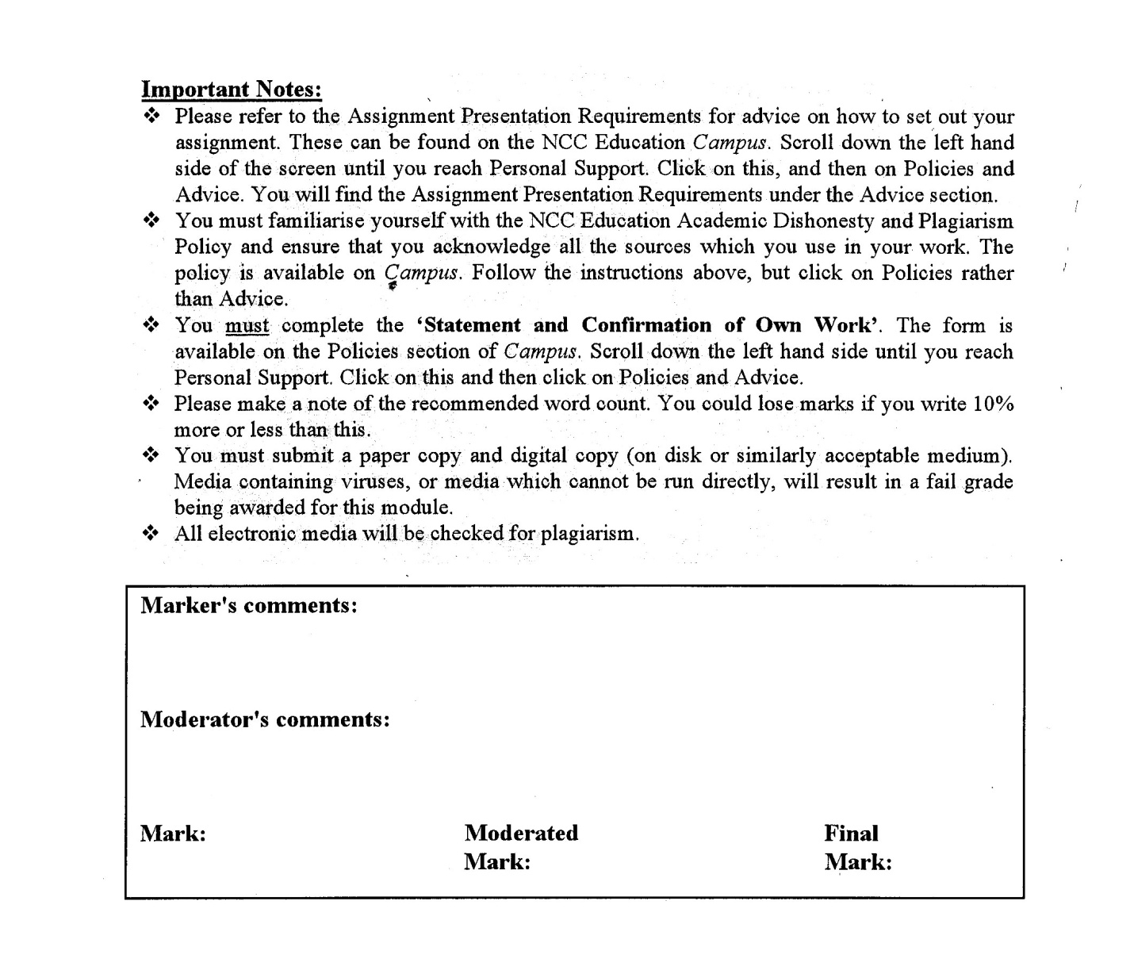



**Statement and Confirmation of Own Work**

**Programme/Qualification name: L4DC**

*All NCC Education assessed assignments submitted by students must have this statement as the cover page or it will not be accepted for marking. Please ensure that this statement is either firmly attached to the cover of the assignment or electronically inserted into the front of the assignment.*

**Student declaration**

I have read and understood NCC Education’s Policy on Academic Dishonesty and Plagiarism.

I can confirm the following details:

**Student ID/Registration number:** **P00202282**

**Name : HTET YOON NADI**

**Centre Name : KMD Institute (Yangon)**

**Module Name : DESIGNING AND DEVELOPING A WEBSITE**

**Module Leader : SHAIN THU**

**Number of words : (1050) WORDS**

I confirm that this is my own work and that I have not plagiarised any part of it. I have also noted the assessment criteria and pass mark for assignments.

**Due Date : 21 January 2024**

**Student Signature : HTET**

**Submitted Date : 21 January 2024**

# Table of Contents

Contents

Table of Contents 3

Introduction 5

Task-1 Web Design Print Screen 7

Task-2 CSS 34

Task-3 Test the website and write a test report 72

Using the W3C validation service (http://validator.w3.org/) 72

Accessibility using a screen reader 76

Testing the website on two browsers 78

Test Report 81

The role of the W3C 81

Task-4 Critical Evaluation 83

1. Accessibility features 83

2. Embedded functional multimedia components 83

3. How the Internet and Web can be used 83

4. Improvements for further development 84

References 85

Bibliography 85

Candidate checklist 86

# Introduction

In this assignment, it will need to implement the website as the given scenario “ Standing Desk Company”. And it will be created with five pages Home Page, Rising Desks, Contact Us Page, Benefits, and Basket. On the Homepage, the dropdown, navigation bar, pop-up, and section footer must be included.

**Task one** there will be required the images of created websites and **the task two** will require CSS code identification. **The task three** will test for the website and have to write a short report of those testing. **Task four** will need to evaluate for the created website.

**Task 1**

**HTML**

## Task-1 Website design Screenshot

For the task will show the website design with screen shot follow as the scenario.

# Desktop View of Home Page

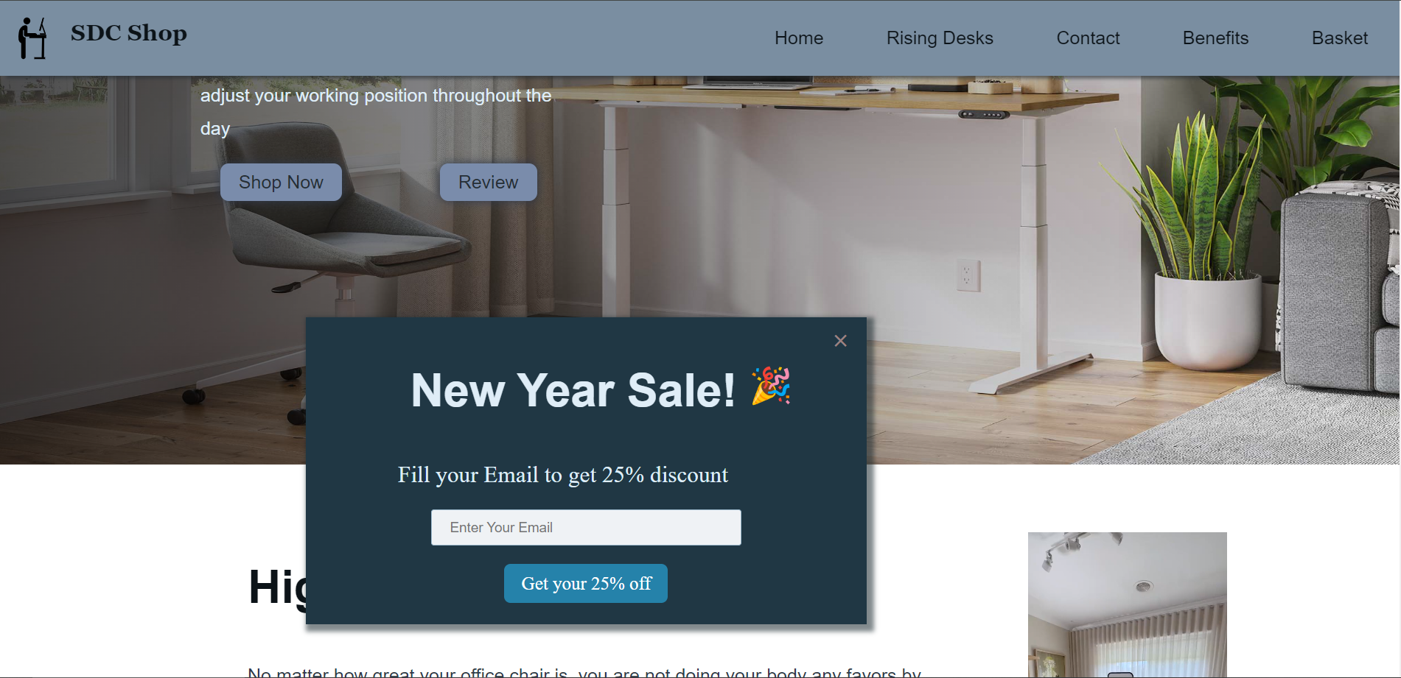

**Home Page Drop down contact**

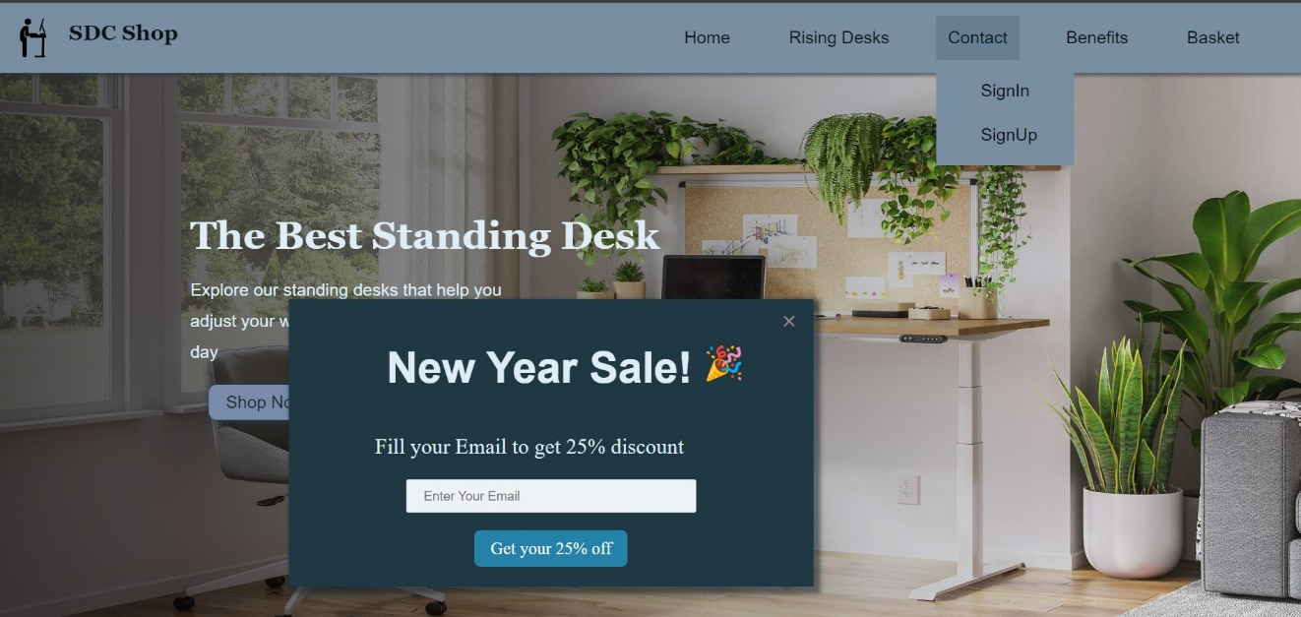

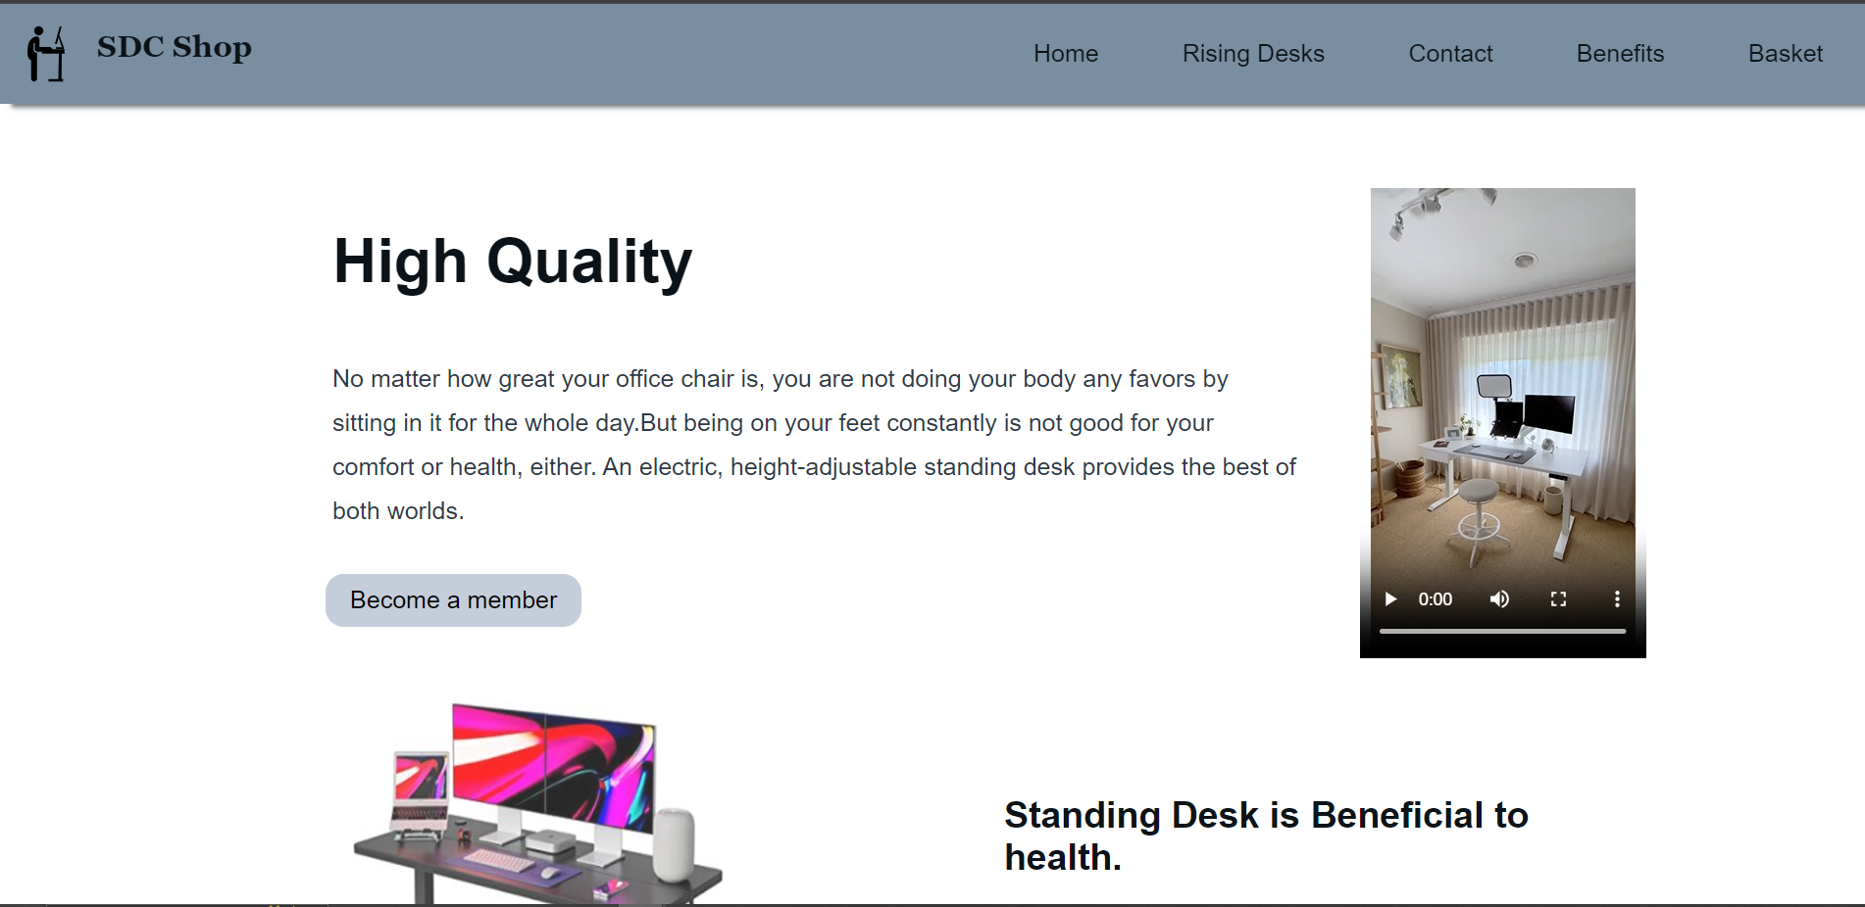

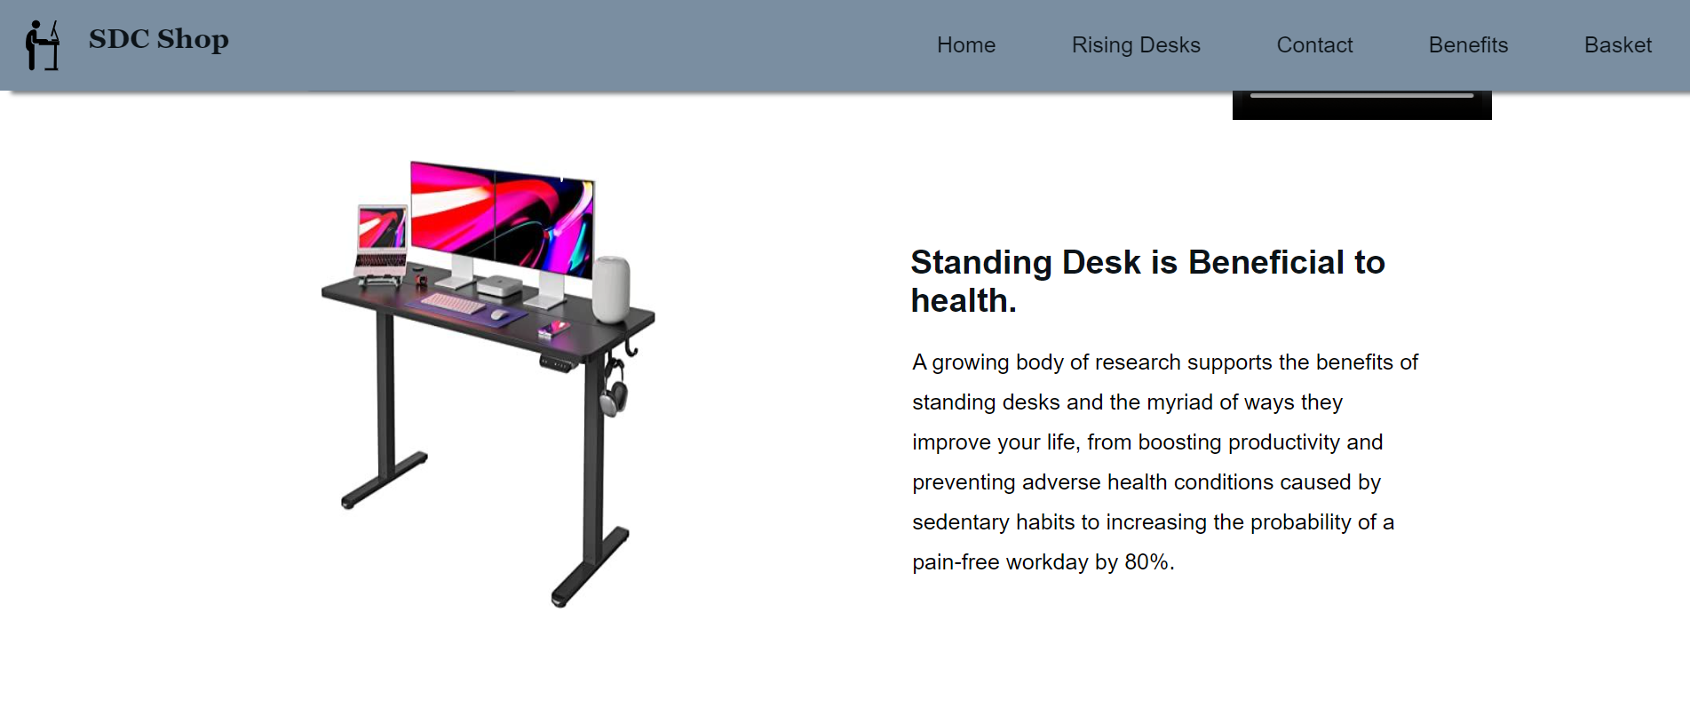

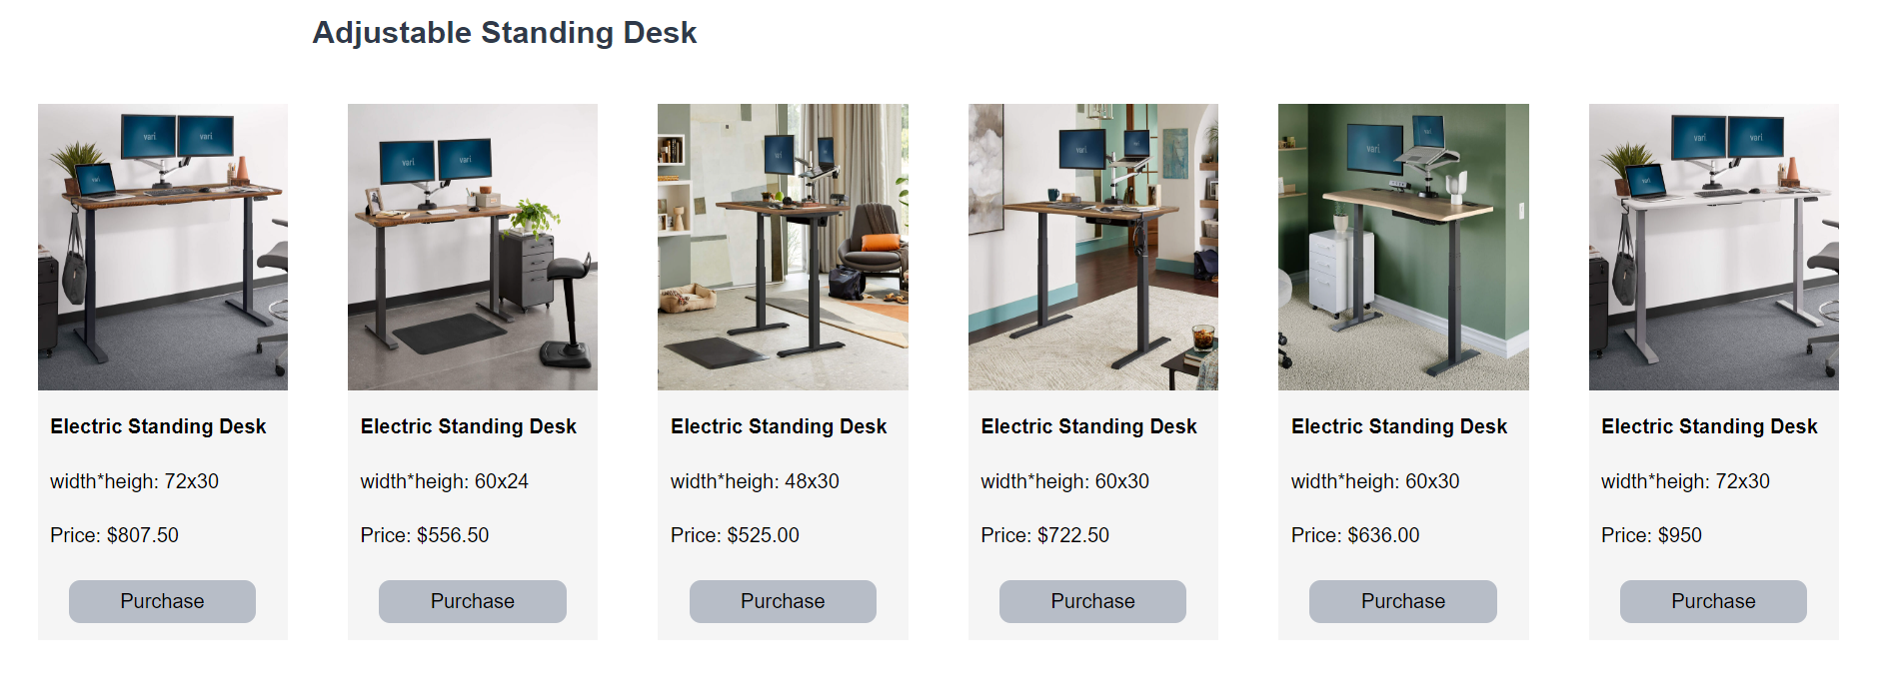



**Rising Desk Page**

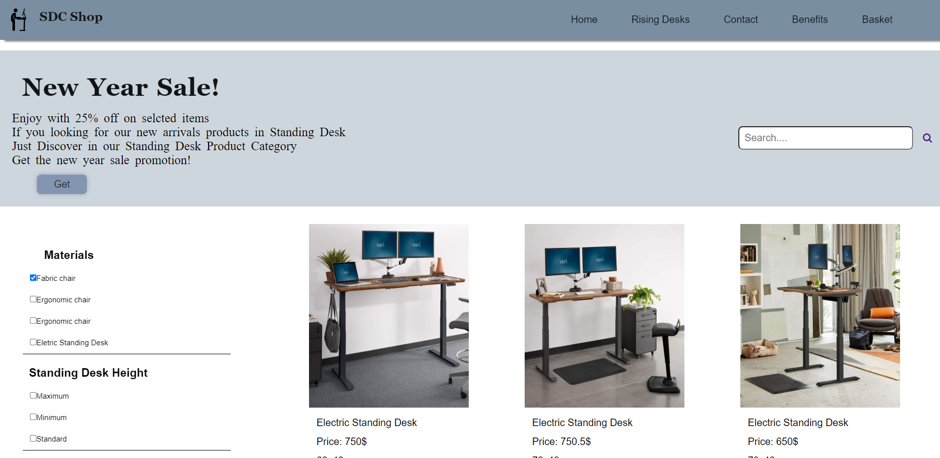

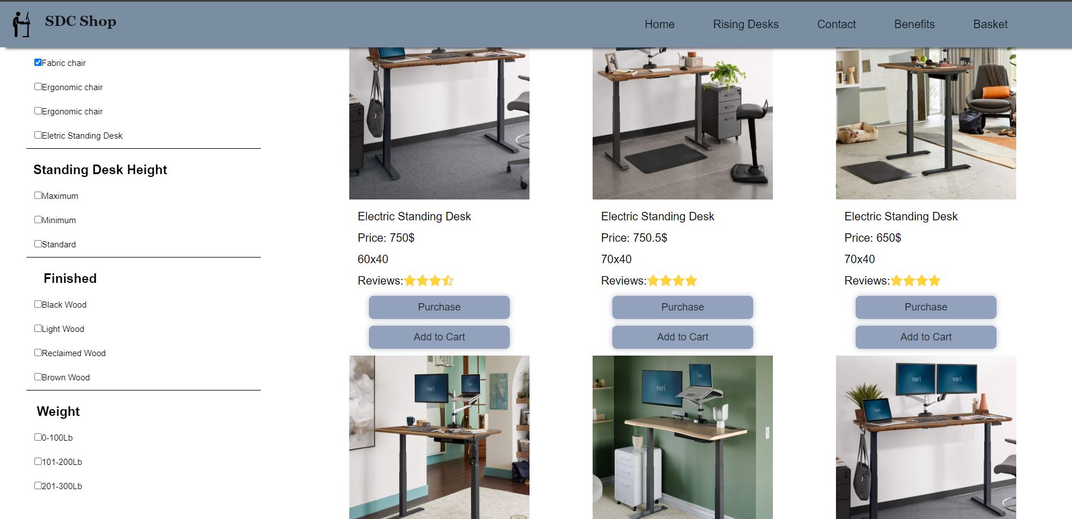

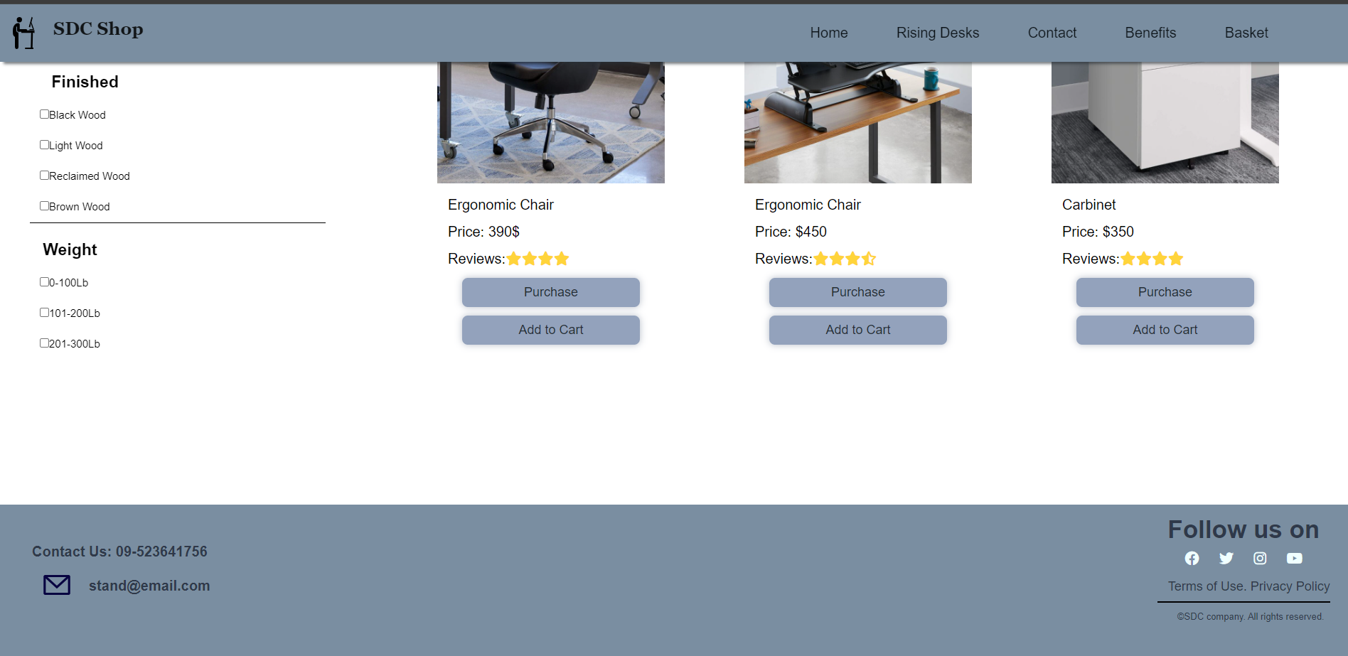

**Contant Us Page**

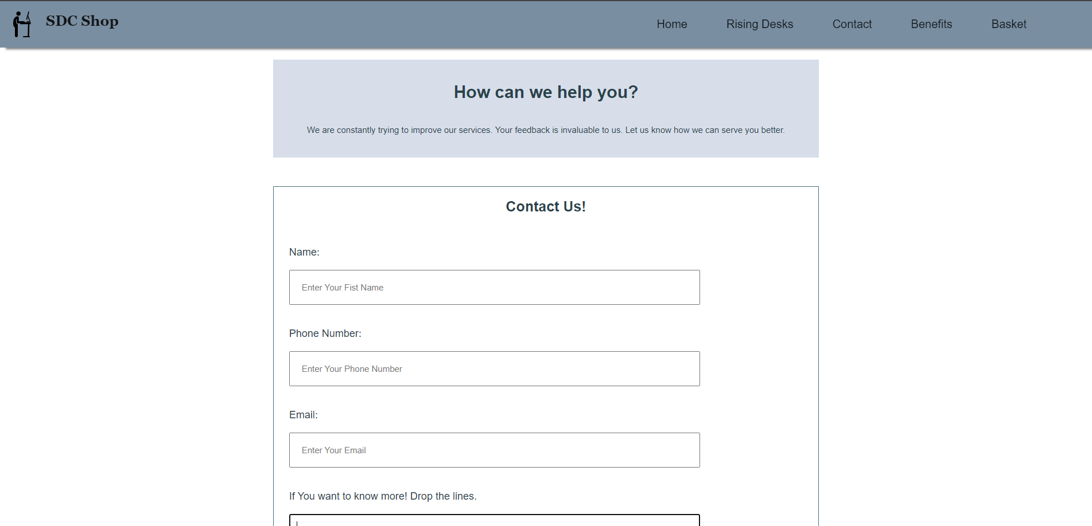

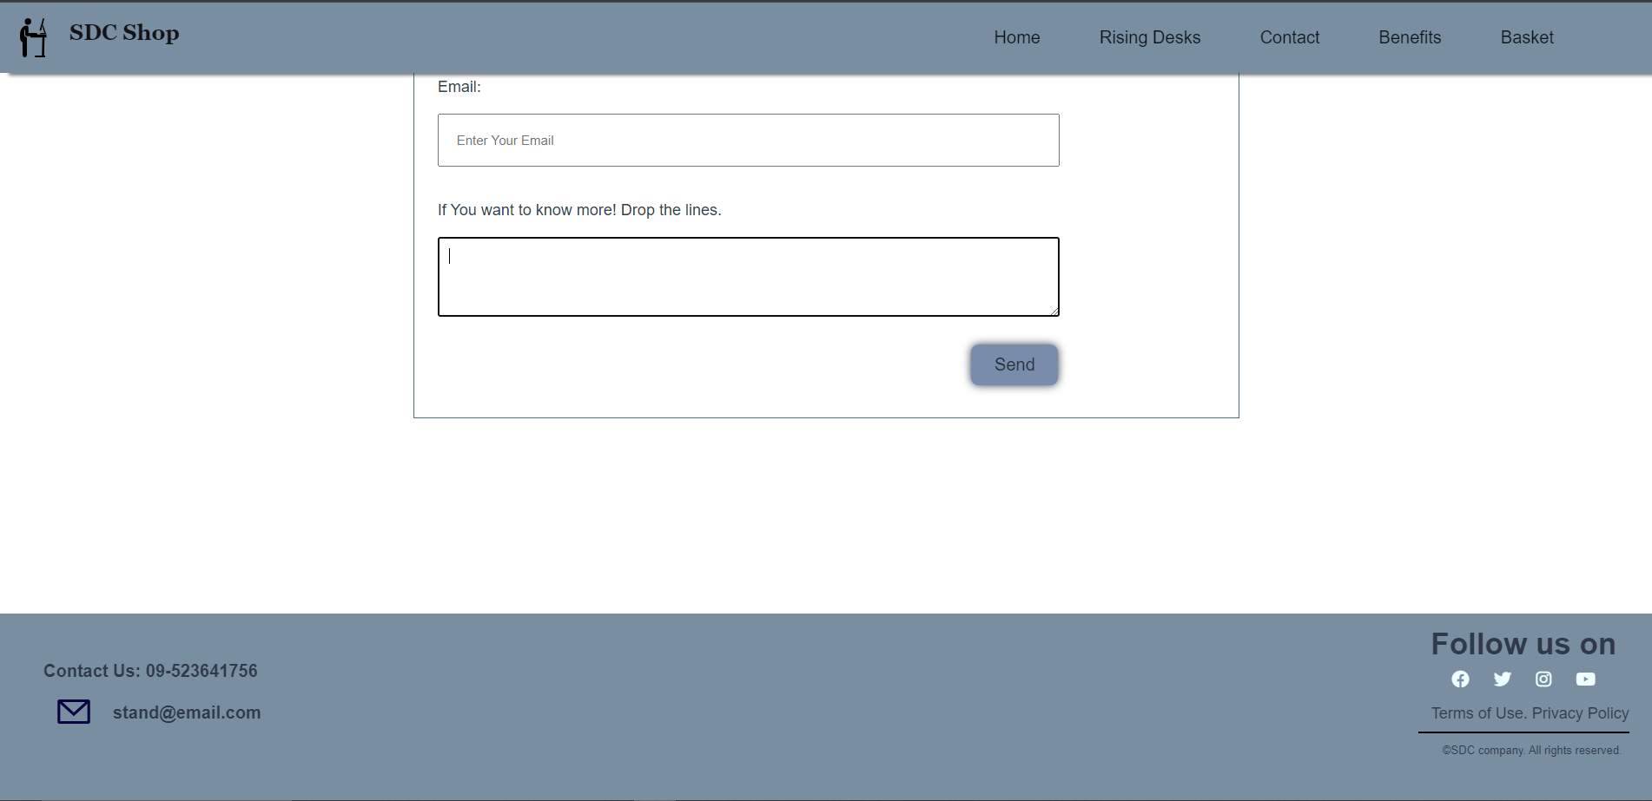

**Benefits Page**

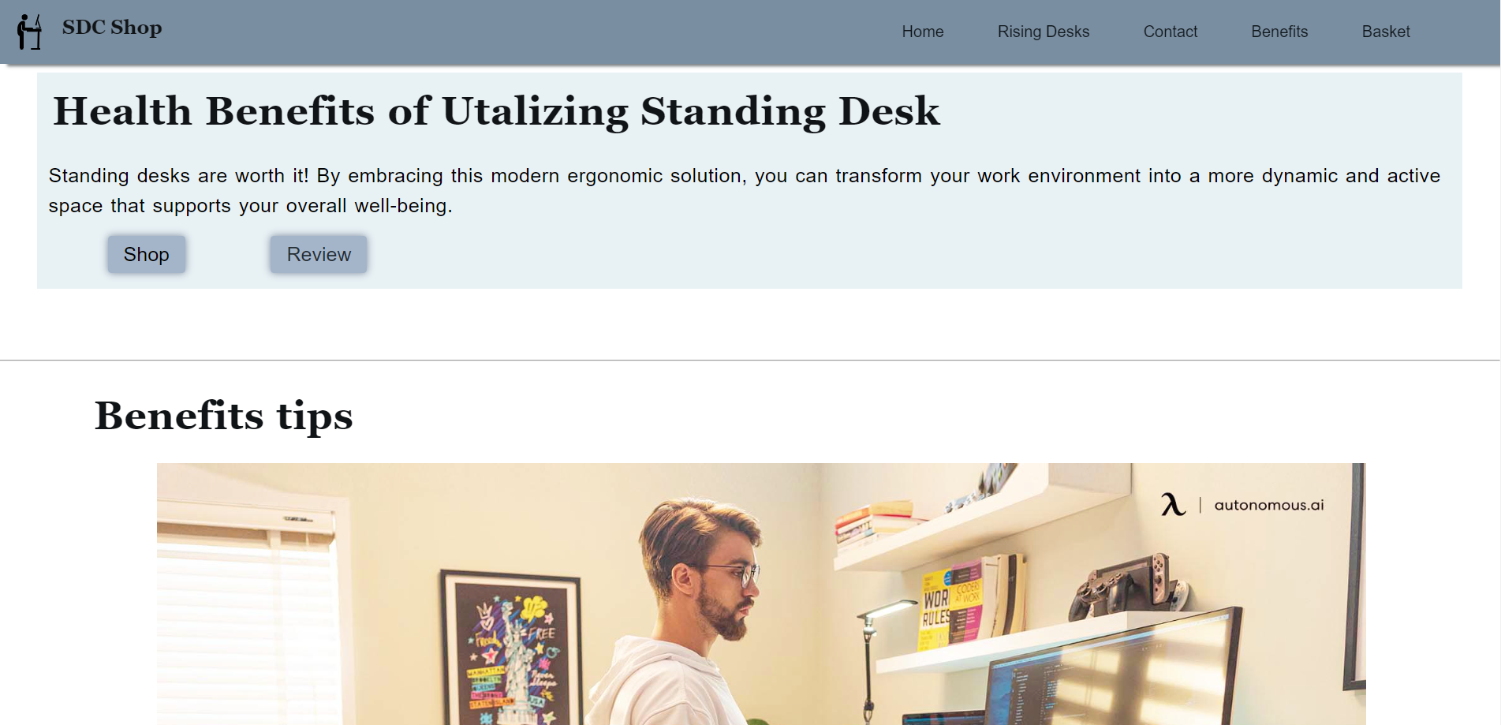

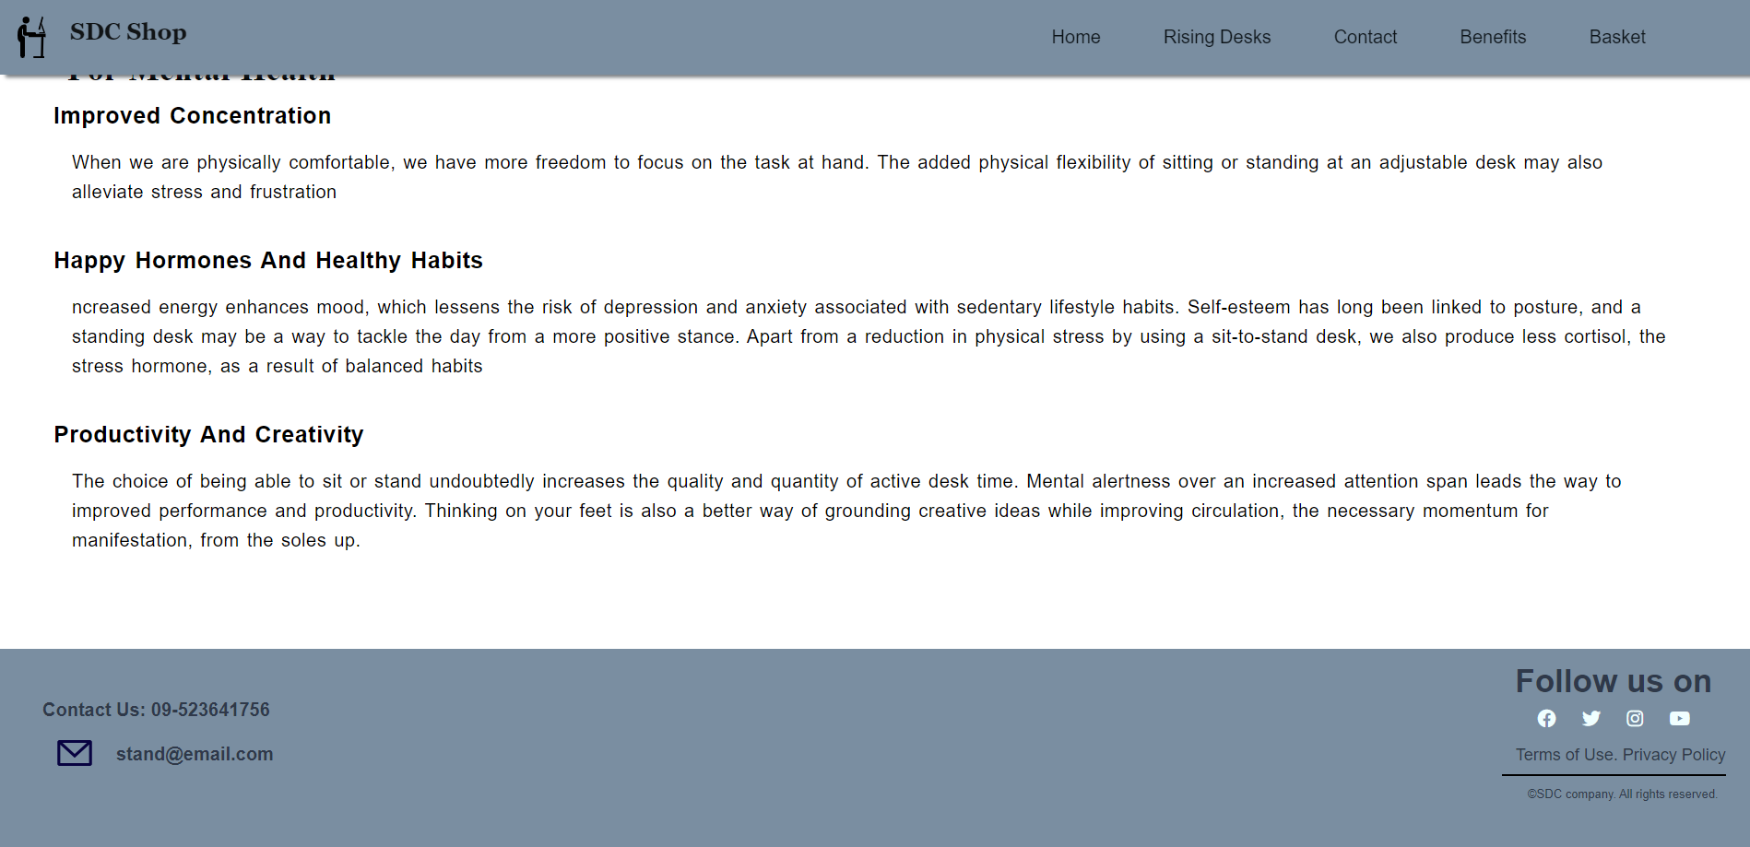

**Basket Page**

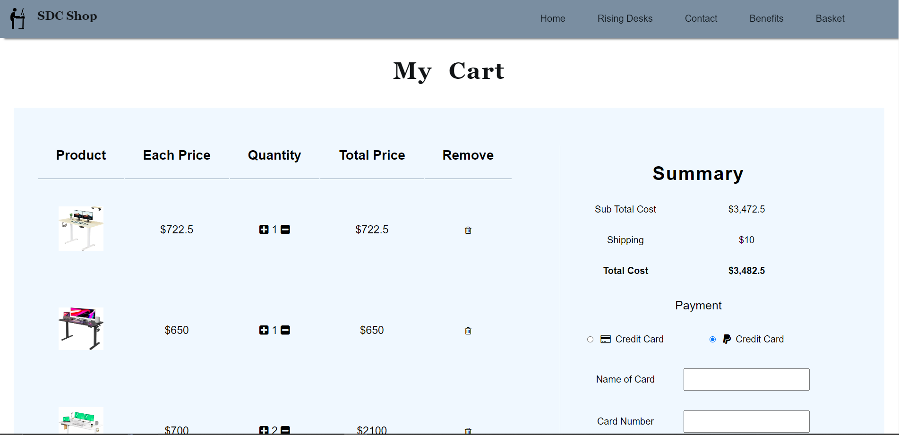

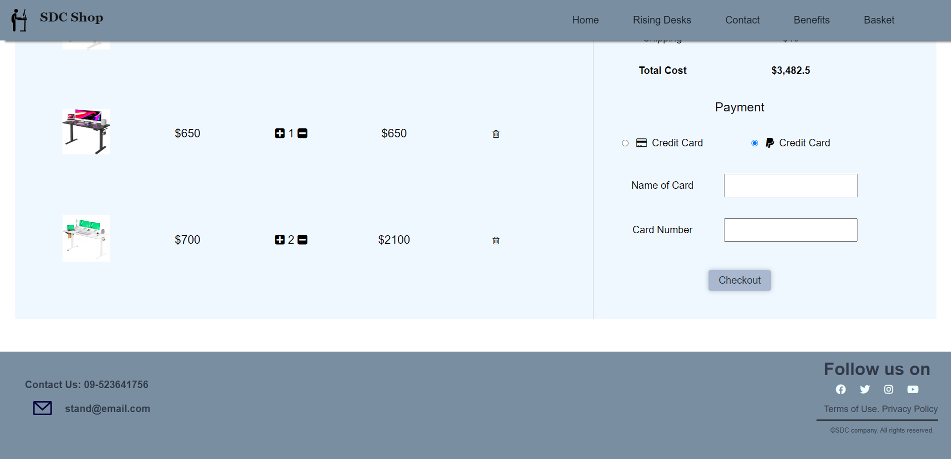

Mobile Device View (IPhone 12 Pro)

Home Page

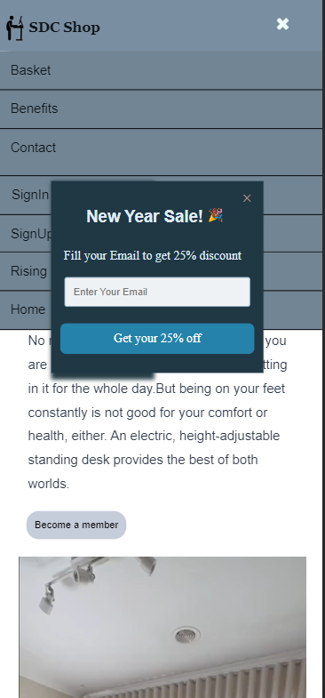 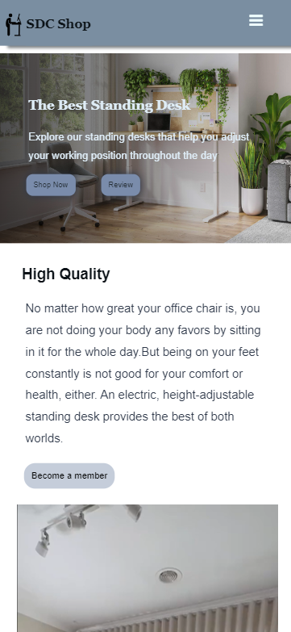

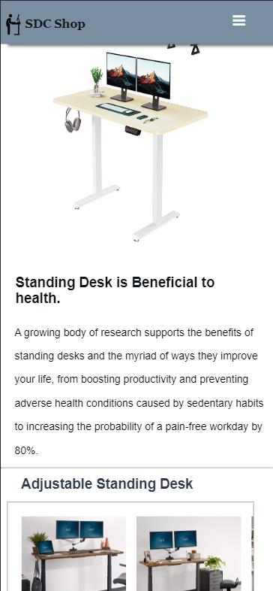 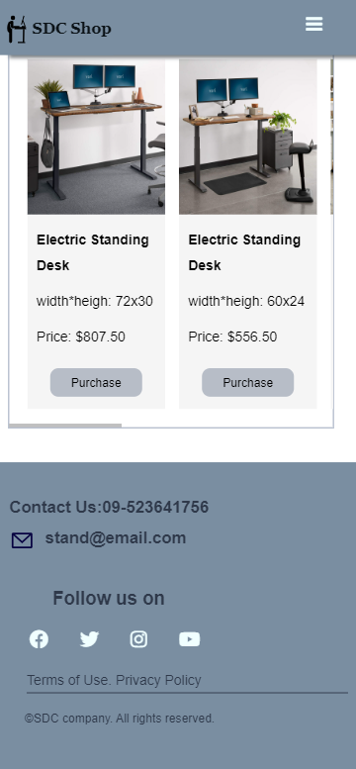

Rising Desk Page

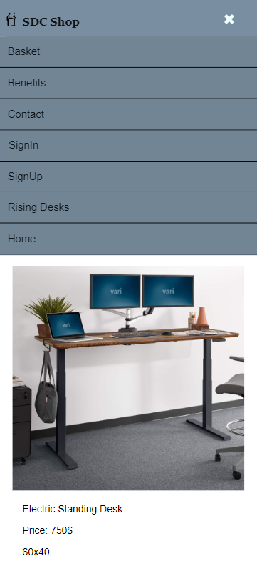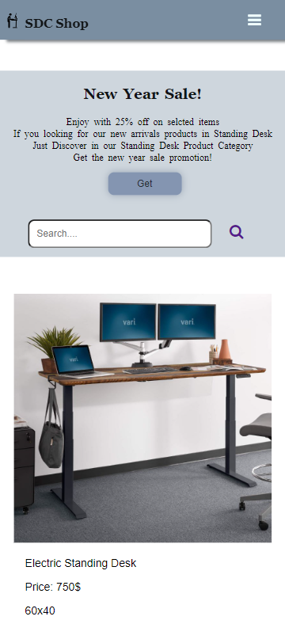

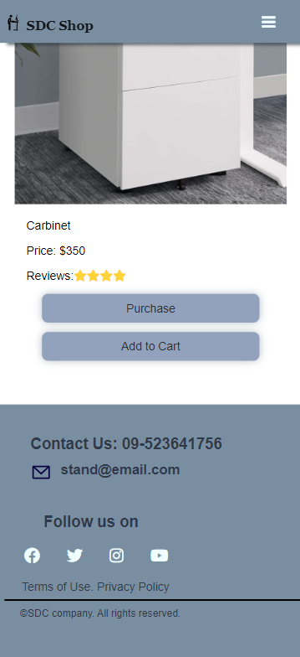

**Contact Us page**

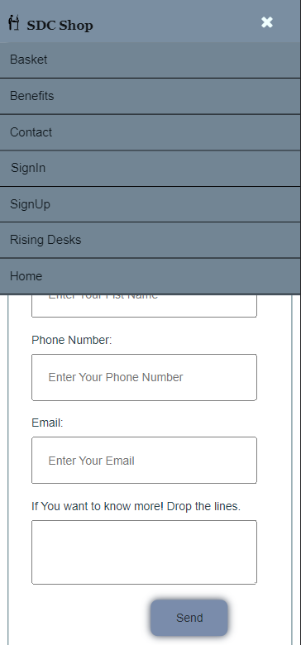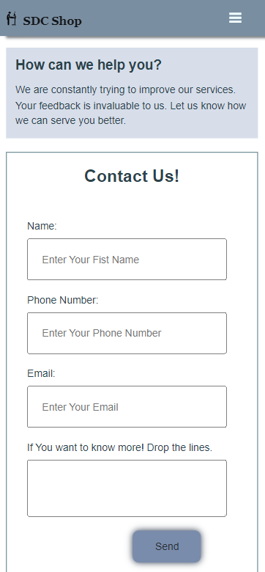

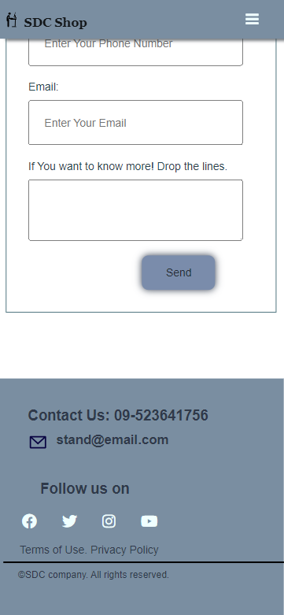

**Benefits Page**

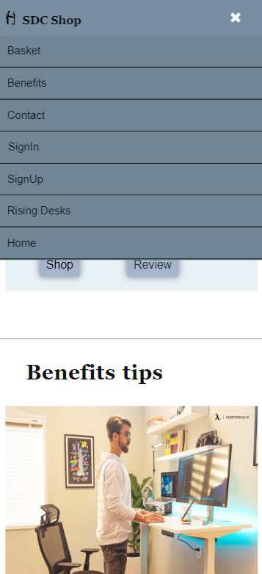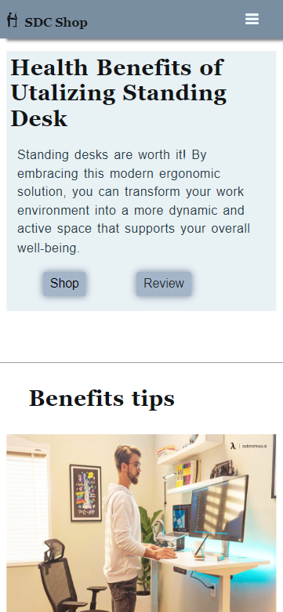

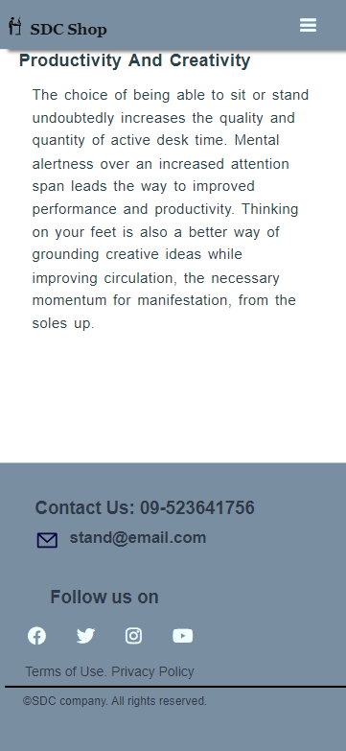

**Basket**

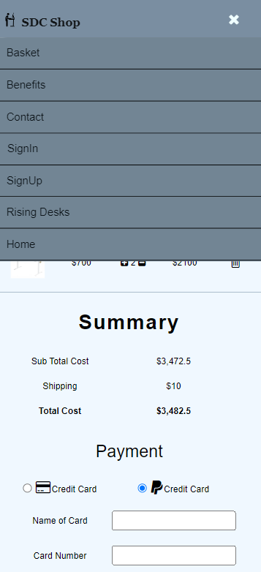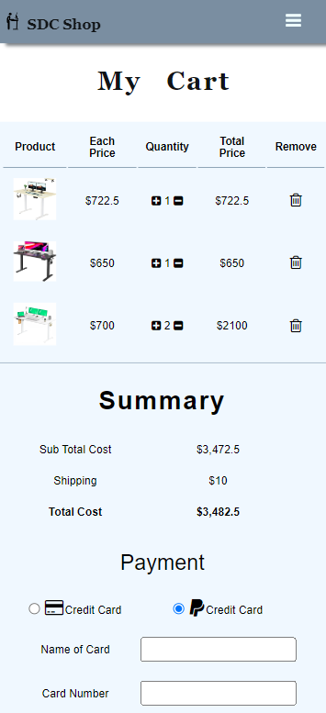

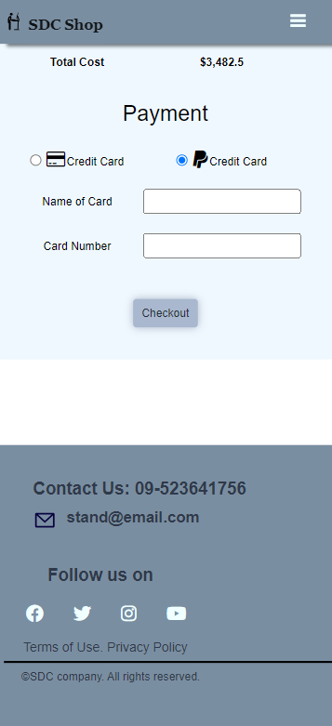

**Tablet View (IPad Air)**

**Home Page**

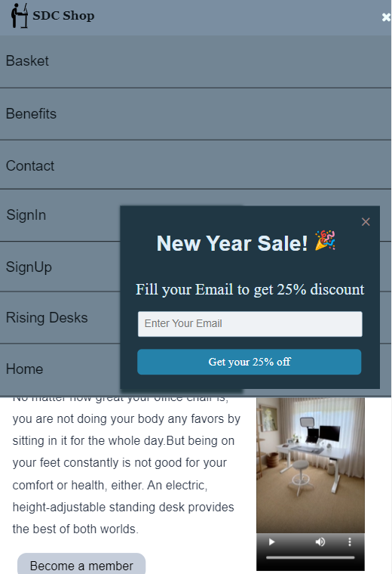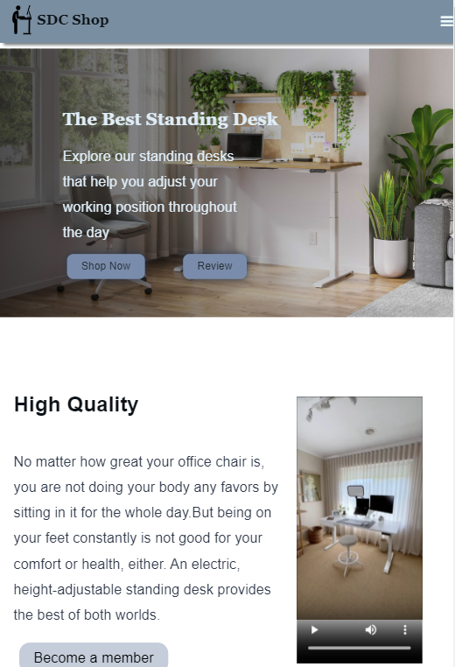

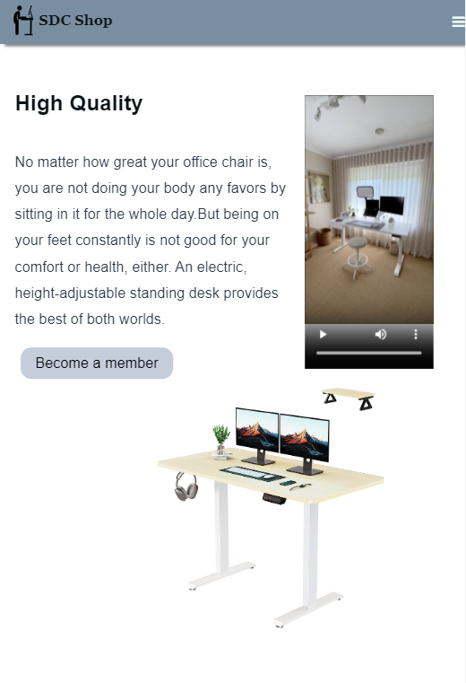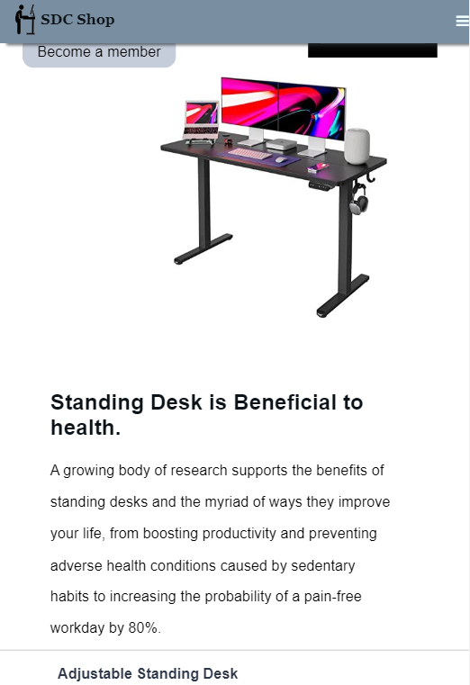

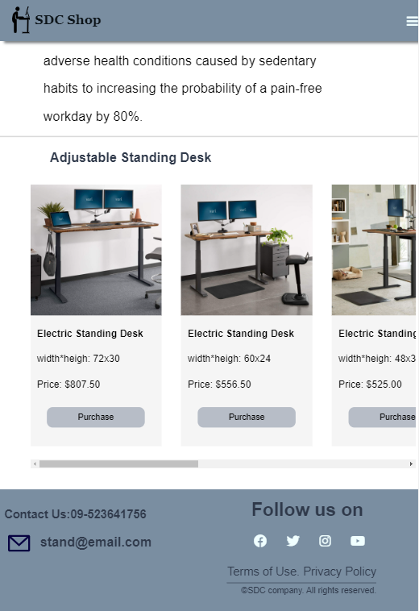

**Rising Desk**

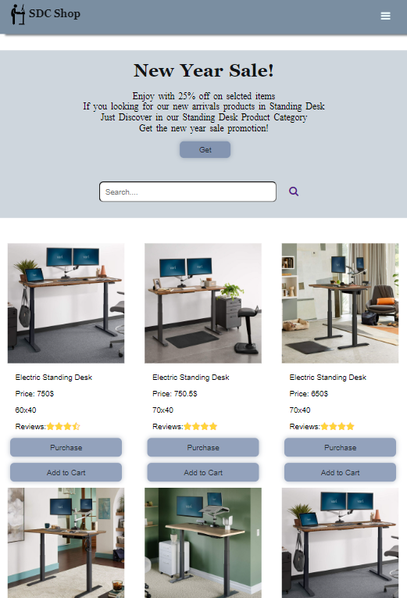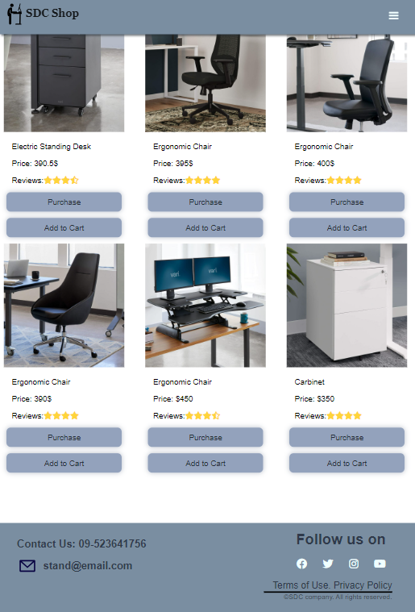

**Contact Us Page**

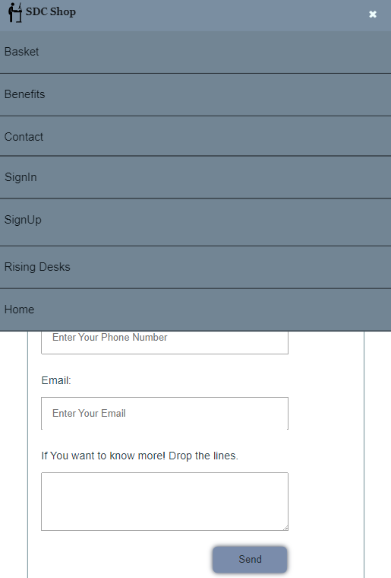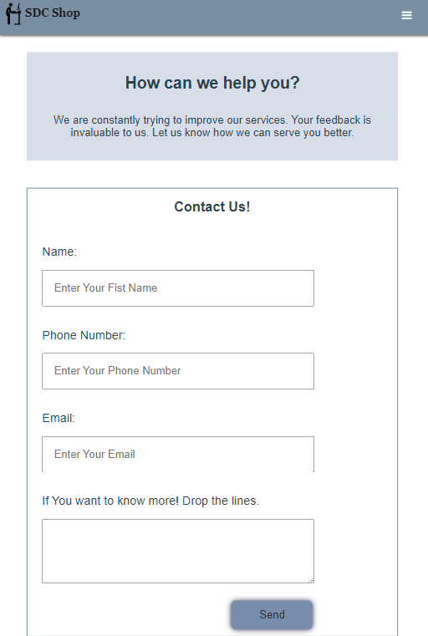

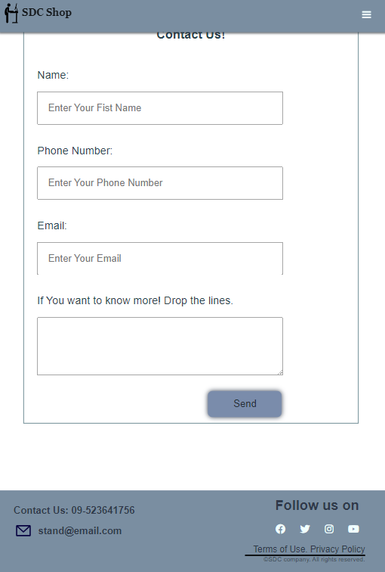

**Benefits Page**

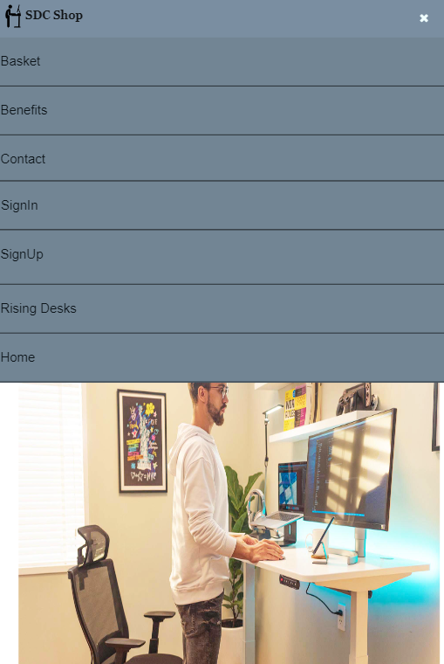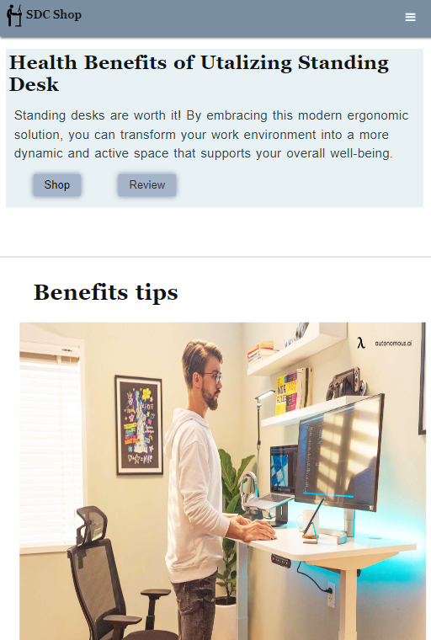

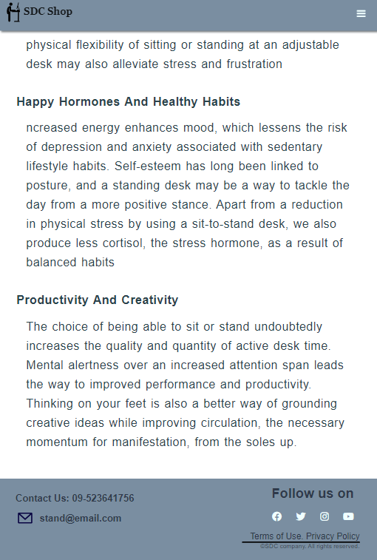

**Basket Page**

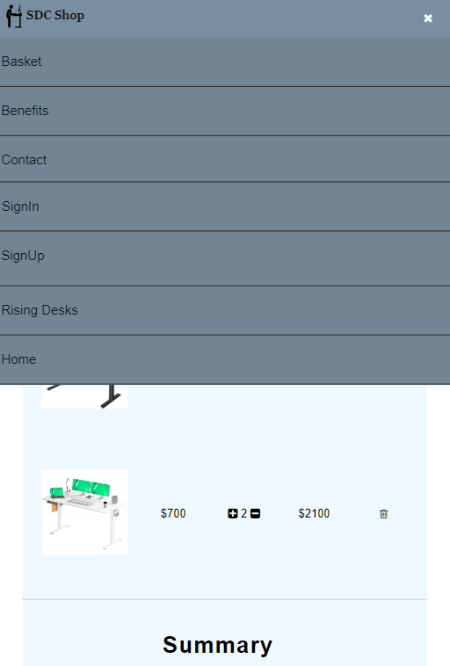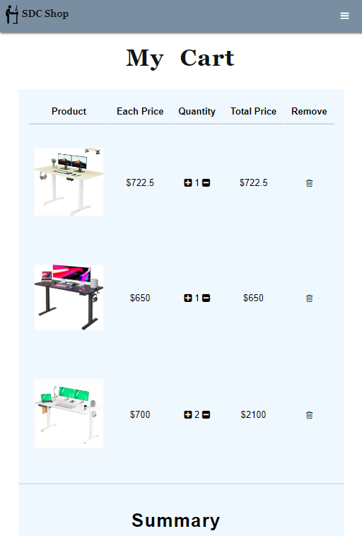

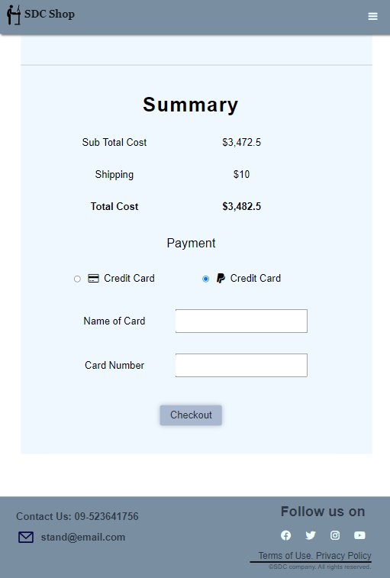

**Task 2**

**CSS**

# Task-2 CSS

**Desktop View**

**Home Page Css**

*

{

    margin: 0 ;

    padding: 0;

}

/**************** Header Style start ****************/

.heading

{

    display: flex;

    background-color: #7a8ea1;

    transform: translate(0px, 0px);

    padding: 0 15px;

    width: 100%;

    box-shadow: 10px 3px 4px  #272e359f;

    position: fixed;

    top: 0;

    z-index: 1;

    justify-content: space-between;

}

.logo

{

    display: flex;

}

#contact ul {

    display: block;

}

img

{

    width: 45px;

}

h1

{

    font-family: "Serif","Georgia";

    color: #0c1318;

    font-size: 25px;

    padding: 20px;

}

.main-navigation

{

    display: flex;

    flex-wrap: wrap;

    padding: 15px;

    float: right;

}

.menu ul{

    float: right;

}

.menu ul li a{

    color: #0c1318;

}

.menu a:hover{

    background-color: #31556944;

}

.menu ul li {

    float: right;

    list-style: none;

    position: relative;

    padding: 0px 20px;

}

.menu ul li a{

    display: block;

    font-family: Arial, Helvetica, sans-serif;

    font-size: 20px;

    padding: 14px;

    text-decoration: none;

    cursor: pointer;

}

.menu ul li ul{

    display: none;

    position: absolute;

    background-color: #7a8ea1;

    padding: 10px;

}

.menu ul li:hover ul{

    display: block;

}

.menu ul li ul li {

    width: 100px;

}

.menu ul li ul li a{

    padding: 14px 22px;

}

.menu ul li ul li a:hover{

    background-color: #31556944;

}

label #bar,

label #cancel {

    font-size: 20px;

    float: right;

    cursor: pointer;

    display: none;

}

#check

{

    display: none;

}

/**************** Header Style end ****************/

/*******************Popup Style start ****************/

.popup-model

{

    position: absolute;

    position: fixed;

    left: 20%;

    top: 40%;

    display: center;

    z-index: 1;

    width: 40%;

    margin: 50px;

    margin-left: 2%;

    box-shadow: 4px 4px 5px 4px rgba(22, 37, 43, 0.541);

    color: #dfedf7;

}

.popup

{

    padding: 9px 0px;

    background-color: #203744;

}

.popup-title

{

    text-align: center;

    line-height: 2.4;

    padding: 10px 9px 4px 9px;

}

.popup-title h2

{

    font-family: sans-serif;

    font-weight: bold;

    font-size: 50px;

    text-align: center;

    margin-bottom: 10px;

    margin-left: 60px;

}

.popup-title p

{

    text-decoration: none;

    font-family: "Times New Roman",Times, serif;

    font-size: 25px;

    margin-left: 0;

    padding-left: 0px;

}

#popup-close

{

    display: block;

    float: right;

    font-size: 30px;

    color: #9c8282;

    cursor: pointer;

    padding-right: 20px;

    font-weight: bold;

}

#popup-close:hover

{

    color: #a3a8af;

}

.popup-input

{

    padding: 10px 20px;

    margin-top: 15px;

    border-radius: 3px;

    border: 1px solid #9dbace;

    background-color:  #eff2f5;

    width: 50%;

    font-size: 15px;

}

.popup-button

{

    border: none;

    cursor: pointer;

    width: 30%;

    border-radius: 7px;

    background-color: #2582aa;

    color: white;

    display: block;

    padding: 10px;

    margin-left: 35%;

    margin-top: 20px;

    margin-bottom: 10px;

    font-size: 20px;

    transition-duration: 0.5s;

    font-family: "Times New Roman",Times, serif;

}

.popup-button:hover

{

    background-color: #1d4d61;

    cursor: pointer;

}

/****************Popup Style end ****************/

/**************** intro-img start ****************/

.review{

    background-image: linear-gradient( to right, rgba(0,0,0,0.7),rgba(172, 172, 172, 0));

    width: 100%;

    height:95vh;

    position: absolute;

}

.content{

    margin-top: 10%;

    margin-left: 10%;

}

.content h1{

    margin-left: 0%;

    padding-left: 5%;

    color: #dfedf7;

    font-size: 45px;

}

.content p{

    margin-left: 0%;

    margin-right: 65%;

    padding-left: 5%;

    color: #dfedf7;

    font-size: 20px;

}

.content button{

    margin: 20px 12px 8px 90px;

    padding: 9px 20px;

    border-radius: 9px;

    border:none ;

    background: #7a8cab;

    cursor: pointer;

    font-size: 20px;

    box-shadow: 0 0 10px #2f394a;

    transition-duration: 0.3s;

    color: #252e35;

}

.content button:hover, button:focus, button:active

{

    background-color: #989fac;

    -webkit-transform: scale(1.1);

    transform: scale(1.1);

}

.intro-img{

    margin-top: 70px;

}

.intro-img img{

    width: 100%;

    height:95vh;

}

/**************** intro-img end ****************/

/**************** section Style start ****************/

.about

{

    display: flex;

    padding-top: 10px;

    padding-right: 10%;

    color: #2f394a;

}

.about h1

{

    font-family: sans-serif;

    font-size: 50px;

    margin-top: 70px;

    margin-left: 50px;

    margin-right: 50px;

    margin-bottom: 30px;

    padding-left: 20%;

}

p

{

    font-family: Arial, Helvetica, sans-serif;

    margin-left: 50px;

    line-height: 1.8;

    font-size: 20px;

    padding-left: 20%;

    margin-right: 50px;

}

.about button{

    margin-left:24%;

    margin-top: 3%;

    padding: 10px 20px;

    border-radius: 15px;

    background: #c5cdda;

    transition-duration: 0.5s;

    cursor: pointer;

    font-size: 20px;

    border: none;

}

.video-container video

{

    width: 90%;

    height: 80%;

    margin-top: 60px

}

/**************** pic slide style start *********/

.standingDesk-show

{

    margin-bottom: 100px;

    display: flex;

    margin-left: 15%;

}

.slide-fade

{

    display: none;

}

.slide-fade img{

    height: 55vh;

    width: 250%;

    margin-left: 50%;

    display: block;

    margin-right: 12%;

}

.slide-show

{

    margin: auto;

}

.slide-dot

{

    height: 10px;

    width: 10px;

    margin-top: 10px;

    margin-left: 12%;

    background: white;

    border-radius: 50%;

    display: inline-block;

    transition: background-color 0.6s ease;

}

.dotted

{

    position: relative;

    margin-top: -30px;

    text-align: center;

}

.active

{

    background-color: #dfedf7;

}

.fade

{

    animation-name: fade;

    animation-duration: 0.5s;

}

@keyframes fade

{

 from{opacity: .5;}

 to{opacity: 1;}

}

.healthy

{

    margin-top: 55px;

    float: right;

    margin-right: 15%;

    margin-left: 9%;

}

.healthy h1

{

    margin-left: 20%;

    padding-left: 55px;

    font-size: 30px;

    font-family: Arial, Helvetica, sans-serif;

}

.healthy p

{

    font-family: Arial, Helvetica, sans-serif;

    font-size: 20px;

    padding-left: 21%;

}

/**************** pic slide style end *********/

/**************** Images product style start ****************/

.images-product

{

    color: #2f394a;

}

.images-product h2

{

    font-size: 25px;

    font-family: Arial, Helvetica, sans-serif;

    padding-top: 12px;

    padding-right: 70px;

    padding-left: 250px;

    padding-bottom: 12px;

}

.view-images

{

    display: flex;

    column-gap: 3em;

    margin: 10px 200px 0px 20px;

    padding: 20px 10px 20px 10px;

    width: 40%;

}

.view-images img

{

    width: 200.33px;

    height: 230px;

}

.card

{

    background-color: whitesmoke;

    width: 200.33px;

    height: 430px;

}

.purchase

{

    margin: 6px 10px 8px 25px;

    padding: 8px 20px;

    border-radius: 9px;

    border: none ;

    background: #b7bdc7;

    transition-duration: 0.5s;

    cursor: pointer;

    font-size: 16px;

    width: 150px;

}

button:hover{background-color: #989fac;}

.product-facts p

{

    display: block;

    font-family: Arial, Helvetica, sans-serif;

    font-size: 16px;

    margin-block-start: 10px;

    margin-block-end: 20px;

    margin-inline-start: 0px;

    margin-inline-end: 0px;

    padding-left: 10px;

    margin-bottom: 15px;

}

/*********** Images product style end ************/

/**************** section Style end ****************/

/**************** footer Style start ****************/

.footer

{

    color: #2f394a;

    background-color: #7a8ea1;

    width: 100%;

    padding-bottom: 50px;

    font-family: Arial, Helvetica, sans-serif;

    display: flex;

    margin-block-start: 2em;

}

.email

{

    padding: 10px 0px 20px 5px;

    display: flex;

}

.email h4

{

    padding-top: 10px;

    font-size: 18px;

}

.email img

{

    padding-left: 5px;

}

.terms

{

    padding-top: 30px;

}

.followUs

{

    text-align: center;

    margin-left: 60%;

    margin-top: 15px;

}

.followUs h4

{

    font-size: 35px;

    padding-left: px;

    padding-bottom: 12px;

}

.contact

{

    padding-top: 40px;

}

.contact h4

{

    padding-top: 15px;

    padding-left: 20px;

    font-size: 18px;

}

.term

{

    padding-top: 20px;

    padding-bottom: 10px;

    padding-left: 10px;

}

.term p

{

    font-size: 18px;

    padding-left: 5px;

    border-bottom: solid 1px;

}

.copy p

{

    padding-top: 12px;

    padding-left: 20px;

    font-size: small;

}

.fontawesome a

{

    padding: 12px;

    font-size: 15px;

}

/**************** footer Style end ****************/

/**** for tablet responsive**********/

@media only screen and (max-width: 820px) {

    /**** header responsive**********/

.heading

{

    padding: 9px 20px 0px 15px;

    height: 55px

}

.logo

{

    display: flex;

}

.logo img

{

    width: 40px;

    height: 45px;

}

.logo h1

{

    font-size: 20px;

    padding: 10px 2px 0px 2px;

}

.menu

{

    float: right;

    padding-bottom: 20px;

}

.main-navigation a

{

    text-decoration: none;

    font-size: 20px;

    color: #2f394a;

    font-size: 19px;

    font-family: Arial, Helvetica, sans-serif;

    padding: 20px;

    font-size: 20px;

    transition-duration: 0.5s;

}

.checkbtn

{

    display: block;

    float: right;

}

.main-navigation

{

    padding-bottom: 15px;

}

.main-navigation i

{

    padding-top: 15px;

    padding-left: 15px

}

.menu

{

    padding-top: 20px;

    width: 50%;

}

.menu a

{

    display: grid;

    cursor: pointer;

    padding-top: 20px;

    padding-left: 350px;

    padding-bottom: 23px;

    font-size: 20px;

    font-family: system-ui;

    font-weight: 500;

    justify-content: flex-start;

    transition-duration: 0.5s;

    border: solid 1px currentColor;

    margin-left: 0px;

}

.menu a:hover{color: #93a1ba;}

label #bar

{

    padding-left: 350px;

    padding-top: 0px;

}

label #cancel

{

    padding-left: 350px;

    display: block;

    padding-top: 0px;

}

.menu ul

{

    position: fixed;

    background-color: #728594;

    width: 100%;

    height: 62.5vh;

    left: -1px;

    overflow: hidden;

    display: flex;

    flex-direction: column;

}

.menu ul li{

    float: right;

    list-style: none;

    position: relative;

    padding: 15px 0px;

    border-bottom: solid 1.5px;

}

.menu ul li a{

    display: block;

    font-family: Arial, Helvetica, sans-serif;

    font-size: 23px;

    padding: 14px;

    text-decoration: none;

    cursor: pointer;

    border: none;

}

.menu ul li ul{

    display: inline-flex;

    position: relative;

    width: 100%;

    float: initial;

    height: 15vh;

    padding-left: 0px;

    background-color: #728594;

}

.menu ul li ul li a{

    padding-left: 15px;

}

#signin{

    border: solid 0.5px;

    width: 100%;

}

#check:checked ~ .menu ul {

    max-height: 0px;

    background-color: #7a8ea1;

    transition-duration: 500ms;

}

#check:checked ~ label #bar {

    display: block;

}

#check:checked ~ label #cancel{

    display: none;

}

/**** header responsive**********/

.about

{

    display: flex;

    padding-top: 25px;

    color: #2f394a;

    margin: 12px;

    padding-right: 110px;

}

.about h1

{

    font-size: 30px;

    margin-top: 45px;

    margin-right: 20px;

    margin-bottom: 25px;

    padding-left: 12px;

    margin-left: 0px;

}

.about p

{

    font-family: Arial, Helvetica, sans-serif;

    line-height: 1.8;

    font-size:20px;

    padding-left: 12px;

    margin-right:10px;

    margin-left: 0px;

}

.about button{

    margin-left:5%;

    margin-top: 5%;

    padding: 10px 20px;

    border-radius: 15px;

    background: #c5cdda;

    transition-duration: 0.5s;

    cursor: pointer;

    font-size: 20px;

    border: none;

}

/**** video responsive**********/

.video-container

{

    margin-left: 5px;

}

.video-container video

{

    width: 180%;

    height: 95%;

    margin-top: 10px;

    border-radius: 0px;

}

/**** video responsive**********/

/********intro-img start*******/

.review{

    background-image: linear-gradient( to right, rgba(0,0,0,0.7),rgba(172, 172, 172, 0));

    width: 100%;

    height:40vh;

    position: absolute;

}

.content{

    margin-top: 10%;

    margin-left: 10%;

}

.content h1{

    margin-left: 0%;

    padding-left: 5%;

    color: #dfedf7;

    font-size: 25px;

}

.content p{

    margin-left: 0%;

    margin-right: 50%;

    padding-left: 5%;

    color: #dfedf7;

    font-size: 20px;

}

.content button{

    margin: 12px 15px 8px 35px;

    padding: 9px 20px;

    border-radius: 9px;

    border:none ;

    background: #7a8cab;

    cursor: pointer;

    font-size: 15px;

    box-shadow: 0 0 10px #2f394a;

    transition-duration: 0.3s;

    color: #252e35;

}

.content button:hover, button:focus, button:active

{

    background-color: #989fac;

    -webkit-transform: scale(1.1);

    transform: scale(1.1);

}

.intro-img{

    margin-top: 70px;

}

.intro-img img{

    width: 100%;

    height:40vh;

}

/********intro-img end********/

/**************** pic slide style start *********/

.standingDesk-show

{

    margin-bottom: 8px;

    margin-left: 20px;

    display: inline-block;

}

.slide-fade

{

    display: none;

}

.slide-fade img{

    width: 50%;

    margin-left: 200px;

    height: 35vh;

}

.slide-show

{

    margin: auto;

}

.slide-dot

{

    height: 10px;

    width: 10px;

    margin-top: 10px;

    margin-left: 12%;

    background: white;

    border-radius: 50%;

    display: inline-block;

    transition: background-color 0.6s ease;

}

.dotted

{

    position: relative;

    margin-top: -30px;

    text-align: center;

}

.active

{

    background-color: #dfedf7;

}

.fade

{

    animation-name: fade;

    animation-duration: 0.5s;

}

@keyframes fade

{

 from{opacity: .5;}

 to{opacity: 1;}

}

.healthy{

    margin-left: 0px;

    margin-right: 100px;

}

.healthy h1

{

    margin-left: 0px;

    padding-left: 50px;

    font-size: 30px;

    font-family: Arial, Helvetica, sans-serif;

}

.healthy p

{

    font-family: Arial, Helvetica, sans-serif;

    font-size: 20px;

    padding-left:50px;

    margin: 0px;

    line-height: 2.15;

}

/**************** pic slide style end *********/

/*********** Images product style end ************/

.images-product

{

    color: #2f394a;

}

.images-product h2

{

    font-size: 20px;

    font-family: Arial, Helvetica, sans-serif;

    padding-top: 20px;

    padding-left: 80px;

    padding-bottom: 10px;

}

.view-images

{

    display: flex;

    column-gap: 2em;

    margin: 9px 20px 0px 50px;

    padding: 10px 10px 20px 0px;

    width: 90%;

    font-size: 15px;

    overflow-x: scroll;

}

.view-images ::-webkit-scrollbar

{

    width: 0px;

}

.view-images img

{

    width: 200.33px;

    height: 200px;

}

.card

{

    background-color: whitesmoke;

    width: 200.33px;

    height: 400px;

}

.product-facts p

{

    display: block;

    font-family: Arial, Helvetica, sans-serif;

    font-size: 15px;

    margin-block-start: 10px;

    margin-block-end: 20px;

    margin-inline-start: 0px;

    margin-inline-end: 0px;

    padding-left: 10px;

    margin-bottom: 12px;

}

.purchase

{

    margin: 9px 10px 8px 25px;

    padding: 8px 5px;

    border-radius: 9px;

    border: none;

    background: #b7bdc7;

    transition-duration: 0.5s;

    cursor: pointer;

    font-size: 13px;

    width: 150px;

}

button:hover{background-color: #989fac;}

/*********** Images product style end ************/

/**************** footer Style start ****************/

.footer

{

    color: #2f394a;

    background-color: #7a8ea1;

    width: 100%;

    padding-bottom: 30px;

    font-family: Arial, Helvetica, sans-serif;

    display: flex;

    margin-block-start: 2em;

}

.email

{

    padding: 10px 0px 20px 0px;

    display: flex;

}

.email h4

{

    padding-top: 10px;

    font-size: 20px;

}

.email img

{

    padding-left: 10px;

}

.terms

{

    padding-top: 30px;

}

.followUs

{

    text-align: right;

    padding-left: 50px;

    margin-left: 5px

}

.followUs h4

{

    font-size: 28px;

    padding-left: 5px;

    padding-right: 70px;

}

.contact

{

    padding-top: 20px;

    font-size: 15px;

}

.contact h4

{

    padding-top: 9px;

    padding-left: 10px;

}

.term

{

    padding-top: 20px;

    padding-bottom: 0px;

}

.term p

{

    font-size: 18px;

    padding: 0;

    border-bottom: solid 1px;

}

.copy p

{

    padding: 0;

    font-size: small;

}

.fontawesome

{

    padding: 5px 55px 0px 50px;

    font-size: 22px;

}

/**************** footer Style end ****************/

/*******************Popup Style start ****************/

.popup-model

{

    position: fixed;

    left: 0px;

    top: 15%;

    z-index: 1;

    width: 30%;

    margin: 200px;

    box-shadow: 4px 4px 5px 4px rgb(36 60 69);

    color: #dfedf7;

}

.popup

{

    padding: 9px 0px;

    background-color: #203744;

    width: 220%;

}

.popup-title

{

    text-align: center;

    line-height: 2.4;

    padding: 10px 9px 4px 9px;

}

.popup-title h2

{

    font-family: sans-serif;

    font-weight: bold;

    font-size: 35px;

    text-align: center;

    margin-bottom: 10px;

    margin-left: 10px;

}

.popup img

{

    width: 35px;

}

.popup-title p

{

    text-decoration: none;

    font-family: "Times New Roman",Times, serif;

    font-size: 26px;

    margin-right: 0px;

    padding-left: 0px;

}

.popup-input

{

    padding: 10px 10px;

    margin-top: 12px;

    border-radius: 3px;

    border: 1px solid #9dbace;

    background-color:  #eff2f5;

    width: 85%;

    font-size: 17px;

}

.popup-button

{

    width: 90%;

    display: block;

    margin-top: 20px;

    margin-bottom: 10px;

    font-size: 19px;

    margin-left: 19px;

}

#popup-close

{

display: block;

    float: right;

    font-size: 30px;

    color: #9c8282;

    cursor: pointer;

    padding-right: 15px;

    font-weight: bold;

}

#popup-close:hover

{

    color: #a3a8af;

}

/**** popup responsive**********/

/**** for tablet responsive**********/

}

/**** for mobile responsive**********/

@media only screen and (max-width: 390px) {

/**** header responsive**********/

.heading

{

    width: 500px;

    padding-left: 0;

    height: 53px;

}

.logo

{

    display: flex;

    text-align: center;

}

.logo img

{

    width: 35px;

    height: 30px;

    padding-top: 10px;

}

.logo h1

{

    font-size: 17px;

    padding-top: 14px;

    padding-left: 0px;

    background-color: #7a8ea1;

}

.checkbtn

{

    display: block;

    float: right;

}

.main-navigation

{

    padding: 10px 65px 0px 45px;

}

.main-navigation i

{

    padding-top: 15px;

    padding-left: 15px

}

.main-navigation

{

    flex-wrap: wrap;

}

.menu{

    padding-top: 22.5px;

}

.menu ul{

    float: right;

    height: 40vh;

}

.menu ul li a{

    color: #0c1318;

}

.menu a:hover{

    background-color: #31556944;

}

.menu ul li {

    list-style: none;

    position: relative;

    padding: 0px;

    border-bottom: solid 0.5px;

}

.menu ul li a{

    display: block;

    font-family: Arial, Helvetica, sans-serif;

    font-size: 16px;

    padding: 14px;

    text-decoration: none;

    cursor: pointer;

    border: none;

    padding-left: 13.5px;

}

.menu ul li ul li a:hover{

    background-color: #31556944;

}

.menu ul li ul {

    display: inline-flex;

    position: relative;

    width: 100%;

    float: initial;

    height: 11vh;

    padding-left: 0px;

    background-color: #728594;

    padding-bottom: 0px;

}

label #bar

{

    padding-left: 0px;

    padding-right: 85px;

}

label #cancel

{

    padding-left: 0px;

    padding-right: 85px;

    display: block;

}

ul

{

    position: fixed;

    background-color: #728594;

    width: 100%;

    height: 38vh;

    left: -1px;

    overflow: hidden;

}

#check:checked ~ .menu ul {

    max-height: 0px;

    background-color: #7a8ea1;

    transition-duration: 500ms;

}

#check:checked ~ label #bar {

    display: block;

}

#check:checked ~ label #cancel{

    display: none;

}

/**** header responsive**********/

/**** about responsive**********/

.about

{

display: inline-block;

    padding-top: 5px;

    color: #2f394a;

    padding-left: 7px;

    padding-bottom: 7px;

    margin-left: 7px;

    padding-right: 5px;

}

.about h1

{

    font-size: 20px;

    padding-left: 10px;

    margin-left: 5px;

    padding-top: 9px;

    margin-bottom: 10px;

    padding-bottom: 10px;

    margin-top: 0px;

}

.about p

{

    margin-left: 10px;

    line-height: 1.8;

    font-size: 16px;

    padding-left: 10px;

}

.about button{

    margin-left: 5%;

    margin-top: 5%;

    padding: 10px 10px;

    border-radius: 15px;

    background: #c5cdda;

    transition-duration: 0.5s;

    cursor: pointer;

    font-size: 12px;

    border: none;

}

.video-container

{

    margin: 9px 2px 2px 9px;

}

.video-container video

{

    width: 100%;

    height: 20%;

    margin-top: 12px;

    border-radius: 0px;

}

/**** about responsive**********/

/********intro-img start*******/

.review{

    background-image: linear-gradient( to right, rgba(0,0,0,0.7),rgba(172, 172, 172, 0));

    width: 100%;

    height:30vh;

    position: absolute;

}

.content{

    margin-top: 10%;

    margin-left: 5%;

}

.content h1{

    margin-left: 0%;

    padding-left: 5%;

    color: #dfedf7;

    font-size: 17.8px;

}

.content p{

    margin-left: 0%;

    margin-right: 10%;

    padding-left: 5%;

    color: #dfedf7;

    font-size: 14px;

}

.content button{

    margin: 12px 15px 8px 15px;

    padding: 9px 10px;

    border-radius: 9px;

    border: none;

    background: #7a8cab;

    cursor: pointer;

    font-size: 10px;

    box-shadow: 0 0 10px #2f394a;

    transition-duration: 0.3s;

    color: #252e35;

}

.content button:hover, button:focus, button:active

{

    background-color: #989fac;

    -webkit-transform: scale(1.1);

    transform: scale(1.1);

}

.intro-img{

    margin-top: 70px;

}

.intro-img img{

    width: 100%;

    height: 30vh;

}

/********intro-img end********/

/**************** pic slide style start *********/

.standingDesk-show

{

    margin-bottom: 8px;

    margin-left: 20px;

    display: inline-block;

}

.slide-fade

{

    display: none;

}

.slide-fade img{

    width: 60%;

    margin-left: 55px;

    height: 35vh;

}

.slide-show

{

    margin: auto;

}

.slide-dot

{

    height: 10px;

    width: 10px;

    margin-top: 10px;

    margin-left: 12%;

    background: white;

    border-radius: 50%;

    display: inline-block;

    transition: background-color 0.6s ease;

}

.dotted

{

    position: relative;

    margin-top: -30px;

    text-align: center;

}

.active

{

    background-color: #dfedf7;

}

.fade

{

    animation-name: fade;

    animation-duration: 0.5s;

}

@keyframes fade

{

 from{opacity: .5;}

 to{opacity: 1;}

}

.healthy{

    margin-left: 0px;

    margin-right: 10px;

    margin-top: 2px;

}

.healthy h1

{

    margin-left: 0px;

    font-size: 20px;

    font-family: Arial, Helvetica, sans-serif;

    padding-left: 1px;

}

.healthy p

{

    font-family: Arial, Helvetica, sans-serif;

    font-size: 15px;

    padding-left:0px;

    margin: 0px;

    line-height: 2.25;

}

/**************** pic slide style end *********/

/**** popup responsive**********/

.popup-model

{

    position: fixed;

    left: 12px;

    top: 20%;

    z-index: 1;

    width: 30%;

    margin: 50px;

    box-shadow: 4px 4px 5px 4px rgb(36 60 69);

    color: #dfedf7;

}

.popup

{

    padding: 9px 0px;

    background-color: #203744;

    width: 220%;

}

.popup-title

{

    text-align: center;

    line-height: 2.4;

    padding: 10px 9px 4px 9px;

}

.popup-title h2

{

    font-family: sans-serif;

    font-weight: bold;

    font-size: 20px;

    text-align: center;

    margin-bottom: 10px;

    margin-left: 10px;

}

.popup img

{

    width: 18px;

}

.popup-title p

{

    text-decoration: none;

    font-family: "Times New Roman",Times, serif;

    font-size: 15px;

    margin-left: 0;

    padding-left: 0px;

    margin-right: 12px;

}

.popup-input

{

    padding: 10px 10px;

    margin-top: 12px;

    border-radius: 3px;

    border: 1px solid #9dbace;

    background-color:  #eff2f5;

    width: 85%;

    font-size: 12px;

}

.popup-button

{

    width: 98%;

    display: block;

    padding: 10px;

    margin-top: 20px;

    margin-bottom: 10px;

    font-size: 15px;

    margin-left: 2px;

}

#popup-close

{

    display: block;

    float: right;

    font-size: 20px;

    color: #9c8282;

    cursor: pointer;

    padding-right: 15px;

    font-weight: bold;

}

#popup-close:hover

{

    color: #a3a8af;

}

/**** popup responsive**********/

/**** image product responsive*****/

.images-product h2

{

    font-size: 20px;

    padding-top: 10px;

    padding-left: 29px;

    padding-bottom: 9px;

}

.view-images

{

    display: flex;

    column-gap: 1em;

    margin: 5px 9px;

    padding: 20px 20px 20px 20px;

    border: 1px solid #95a1b8;

    width: 80%;

}

.card{

    width: 150px;

    height: 45vh;

}

.view-images img{

    width: 150px;

    height: 20vh;

}

.purchase

{

    margin: 9px 15px 5px 25px;

    padding: 8px 5px;

    border-radius: 9px;

    border: none;

    background: #b7bdc7;

    transition-duration: 0.5s;

    cursor: pointer;

    font-size: 13px;

    width: 100px;

}

button:hover{background-color: #989fac;}

/**** image product responsive****/

/**** footer responsive****/

.footer

{

    width: 100%;

    padding-bottom: 50px;

    font-family: Arial, Helvetica, sans-serif;

    display: inline-block;

}

.email

{

    padding: 10px 0px 20px 9px;

    display: flex;

}

.contact h4

{

    padding-top: 9px;

    padding-left: 10px;

}

.email img

{

    padding-left: 0px;

    width: 30px;

}

.contact h2

{

    padding-top: 1px;

    padding-left: 10px;

    font-size: 18px;

}

.contact

{

    padding-top: 30px;

}

.email h4{

    padding-top: 2px;

    font-size: 18px;

}

.followUs

{

    text-align: start;

    padding-left: 2px;

    padding-top: 2px;

}

.followUs h4

{

    font-size: 20px;

    padding-left: 50px;

}

.fontawesome

{

    padding: 10px 0px 0px 10px;

    font-size: 18px;

}

.fontawesome a{

    padding: 15px;

}

.term

{

    padding-top: 10px;

    padding-bottom: 8px;

    font-size: 7px;

}

.term p

{

    font-size: 15px;

    padding: 0;

    margin: 10px 12px 0px 12px;

}

.copy p

{

    padding: 0;

    font-size: 13px;

    margin: 8px 12px 0px 20px;

}

/**** footer responsive****/

}

/**** for mobile responsive**********/

**Contact Us Page Css**

*

{

    margin: 0 ;

    padding: 0;

    box-sizing: border-box;

}

/**************** Header Style start ****************/

.heading

{

    display: flex;

    background-color: #7a8ea1;

    transform: translate(0px, 0px);

    padding: 0 15px;

    width: 100%;

    box-shadow: 10px 3px 4px  #272e359f;

    position: fixed;

    top: 0;

    z-index: 1;

    justify-content: space-between;

}

.logo

{

    display: flex;

}

img

{

    width: 45px;

}

h1

{

    font-family: "Serif","Georgia";

    color: #111416;

    font-size: 25px;

    padding: 20px;

}

.main-navigation

{

    display: flex;

    flex-wrap: wrap;

    padding: 15px;

    margin-right: 50px;

}

.menu ul{

    float: right;

}

.menu ul li a{

    color: #0c1318;

}

.menu a:hover{

    background-color: #31556944;

}

.menu ul li {

    float: right;

    list-style: none;

    position: relative;

    padding: 0px 20px;

}

.menu ul li a{

    display: block;

    font-family: Arial, Helvetica, sans-serif;

    font-size: 20px;

    padding: 14px;

    text-decoration: none;

    cursor: pointer;

}

.menu ul li ul{

    display: none;

    position: absolute;

    background-color: #7a8ea1;

    padding: 10px;

}

.menu ul li:hover ul{

    display: block;

}

.menu ul li ul li {

    width: 200px;

}

.menu ul li ul li a{

    padding: 14px 22px;

}

.menu ul li ul li a:hover{

    background-color: #31556944;

}

label #bar,

label #cancel {

    font-size: 20px;

    float: right;

    cursor: pointer;

    display: none;

}

#check

{

    display: none;

}

/**************** Header Style end ****************/

/**************** section Style start ****************/

section{

    width: 100%;

    height: 130vh;

    color: #29434b;

}

section h1{

    color: #29434b;

}

.contact-intro{

    margin: 100px auto 50px auto;

    text-align: center;

    background-color: #9daecc69;

    width: 50%;

    padding: 20px;

}

.contact-intro h1{

    font-family: Arial, Helvetica, sans-serif;

    font-size: 30px;

}

.contact-intro p{

    font-family: Arial, Helvetica, sans-serif;

    font-size: 15px;

    padding: 20px;

}

.signup form

{

    width: 50%;

    border: solid 1px #4A707A;

    font-family: Arial, Helvetica, sans-serif;

    margin: 50px auto 20px auto;

    height: 85vh;

}

.signup h1{

    font-family: Arial, Helvetica, sans-serif;

    text-align: center;

}

.signup-facts{

    padding: 15px;

    font-size: 20px;

}

.input{

    padding: 20px 12px;

    display: grid;

    border: 50px;

    font-family: Arial, Helvetica, sans-serif;

    font-size: 18px;

}

.input input{

    padding: 20px;

    font-size: 15px;

    width: 80%;

}

.input label{

    padding-bottom: 20px;

    text-align: left;

}

.input textarea{

    font-size: 15px;

    padding: 12px;

    max-width:80%;

    height: 10vh;

}

.send{

    margin: 0% 60%;

    width: 150px;

    text-align: center;

    padding: 12px;

}

.send button{

    position: absolute;

    border-radius: 9px;

    border:none ;

    background: #7a8cab;

    cursor: pointer;

    font-size: 20px;

    box-shadow: 0 0 10px #2f394a;

    transition-duration: 0.3s;

    color: #252e35;

    padding: 12px;

    width: 100px;

}

.send button:hover, button:focus, button:active

{

    background-color: #989fac;

    -webkit-transform: scale(1.2);

    transform: scale(1.2);

}

a:hover{color: #7a8ea1;}

/**************** section Style end ****************/

/**************** footer Style start ****************/

.footer

{

    color: #2f394a;

    background-color: #7a8ea1;

    width: 100%;

    padding-bottom: 50px;

    font-family: Arial, Helvetica, sans-serif;

    display: flex;

    margin-block-start: 2em;

}

.email

{

    padding: 10px 0px 20px 10px;

    display: flex;

}

.email h4

{

    padding-top: 20px;

    font-size: 20px;

    padding-left: 0px;

}

.email img

{

    padding-left: 20px;

    width: 70px;

}

.terms

{

    padding-top: 30px;

}

.followUs

{

    text-align: center;

    margin-left: 70%;

    margin-top: 15px;

}

.followUs h4

{

    font-size: 35px;

    padding-left: 0px;

    padding-bottom: 12px;

}

.contact

{

    padding-top: 40px;

    padding-left: 30px;

}

.contact h4

{

    padding-top: 15px;

    padding-left: 20px;

    font-size: 20px;

}

.term

{

    padding-top: 20px;

    padding-bottom: 10px;

    padding-left: 10px;

}

.term p

{

    font-size: 18px;

    padding-left: 5px;

}

.copy p

{

    padding-top: 12px;

    padding-left: 20px;

    font-size: small;

}

.fontawesome a

{

    padding: 12px;

    font-size: 15px;

}

/**************** footer Style end ****************/

@media only screen and (max-width: 820px) {

    /**** header responsive**********/

.heading

{

    padding: 9px 20px 0px 15px;

    height: 70px

}

.logo

{

    display: flex;

}

.logo img

{

    width: 40px;

    height: 45px;

}

.logo h1

{

    font-size: 20px;

    padding: 10px 2px 0px 2px;

}

.menu

{

    float: right;

    padding-bottom: 20px;

}

.main-navigation a

{

    text-decoration: none;

    font-size: 20px;

    color: #2f394a;

    font-size: 19px;

    font-family: Arial, Helvetica, sans-serif;

    padding: 20px;

    font-size: 20px;

    transition-duration: 0.5s;

}

.checkbtn

{

    display: block;

    float: right;

}

.main-navigation

{

    padding-bottom: 15px;

    margin-right: 0px;

}

.main-navigation i

{

    padding-top: 15px;

    padding-left: 15px

}

.menu

{

    padding-top: 25px;

    width: 50%;

}

.menu a

{

    display: grid;

    cursor: pointer;

    padding-top: 20px;

    padding-left: 350px;

    padding-bottom: 23px;

    font-size: 20px;

    font-family: system-ui;

    font-weight: 500;

    justify-content: flex-start;

    transition-duration: 0.5s;

    border: solid 1px currentColor;

    margin-left: 0px;

}

.menu a:hover{color: #93a1ba;}

label #bar

{

    padding-left: 350px;

    padding-top: 0px;

}

label #cancel

{

    padding-left: 350px;

    display: block;

    padding-top: 0px;

}

.menu ul

{

    position: fixed;

    background-color: #728594;

    width: 100%;

    height: 51.5vh;

    left: -1px;

    overflow: hidden;

    display: flex;

    flex-direction: column;

}

.menu ul li{

    float: right;

    list-style: none;

    position: relative;

    padding: 15px 0px;

    border-bottom: solid 1.5px;

}

.menu ul li a{

    display: block;

    font-family: Arial, Helvetica, sans-serif;

    font-size: 23px;

    padding: 14px;

    text-decoration: none;

    cursor: pointer;

    border: none;

}

.menu ul li ul{

    display: inline-flex;

    position: relative;

    width: 100%;

    float: initial;

    height: 15vh;

    padding-left: 0px;

    background-color: #728594;

}

.menu ul li ul li a{

    padding-left: 15px;

}

#signin{

    border: solid 0.5px;

    width: 110%;

}

label #bar

{

    padding-left: 350px;

    padding-top: 0px;

}

label #cancel

{

    padding-left: 350px;

    display: block;

    padding-top: 0px;

}

ul

{

    position: fixed;

    background-color: #728594;

    width: 100%;

    height: 30.5vh;

    left: -1px;

    overflow: hidden;

}

#check:checked ~ .menu ul {

    max-height: 0px;

    background-color: #7a8ea1;

    transition-duration: 500ms;

}

#check:checked ~ label #bar {

    display: block;

}

#check:checked ~ label #cancel{

    display: none;

}

/**** header responsive**********/

/************** section Style start ****************/

section{

    width: 100%;

    height: 100vh;

    color: #29434b;

}

section h1{

    color: #29434b;

}

.contact-intro{

    margin: 100px auto 50px auto;

    text-align: center;

    background-color: #9daecc69;

    width: 85%;

    padding: 20px;

}

.contact-intro h1{

    font-family: Arial, Helvetica, sans-serif;

    font-size: 30px;

}

.contact-intro p{

    font-family: Arial, Helvetica, sans-serif;

    font-size: 20px;

    padding: 20px;

}

.signup form

{

    width: 85%;

    border: solid 1px #4A707A;

    font-family: Arial, Helvetica, sans-serif;

    margin: 50px auto 20px auto;

    height: 70vh;

}

.signup h1{

    font-family: Arial, Helvetica, sans-serif;

    text-align: center;

}

.signup-facts{

    padding: 15px;

    font-size: 20px;

}

.input{

    padding: 20px 12px;

    display: grid;

    border: 50px;

    font-family: Arial, Helvetica, sans-serif;

    font-size: 22px;

}

.input input{

    padding: 20px;

    font-size: 20px;

    width: 80%;

}

.input label{

    padding-bottom: 20px;

    text-align: left;

}

.input textarea{

    font-size: 22px;

    padding: 12px;

    max-width:80%;

    height: 10vh;

}

.send{

    margin: 0% 40%;

    width: 200px;

    text-align: center;

    padding: 12px;

}

.send button{

    position: absolute;

    border-radius: 9px;

    border:none ;

    background: #7a8cab;

    cursor: pointer;

    font-size: 20px;

    box-shadow: 0 0 10px #2f394a;

    transition-duration: 0.3s;

    color: #252e35;

    padding: 15px;

    width: 150px;

}

.send button:hover, button:focus, button:active

{

    background-color: #989fac;

    -webkit-transform: scale(1.2);

    transform: scale(1.2);

}

a:hover{color: #7a8ea1;}

/**************** section Style end ****************/

/**************** footer Style start ****************/

.footer

{

    color: #2f394a;

    background-color: #7a8ea1;

    width: 100%;

    padding-bottom: 30px;

    font-family: Arial, Helvetica, sans-serif;

    display: flex;

    margin-block-start: 2em;

}

.email

{

    padding: 10px 0px 20px 0px;

    display: flex;

}

.email h4

{

    padding-top: 10px;

    font-size: 20px;

}

.email img

{

    padding-left: 10px;

    width: 50px;

}

.terms

{

    padding-top: 30px;

}

.followUs

{

    text-align: right;

    padding-left: 220px;

    margin-left: 5px

}

.followUs h4

{

    font-size: 28px;

    padding-left: 5px;

    padding-right: 12px;

}

.contact

{

    padding-top: 20px;

    font-size: 20px;

}

.contact h4

{

    padding-top: 9px;

    padding-left: 10px;

}

.term

{

    padding-top: 20px;

    padding-bottom: 0px;

}

.term p

{

    font-size: 18px;

    padding: 0;

}

.copy p

{

    padding: 0;

    font-size: small;

}

.fontawesome

{

    padding: 5px 0px 0px 50px;

    font-size: 22px;

}

}

/**************** footer Style end ****************/

/**** for mobile responsive**********/

@media only screen and (max-width: 390px) {

/**** header responsive**********/

.heading

{

    width: 500px;

    padding-left: 0;

    height: 55px;

}

.logo

{

    display: flex;

    text-align: center;

}

.logo img

{

    width: 35px;

    height: 30px;

    padding-top: 10px;

}

.logo h1

{

    font-size: 17px;

    padding-top: 14px;

    padding-left: 0px;

    background-color: #7a8ea1;

}

.checkbtn

{

    display: block;

    float: right;

}

.main-navigation

{

    padding: 10px 65px 0px 45px;

}

.main-navigation i

{

    padding-top: 15px;

    padding-left: 15px

}

.main-navigation

{

    flex-wrap: wrap;

}

.menu{

    padding-top: 16px;

}

.menu ul{

    float: right;

    height: 39vh;

}

.menu ul li a{

    color: #0c1318;

}

.menu a:hover{

    background-color: #31556944;

}

.menu ul li {

    list-style: none;

    position: relative;

    padding: 0px;

    border-bottom: solid 0.5px;

}

.menu ul li a{

    display: block;

    font-family: Arial, Helvetica, sans-serif;

    font-size: 16px;

    padding: 14px;

    text-decoration: none;

    cursor: pointer;

    border: none;

    padding-left: 13.5px;

}

.menu ul li ul li a:hover{

    background-color: #31556944;

}

.menu ul li ul {

    display: inline-flex;

    position: relative;

    width: 100%;

    float: initial;

    height: 11vh;

    padding-left: 0px;

    background-color: #728594;

    padding-top: 0px;

}

label #bar

{

    padding-left: 0px;

    padding-right: 60px;

}

label #cancel

{

    padding-left: 0px;

    padding-right: 60px;

    display: block;

}

ul

{

    position: fixed;

    background-color: #728594;

    width: 100%;

    height: 38vh;

    left: -1px;

    overflow: hidden;

}

#check:checked ~ .menu ul {

    max-height: 0px;

    background-color: #7a8ea1;

    transition-duration: 500ms;

}

#check:checked ~ label #bar {

    display: block;

}

#check:checked ~ label #cancel{

    display: none;

}

/**** header responsive**********/

/************** section Style start ****************/

section{

    width: 100%;

    height: 100vh;

    color: #29434b;

}

section h1{

    color: #29434b;

}

.contact-intro{

    margin: 70px auto 20px auto;

    background-color: #9daecc69;

    width: 95%;

    padding: 7px;

    text-align: left;

}

.contact-intro h1{

    font-family: Arial, Helvetica, sans-serif;

    font-size: 20px;

    padding: 7px;

}

.contact-intro p{

    font-family: Arial, Helvetica, sans-serif;

    font-size: 15px;

    padding: 7px;

    line-height: 1.5;

}

.signup form

{

    width: 95%;

    border: solid 1px #4A707A;

    font-family: Arial, Helvetica, sans-serif;

    margin: 20px auto;

    height: 75vh;

}

.signup h1{

    font-family: Arial, Helvetica, sans-serif;

    text-align: center;

}

.signup-facts{

    padding: 20px;

}

.input{

    padding: 10px 10px;

    display: grid;

    border: 50px;

    font-family: Arial, Helvetica, sans-serif;

    font-size: 15px;

}

.input input{

    padding: 20px;

    font-size: 15px;

    width: 95%;

}

.input label{

    padding-bottom: 10px;

    text-align: left;

}

.input textarea{

    font-size: 15px;

    padding: 12px;

    max-width: 95%;

    height: 10vh;

}

.send{

    margin: 0% 20%;

    width: 200px;

    text-align: center;

    padding: 10px;

}

.send button{

    position: absolute;

    border-radius: 9px;

    border:none ;

    background: #7a8cab;

    cursor: pointer;

    font-size: 15px;

    box-shadow: 0 0 10px #2f394a;

    transition-duration: 0.3s;

    color: #252e35;

    padding: 15px;

    width: 100px;

}

.send button:hover, button:focus, button:active

{

    background-color: #989fac;

    -webkit-transform: scale(1.2);

    transform: scale(1.2);

}

a:hover{color: #7a8ea1;}

/**************** section Style end ****************/

    /**** footer responsive****/

.footer

{

    width: 100%;

    padding-bottom: 50px;

    font-family: Arial, Helvetica, sans-serif;

    display: inline-block;

}

.email

{

    padding: 10px 0px 20px 9px;

    display: flex;

}

.contact h4

{

    padding-top: 9px;

    padding-left: 10px;

}

.email img

{

    padding-left: 0px;

    width: 30px;

}

.contact h2

{

    padding-top: 1px;

    padding-left: 10px;

    font-size: 18px;

}

.contact

{

    padding-top: 30px;

}

.email h4{

    padding-top: 2px;

    font-size: 18px;

}

.followUs

{

    text-align: start;

    padding-left: 2px;

    padding-top: 2px;

}

.followUs h4

{

    font-size: 20px;

    padding-left: 50px;

}

.fontawesome

{

    padding: 10px 0px 0px 10px;

    font-size: 18px;

}

.fontawesome a{

    padding: 15px;

}

.term

{

    padding-top: 10px;

    padding-bottom: 8px;

    font-size: 7px;

}

.term p

{

    font-size: 15px;

    padding: 0;

    margin: 10px 12px 0px 12px;

}

.copy p

{

    padding: 0;

    font-size: 13px;

    margin: 8px 12px 0px 20px;

}

/**** footer responsive****/

}

**Risisng Desk Css**

*

{

    margin: 0 ;

    padding: 0;

    box-sizing: border-box;

}

/**************** Header Style start ****************/

.heading

{

    display: flex;

    background-color: #7a8ea1;

    transform: translate(0px, 0px);

    padding: 0 15px;

    width: 100%;

    box-shadow: 10px 3px 4px  #272e359f;

    position: fixed;

    top: 0;

    z-index: 1;

    justify-content: space-between;

}

.logo

{

    display: flex;

}

img

{

    width: 45px;

}

h1

{

    font-family: "Serif","Georgia";

    color: #111416;

    font-size: 25px;

    padding: 20px;

}

.main-navigation

{

    display: flex;

    flex-wrap: wrap;

    padding: 15px;

    margin-right: 50px;

}

.menu ul{

    float: right;

}

.menu ul li a{

    color: #0c1318;

}

.menu a:hover{

    background-color: #31556944;

}

.menu ul li {

    float: right;

    list-style: none;

    position: relative;

    padding: 0px 20px;

}

.menu ul li a{

    display: block;

    font-family: Arial, Helvetica, sans-serif;

    font-size: 20px;

    padding: 14px;

    text-decoration: none;

    cursor: pointer;

}

.menu ul li ul{

    display: none;

    position: absolute;

    background-color: #7a8ea1;

    padding: 10px;

}

.menu ul li:hover ul{

    display: block;

}

.menu ul li ul li {

    width: 200px;

}

.menu ul li ul li a{

    padding: 14px 22px;

}

.menu ul li ul li a:hover{

    background-color: #31556944;

}

label #bar,

label #cancel {

    font-size: 20px;

    float: right;

    cursor: pointer;

    display: none;

}

#check

{

    display: none;

}

/**************** Header Style end ****************/

/**************** Section Style start ****************/

section{

    width: 100%;

    height: 400vh;

}

.intro{

    width:100%;

    margin-top:100px ;

    background-color: #7a8ea15d;

    display: flex;

    justify-content: space-between;

}

.search{

    margin-top: 150px;

    margin-left: 20px;

    margin-right: 20px;

}

.search input{

    padding: 10px;

    width: 350px;

    font-size: 20px;

    border-radius: 9px;

}

.search a i{

    padding: 15px;

    font-size: 20px;

}

.promo{

    margin: 25px;

    font-family:  serif, sans-serif,arial;

    font-size: 25px;

    word-spacing: 5px;

}

.promo h1{

    font-size: 50px;

}

.promo button{

    padding: 8px;

    border-radius: 8px;

    border:none ;

    background: #62789eaf;

    cursor: pointer;

    font-size: 20px;

    box-shadow: 0 0 10px #4e5e7a69;

    transition-duration: 0.3s;

    color: #252e35;

    margin-top: 15px;

    margin-left: 50px;

    width: 100px;

}

.promo button:hover, button:focus, button:active

{

    background-color: #989fac;

    -webkit-transform: scale(1.1);

    transform: scale(1.1);

}

aside{

    width: 500px;

    height: 100vh;

    position: sticky;

    padding: 25px;

    top: 0;

    height: 95vh;

}

.shop{

    display: flex;

    margin-top: 35px;

}

.sticky-container

{

    font-size: 20px;

    margin-left: 10px;

}

.sticky-container th{

    font-size: 23px;

    font-family: Arial, Helvetica, sans-serif;

}

.sticky-container td{

    font-size: 15px;

    font-family: Arial, Helvetica, sans-serif;

}

.sticky-container input{

    padding: 10px;

}

.firsttb{

    margin: 12px;

    border-bottom: solid 1px;

}

.firsttb table tr th{

    padding: 10px;

}

.firsttb table tr td{

    padding: 12px;

}

.height{

    margin: 12px;

    border-bottom: solid 1px;

}

.height table tr th{

    padding: 10px;

}

.height table tr td{

    padding: 12px;

}

.finished{

    margin: 12px;

    border-bottom: solid 1px;

}

.finished table tr th{

    padding: 10px;

}

.finished table tr td{

    padding: 12px;

}

.weight{

    margin: 12px;

}

.weight table tr th{

    padding: 10px;

}

.weight table tr td{

    padding: 12px;

}

.product-display{

    margin-left: 120px;

}

.groupone{

    display: flex;

    column-gap: 7em;

}

.grouptwo{

    display: flex;

    column-gap: 7em;

}

.groupthree{

    display: flex;

    column-gap: 7em;

}

.groupfour{

    display: flex;

    column-gap: 7em;

}

.groupfive{

    display: flex;

    column-gap: 7em;

}

.product-display img{

    width: 320px;

    height: 40vh;

}

.product-display p{

    margin: 15px;

    font-family: Arial, Helvetica, sans-serif;

    font-size: 20px;

}

.product-display button{

    padding: 10px;

    border-radius: 8px;

    border:none ;

    background: #62789eaf;

    cursor: pointer;

    box-shadow: 0 0 10px #4e5e7a69;

    transition-duration: 0.3s;

    color: #252e35;

    margin: 12px auto;

    width: 250px;

    display: block;

    font-size: 18px;

}

.product-display button:hover, button:focus, button:active

{

    background-color: #989fac;

    -webkit-transform: scale(1.1);

    transform: scale(1.1);

}

/**************** Section Style start ****************/

/**************** footer Style start ****************/

.footer

{

    color: #2f394a;

    background-color: #7a8ea1;

    width: 100%;

    padding-bottom: 50px;

    font-family: Arial, Helvetica, sans-serif;

    display: flex;

    margin-block-start: 2em;

}

.email

{

    padding: 10px 0px 20px 10px;

    display: flex;

}

.email h4

{

    padding-top: 20px;

    font-size: 20px;

    padding-left: 0px;

}

.email img

{

    padding-left: 20px;

    width: 70px;

}

.terms

{

    padding-top: 30px;

}

.followUs

{

    text-align: center;

    margin-left: 70%;

    margin-top: 15px;

}

.followUs h4

{

    font-size: 35px;

    padding-left: 0px;

    padding-bottom: 12px;

}

.contact

{

    padding-top: 40px;

    padding-left: 30px;

}

.contact h4

{

    padding-top: 15px;

    padding-left: 20px;

    font-size: 20px;

}

.term

{

    padding-top: 20px;

    padding-bottom: 10px;

    padding-left: 10px;

}

.term p

{

    font-size: 18px;

    padding-left: 5px;

}

.copy p

{

    padding-top: 12px;

    padding-left: 20px;

    font-size: small;

}

.fontawesome a

{

    padding: 12px;

    font-size: 15px;

}

/**************** footer Style end ****************/

/**************** tablet Style ****************/

@media only screen and (max-width: 820px) {

/**** header responsive**********/

.heading

{

    padding: 9px 20px 0px 15px;

    height: 70px

}

.logo

{

    display: flex;

}

.logo img

{

    width: 40px;

    height: 45px;

}

.logo h1

{

    font-size: 20px;

    padding: 10px 2px 0px 2px;

}

.menu

{

    float: right;

    padding-bottom: 20px;

}

.main-navigation a

{

    text-decoration: none;

    font-size: 20px;

    color: #2f394a;

    font-size: 19px;

    font-family: Arial, Helvetica, sans-serif;

    padding: 20px;

    font-size: 20px;

    transition-duration: 0.5s;

}

.checkbtn

{

    display: block;

    float: right;

}

.main-navigation

{

    padding-bottom: 15px;

    margin-right: 0px;

}

.main-navigation i

{

    padding-top: 15px;

    padding-left: 15px

}

.menu

{

    padding-top: 25px;

    width: 50%;

}

.menu a

{

    display: grid;

    cursor: pointer;

    padding-top: 20px;

    padding-left: 350px;

    padding-bottom: 23px;

    font-size: 20px;

    font-family: system-ui;

    font-weight: 500;

    justify-content: flex-start;

    transition-duration: 0.5s;

    border: solid 1px currentColor;

    margin-left: 0px;

}

.menu a:hover{color: #93a1ba;}

label #bar

{

    padding-left: 350px;

    padding-top: 0px;

}

label #cancel

{

    padding-left: 350px;

    display: block;

    padding-top: 0px;

}

.menu ul

{

    position: fixed;

    background-color: #728594;

    width: 100%;

    height: 51.5vh;

    left: -1px;

    overflow: hidden;

    display: flex;

    flex-direction: column;

}

.menu ul li{

    float: right;

    list-style: none;

    position: relative;

    padding: 15px 0px;

    border-bottom: solid 1.5px;

}

.menu ul li a{

    display: block;

    font-family: Arial, Helvetica, sans-serif;

    font-size: 23px;

    padding: 14px;

    text-decoration: none;

    cursor: pointer;

    border: none;

}

.menu ul li ul{

    display: inline-flex;

    position: relative;

    width: 100%;

    float: initial;

    height: 15vh;

    padding-left: 0px;

    background-color: #728594;

}

.menu ul li ul li a{

    padding-left: 15px;

}

#signin{

    border: solid 0.5px;

    width: 110%;

}

label #bar

{

    padding-left: 350px;

    padding-top: 0px;

}

label #cancel

{

    padding-left: 350px;

    display: block;

    padding-top: 0px;

}

ul

{

    position: fixed;

    background-color: #728594;

    width: 100%;

    height: 30.5vh;

    left: -1px;

    overflow: hidden;

}

#check:checked ~ .menu ul {

    max-height: 0px;

    background-color: #7a8ea1;

    transition-duration: 500ms;

}

#check:checked ~ label #bar {

    display: block;

}

#check:checked ~ label #cancel{

    display: none;

}

/**** header responsive**********/

section{

    width: 100%;

    height: 235vh;

}

.intro{

    width:100%;

    margin-top:100px;

    background-color: #7a8ea15d;

    display: block;

    text-align: center;

    height: 28vh;

}

.search{

    margin: 35px auto;

}

.search input{

    padding: 10px;

    width: 350px;

    font-size: 15px;

    border-radius: 9px;

}

.search a i{

    padding: 20px;

    font-size: 20px;

}

.promo{

    margin: 15px auto;

    font-family:  serif, sans-serif,arial;

    font-size: 18px;

    word-spacing: 3px;

}

.promo h1{

    font-size: 35px;

}

.promo button{

    padding: 8px;

    border-radius: 8px;

    border:none ;

    background: #62789eaf;

    cursor: pointer;

    font-size: 15px;

    box-shadow: 0 0 10px #4e5e7a69;

    transition-duration: 0.3s;

    color: #252e35;

    margin-top: 15px;

    margin-left: 5px;

    width: 100px;

}

.promo button:hover, button:focus, button:active

{

    background-color: #989fac;

    -webkit-transform: scale(1.1);

    transform: scale(1.1);

}

aside{

    display: none;

}

.product-display{

    margin:15px;

}

.groupone{

    display: flex;

    column-gap: 2.5em;

}

.grouptwo{

    display: flex;

    column-gap: 2.5em;

}

.groupthree{

    display: flex;

    column-gap: 2.5em;

}

.groupfour{

    display: flex;

    column-gap: 2.5em;

}

.groupfive{

    display: flex;

    column-gap: 2.5em;

}

.product-display img{

    width: 230px;

    height: 20vh;

}

.product-display p{

    margin: 15px;

    font-family: Arial, Helvetica, sans-serif;

    font-size: 15px;

}

.product-display button{

    padding: 10px;

    border-radius: 8px;

    border:none ;

    background: #62789eaf;

    cursor: pointer;

    box-shadow: 0 0 10px #4e5e7a69;

    transition-duration: 0.3s;

    color: #252e35;

    margin: 12px auto;

    width: 220px;

    display: block;

    font-size: 15px;

}

.product-display button:hover, button:focus, button:active

{

    background-color: #989fac;

    -webkit-transform: scale(1.1);

    transform: scale(1.1);

}

/**************** footer Style start ****************/

.footer

{

    color: #2f394a;

    background-color: #7a8ea1;

    width: 100%;

    padding-bottom: 30px;

    font-family: Arial, Helvetica, sans-serif;

    display: flex;

    margin-block-start: 2em;

}

.email

{

    padding: 10px 0px 20px 0px;

    display: flex;

}

.email h4

{

    padding-top: 10px;

    font-size: 20px;

}

.email img

{

    padding-left: 10px;

    width: 50px;

}

.terms

{

    padding-top: 30px;

}

.followUs

{

    text-align: right;

    padding-left: 220px;

    margin-left: 5px

}

.followUs h4

{

    font-size: 28px;

    padding-left: 5px;

    padding-right: 12px;

}

.contact

{

    padding-top: 20px;

    font-size: 20px;

}

.contact h4

{

    padding-top: 9px;

    padding-left: 10px;

}

.term

{

    padding-top: 20px;

    padding-bottom: 0px;

}

.term p

{

    font-size: 18px;

    padding: 0;

}

.copy p

{

    padding: 0;

    font-size: small;

}

.fontawesome

{

    padding: 5px 0px 0px 50px;

    font-size: 22px;

}

/**************** footer Style end ****************/

}

@media only screen and (max-width: 390px) {

/**** header responsive**********/

.heading

{

    width: 500px;

    padding-left: 0;

    height: 55px;

}

.logo

{

    display: flex;

    text-align: center;

}

.logo img

{

    width: 35px;

    height: 30px;

    padding-top: 10px;

}

.logo h1

{

    font-size: 17px;

    padding-top: 14px;

    padding-left: 0px;

    background-color: #7a8ea1;

}

.checkbtn

{

    display: block;

    float: right;

}

.main-navigation

{

    padding: 10px 65px 0px 45px;

}

.main-navigation i

{

    padding-top: 15px;

    padding-left: 15px

}

.main-navigation

{

    flex-wrap: wrap;

}

.menu{

    padding-top: 16px;

}

.menu ul{

    float: right;

    height: 39vh;

}

.menu ul li a{

    color: #0c1318;

}

.menu a:hover{

    background-color: #31556944;

}

.menu ul li {

    list-style: none;

    position: relative;

    padding: 0px;

    border-bottom: solid 0.5px;

}

.menu ul li a{

    display: block;

    font-family: Arial, Helvetica, sans-serif;

    font-size: 16px;

    padding: 14px;

    text-decoration: none;

    cursor: pointer;

    border: none;

    padding-left: 13.5px;

}

.menu ul li ul li a:hover{

    background-color: #31556944;

}

.menu ul li ul {

    display: inline-flex;

    position: relative;

    width: 100%;

    float: initial;

    height: 11vh;

    padding-left: 0px;

    background-color: #728594;

    padding-top: 0px;

}

label #bar

{

    padding-left: 0px;

    padding-right: 60px;

}

label #cancel

{

    padding-left: 0px;

    padding-right: 60px;

    display: block;

}

ul

{

    position: fixed;

    background-color: #728594;

    width: 100%;

    height: 38vh;

    left: -1px;

    overflow: hidden;

}

#check:checked ~ .menu ul {

    max-height: 0px;

    background-color: #7a8ea1;

    transition-duration: 500ms;

}

#check:checked ~ label #bar {

    display: block;

}

#check:checked ~ label #cancel{

    display: none;

}

/**** header responsive**********/

/**** section responsive**********/

    section{

    width: 100%;

    height: 1050vh;

}

.intro{

    width:100%;

    margin-top:95px;

    background-color: #7a8ea15d;

    display: block;

    text-align: center;

    height: 30vh;

}

.search{

    margin: 20px auto;

}

.search input{

    padding: 10px;

    width: 250px;

    font-size: 13px;

    border-radius: 9px;

}

.search a i{

    padding: 20px;

    font-size: 20px;

}

#product option{

    padding: 10px;

}

.promo{

    margin: 15px auto;

    font-family:  serif, sans-serif,arial;

    font-size: 13px;

    word-spacing: 3px;

}

.promo h1{

    font-size: 20px;

}

.promo button{

    padding: 8px;

    border-radius: 8px;

    border:none ;

    background: #62789eaf;

    cursor: pointer;

    font-size: 13px;

    box-shadow: 0 0 10px #4e5e7a69;

    transition-duration: 0.3s;

    color: #252e35;

    margin-top: 12px;

    width: 100px;

    margin-left: 5px;

}

.promo button:hover, button:focus, button:active

{

    background-color: #989fac;

    -webkit-transform: scale(1.1);

    transform: scale(1.1);

}

aside{

    display: none;

}

.product-display{

    margin:15px auto;

}

.groupone{

    display: grid;

    column-gap: 2.5em;

}

.grouptwo{

    display: grid;

    column-gap: 2.5em;

}

.groupthree{

    display: grid;

    column-gap: 2.5em;

}

.groupfour{

    display: grid;

    column-gap: 2.5em;

}

.groupfive{

    display: grid;

    column-gap: 2.5em;

}

.product-display img{

    width: 350px;

    height: 40vh;

}

.product-display p{

    margin: 15px;

    font-family: Arial, Helvetica, sans-serif;

    font-size: 15px;

}

.product-display button{

    padding: 10px;

    border-radius: 8px;

    border:none ;

    background: #62789eaf;

    cursor: pointer;

    box-shadow: 0 0 10px #4e5e7a69;

    transition-duration: 0.3s;

    color: #252e35;

    margin: 12px auto;

    width: 280px;

    display: block;

    font-size: 15px;

}

.product-display button:hover, button:focus, button:active

{

    background-color: #989fac;

    -webkit-transform: scale(1.1);

    transform: scale(1.1);

}

/**** footer responsive****/

.footer

{

    width: 100%;

    padding-bottom: 50px;

    font-family: Arial, Helvetica, sans-serif;

    display: inline-block;

}

.email

{

    padding: 10px 0px 20px 9px;

    display: flex;

}

.contact h4

{

    padding-top: 9px;

    padding-left: 10px;

}

.email img

{

    padding-left: 0px;

    width: 30px;

}

.contact h2

{

    padding-top: 1px;

    padding-left: 10px;

    font-size: 18px;

}

.contact

{

    padding-top: 30px;

}

.email h4{

    padding-top: 2px;

    font-size: 18px;

}

.followUs

{

    text-align: start;

    padding-left: 2px;

    padding-top: 2px;

}

.followUs h4

{

    font-size: 20px;

    padding-left: 50px;

}

.fontawesome

{

    padding: 10px 0px 0px 10px;

    font-size: 18px;

}

.fontawesome a{

    padding: 15px;

}

.term

{

    padding-top: 10px;

    padding-bottom: 8px;

    font-size: 7px;

}

.term p

{

    font-size: 15px;

    padding: 0;

    margin: 10px 12px 0px 12px;

}

.copy p

{

    padding: 0;

    font-size: 13px;

    margin: 8px 12px 0px 20px;

}

/**** footer responsive****/

}

**Basket Page Css**

*

{

    margin: 0 ;

    padding: 0;

    box-sizing: border-box;

}

/**************** Header Style start ****************/

.heading

{

    display: flex;

    background-color: #7a8ea1;

    transform: translate(0px, 0px);

    padding: 0 15px;

    width: 100%;

    box-shadow: 10px 3px 4px  #272e359f;

    position: fixed;

    top: 0;

    z-index: 1;

    justify-content: space-between;

}

.logo

{

    display: flex;

}

img

{

    width: 45px;

}

h1

{

    font-family: "Serif","Georgia";

    color: #111416;

    font-size: 25px;

    padding: 20px;

}

.main-navigation

{

    display: flex;

    flex-wrap: wrap;

    padding: 15px;

    margin-right: 50px;

}

.menu ul{

    float: right;

}

.menu ul li a{

    color: #0c1318;

}

.menu a:hover{

    background-color: #31556944;

}

.menu ul li {

    float: right;

    list-style: none;

    position: relative;

    padding: 0px 20px;

}

.menu ul li a{

    display: block;

    font-family: Arial, Helvetica, sans-serif;

    font-size: 20px;

    padding: 14px;

    text-decoration: none;

    cursor: pointer;

}

.menu ul li ul{

    display: none;

    position: absolute;

    background-color: #7a8ea1;

    padding: 10px;

}

.menu ul li:hover ul{

    display: block;

}

.menu ul li ul li {

    width: 200px;

}

.menu ul li ul li a{

    padding: 14px 22px;

}

.menu ul li ul li a:hover{

    background-color: #31556944;

}

label #bar,

label #cancel {

    font-size: 20px;

    float: right;

    cursor: pointer;

    display: none;

}

#check

{

    display: none;

}

/**************** Header Style end ****************/

/**************** section Style start ****************/

section{

    width: 100%;

    height: 120vh;

}

.mycart {

    padding-top: 100px;

    text-align: center;

}

.mycart h1{

    font-size: 50px;

    word-spacing: 20px;

    letter-spacing: 2.0px;

}

.cart {

    margin: 30px;

    display: flex;

    background-color: aliceblue;

}

.first-table

{

    padding: 50px;

    width: 60%;

    font-size: 23px;

    font-family: Arial, Helvetica, sans-serif;

}

.first-table th{

    font-size: 28px;

    padding: 30px;

    border-bottom: solid 1px #859caf;

}

.first-table td{

    text-align: center;

    padding: 50px 12px;

}

.first-table img{

    width: 130px;

}

.second-table {

    margin-top: 80px;

    margin-left: 50px;

    background-color: rgba(240, 248, 255, 0.596);

    text-align: center;

    padding: 35px;

    font-family: Arial, Helvetica, sans-serif;

    font-size: 20px;

    border-left: solid 1px #93a1ba70;

}

.second-table tr td{

    padding: 20px;

}

.second-table input{

    font-size: 20px;

    padding: 10px;

}

.second-table i{

    padding: 10px;

}

#summary{

    text-align: center;

}

#summary th{

    padding-bottom: 20px;

    font-size: 40px;

    letter-spacing: 1.8px;

}

#Payment{

    text-align: center;

}

#Payment td{

    padding-top: 25px;

    padding-bottom: 15px;

    font-size: 25px;

}

#checkout{

    text-align: center;

}

#checkout td{

    text-align: center;

    padding-top: 35px;

    padding-bottom: 20px;

}

#checkout button{

    padding: 9px 20px;

    border-radius: 4px;

    border:none ;

    background: #62789e7e;

    cursor: pointer;

    font-size: 20px;

    box-shadow: 0 0 10px #4e5e7a69;

    transition-duration: 0.3s;

    color: #252e35;

}

#checkout button:hover, button:focus, button:active

{

    background-color: #989fac;

    -webkit-transform: scale(1.1);

    transform: scale(1.1);

}

/**************** footer Style start ****************/

.footer

{

    color: #2f394a;

    background-color: #7a8ea1;

    width: 100%;

    padding-bottom: 50px;

    font-family: Arial, Helvetica, sans-serif;

    display: flex;

    margin-block-start: 2em;

}

.email

{

    padding: 10px 0px 20px 10px;

    display: flex;

}

.email h4

{

    padding-top: 20px;

    font-size: 20px;

    padding-left: 0px;

}

.email img

{

    padding-left: 20px;

    width: 70px;

}

.terms

{

    padding-top: 30px;

}

.followUs

{

    text-align: center;

    margin-left: 70%;

    margin-top: 15px;

}

.followUs h4

{

    font-size: 35px;

    padding-left: 0px;

    padding-bottom: 12px;

}

.contact

{

    padding-top: 40px;

    padding-left: 30px;

}

.contact h4

{

    padding-top: 15px;

    padding-left: 20px;

    font-size: 20px;

}

.term

{

    padding-top: 20px;

    padding-bottom: 10px;

    padding-left: 10px;

}

.term p

{

    font-size: 18px;

    padding-left: 5px;

}

.copy p

{

    padding-top: 12px;

    padding-left: 20px;

    font-size: small;

}

.fontawesome a

{

    padding: 12px;

    font-size: 15px;

}

/**************** footer Style end ****************/

/**************** tablet Style ****************/

@media only screen and (max-width: 820px) {

    /**** header responsive**********/

    .heading

    {

        padding: 9px 20px 0px 15px;

        height: 70px

    }

    .logo

    {

        display: flex;

    }

    .logo img

    {

        width: 40px;

        height: 45px;

    }

    .logo h1

    {

        font-size: 20px;

        padding: 10px 2px 0px 2px;

    }

    .menu

    {

        float: right;

        padding-bottom: 20px;

    }

    .main-navigation a

    {

        text-decoration: none;

        font-size: 20px;

        color: #2f394a;

        font-size: 19px;

        font-family: Arial, Helvetica, sans-serif;

        padding: 20px;

        font-size: 20px;

        transition-duration: 0.5s;

    }

    .checkbtn

    {

        display: block;

        float: right;

    }

    .main-navigation

    {

        padding-bottom: 15px;

        margin-right: 0px;

    }

    .main-navigation i

    {

        padding-top: 15px;

        padding-left: 15px

    }

    .menu

    {

        padding-top: 25px;

        width: 50%;

    }

    .menu a

    {

        display: grid;

        cursor: pointer;

        padding-top: 20px;

        padding-left: 350px;

        padding-bottom: 23px;

        font-size: 20px;

        font-family: system-ui;

        font-weight: 500;

        justify-content: flex-start;

        transition-duration: 0.5s;

        border: solid 1px currentColor;

        margin-left: 0px;

    }

    .menu a:hover{color: #93a1ba;}

    label #bar

    {

        padding-left: 350px;

        padding-top: 0px;

    }

    label #cancel

    {

        padding-left: 350px;

        display: block;

        padding-top: 0px;

    }

    .menu ul

    {

        position: fixed;

        background-color: #728594;

        width: 100%;

        height: 51.5vh;

        left: -1px;

        overflow: hidden;

        display: flex;

        flex-direction: column;

    }

    .menu ul li{

        float: right;

        list-style: none;

        position: relative;

        padding: 15px 0px;

        border-bottom: solid 1.5px;

    }

    .menu ul li a{

        display: block;

        font-family: Arial, Helvetica, sans-serif;

        font-size: 23px;

        padding: 14px;

        text-decoration: none;

        cursor: pointer;

        border: none;

    }

    .menu ul li ul{

        display: inline-flex;

        position: relative;

        width: 100%;

        float: initial;

        height: 15vh;

        padding-left: 0px;

        background-color: #728594;

    }

    .menu ul li ul li a{

        padding-left: 15px;

    }

    #signin{

        border: solid 0.5px;

        width: 110%;

    }

    label #bar

    {

        padding-left: 350px;

        padding-top: 0px;

    }

    label #cancel

    {

        padding-left: 350px;

        display: block;

        padding-top: 0px;

    }

    ul

    {

        position: fixed;

        background-color: #728594;

        width: 100%;

        height: 30.5vh;

        left: -1px;

        overflow: hidden;

    }

    #check:checked ~ .menu ul {

        max-height: 0px;

        background-color: #7a8ea1;

        transition-duration: 500ms;

    }

    #check:checked ~ label #bar {

        display: block;

    }

    #check:checked ~ label #cancel{

        display: none;

    }

    /**** header responsive**********/

/**************** section Style start ****************/

section{

    width: 100%;

    height: 160vh;

}

.mycart {

    padding-top: 75px;

    text-align: center;

}

.mycart h1{

    font-size: 50px;

    word-spacing: 20px;

    letter-spacing: 2.0px;

}

.cart {

    margin: 20px 10px 20px 50px;

    display: inline-block;

    background-color: aliceblue;

}

.first-table

{

    padding: 20px;

    width: 100%;

    font-size: 20px;

    font-family: Arial, Helvetica, sans-serif;

    border-bottom: solid 1px #859cafb0;

}

.first-table th{

    font-size: 20px;

    padding: 15px;

    border-bottom: solid 1px #859caf;

}

.first-table td{

    text-align: center;

    padding: 50px 12px;

}

.first-table img{

    width: 150px;

}

.second-table {

    margin-top: 20px;

    margin-left: 50px;

    background-color: rgba(240, 248, 255, 0.596);

    text-align: center;

    padding: 35px;

    font-family: Arial, Helvetica, sans-serif;

    font-size: 20px;

    border-left: none;

}

.second-table tr td{

    padding: 20px;

}

.second-table input{

    font-size: 20px;

    padding: 10px;

}

.second-table i{

    padding: 10px;

}

#summary{

    text-align: center;

}

#summary th{

    padding-bottom: 20px;

    font-size: 40px;

    letter-spacing: 1.8px;

}

#Payment{

    text-align: center;

}

#Payment td{

    padding-top: 25px;

    padding-bottom: 15px;

    font-size: 25px;

}

#checkout{

    text-align: center;

}

#checkout td{

    text-align: center;

    padding-top: 35px;

    padding-bottom: 20px;

}

#checkout button{

    padding: 9px 20px;

    border-radius: 4px;

    border:none ;

    background: #62789e7e;

    cursor: pointer;

    font-size: 20px;

    box-shadow: 0 0 10px #4e5e7a69;

    transition-duration: 0.3s;

    color: #252e35;

}

#checkout button:hover, button:focus, button:active

{

    background-color: #989fac;

    -webkit-transform: scale(1.1);

    transform: scale(1.1);

}

/**************** section Style start ****************/

/**************** footer Style start ****************/

.footer

{

    color: #2f394a;

    background-color: #7a8ea1;

    width: 100%;

    padding-bottom: 30px;

    font-family: Arial, Helvetica, sans-serif;

    display: flex;

    margin-block-start: 2em;

}

.email

{

    padding: 10px 0px 20px 0px;

    display: flex;

}

.email h4

{

    padding-top: 10px;

    font-size: 20px;

}

.email img

{

    padding-left: 10px;

    width: 50px;

}

.terms

{

    padding-top: 30px;

}

.followUs

{

    text-align: right;

    padding-left: 220px;

    margin-left: 5px

}

.followUs h4

{

    font-size: 28px;

    padding-left: 5px;

    padding-right: 12px;

}

.contact

{

    padding-top: 20px;

    font-size: 20px;

}

.contact h4

{

    padding-top: 9px;

    padding-left: 10px;

}

.term

{

    padding-top: 20px;

    padding-bottom: 0px;

}

.term p

{

    font-size: 18px;

    padding: 0;

}

.copy p

{

    padding: 0;

    font-size: small;

}

.fontawesome

{

    padding: 5px 0px 0px 50px;

    font-size: 22px;

}

/**************** footer Style end ****************/

}

/**************** header Style end ****************/

@media only screen and (max-width: 390px) {

/**** header responsive**********/

.heading

{

    width: 500px;

    padding-left: 0;

    height: 55px;

}

.logo

{

    display: flex;

    text-align: center;

}

.logo img

{

    width: 35px;

    height: 30px;

    padding-top: 10px;

}

.logo h1

{

    font-size: 17px;

    padding-top: 14px;

    padding-left: 0px;

    background-color: #7a8ea1;

}

.checkbtn

{

    display: block;

    float: right;

}

.main-navigation

{

    padding: 10px 65px 0px 45px;

}

.main-navigation i

{

    padding-top: 15px;

    padding-left: 15px

}

.main-navigation

{

    flex-wrap: wrap;

}

.menu{

    padding-top: 16px;

}

.menu ul{

    float: right;

    height: 39vh;

}

.menu ul li a{

    color: #0c1318;

}

.menu a:hover{

    background-color: #31556944;

}

.menu ul li {

    list-style: none;

    position: relative;

    padding: 0px;

    border-bottom: solid 0.5px;

}

.menu ul li a{

    display: block;

    font-family: Arial, Helvetica, sans-serif;

    font-size: 16px;

    padding: 14px;

    text-decoration: none;

    cursor: pointer;

    border: none;

    padding-left: 13.5px;

}

.menu ul li ul li a:hover{

    background-color: #31556944;

}

.menu ul li ul {

    display: inline-flex;

    position: relative;

    width: 100%;

    float: initial;

    height: 11vh;

    padding-left: 0px;

    background-color: #728594;

    padding-top: 0px;

}

label #bar

{

    padding-left: 0px;

    padding-right: 60px;

}

label #cancel

{

    padding-left: 0px;

    padding-right: 60px;

    display: block;

}

ul

{

    position: fixed;

    background-color: #728594;

    width: 100%;

    height: 38vh;

    left: -1px;

    overflow: hidden;

}

#check:checked ~ .menu ul {

    max-height: 0px;

    background-color: #7a8ea1;

    transition-duration: 500ms;

}

#check:checked ~ label #bar {

    display: block;

}

#check:checked ~ label #cancel{

    display: none;

}

/**** header responsive**********/

/**************** section Style start ****************/

section{

    width: 100%;

    height: 120vh;

}

.mycart {

    padding-top: 60px;

    text-align: center;

}

.mycart h1{

    font-size: 30px;

    word-spacing: 20px;

    letter-spacing: 2.0px;

}

.cart {

    margin: 10px auto;

    display: inline-block;

    background-color: aliceblue;

}

.first-table

{

    padding: 5px;

    width: 100%;

    font-size: 13px;

    font-family: Arial, Helvetica, sans-serif;

    border-bottom: solid 1px #859cafb0;

}

.first-table th{

    font-size: 12.5px;

    padding: 9px;

    border-bottom: solid 1px #859caf;

}

.first-table td{

    text-align: center;

    padding: 10px 12px;

}

.first-table img{

    width: 50px;

}

.second-table {

    margin-top: 10px;

    margin-left: 10px;

    background-color: rgba(240, 248, 255, 0.596);

    text-align: center;

    padding: 15px;

    font-family: Arial, Helvetica, sans-serif;

    font-size: 13px;

    border-left: none;

}

.second-table tr td{

    padding: 10px;

}

.second-table input{

    font-size: 13px;

    padding: 10px;

}

.second-table i{

    padding: 2px;

}

.second-table input{

    font-size: 13px;

    padding: 5px;

}

#summary{

    text-align: center;

}

#summary th{

    padding-bottom: 20px;

    font-size: 30px;

    letter-spacing: 1.8px;

}

#Payment{

    text-align: center;

}

#Payment td{

    padding-top: 25px;

    padding-bottom: 15px;

    font-size: 25px;

}

#checkout{

    text-align: center;

}

#checkout td{

    text-align: center;

    padding-top: 35px;

    padding-bottom: 20px;

}

#checkout button{

    padding: 9px 10px;

    border-radius: 4px;

    border:none ;

    background: #62789e7e;

    cursor: pointer;

    font-size: 13px;

    box-shadow: 0 0 10px #4e5e7a69;

    transition-duration: 0.3s;

    color: #252e35;

}

#checkout button:hover, button:focus, button:active

{

    background-color: #989fac;

    -webkit-transform: scale(1.1);

    transform: scale(1.1);

}

/**************** section Style start ****************/

/**** footer responsive****/

        .footer

        {

            width: 100%;

            padding-bottom: 50px;

            font-family: Arial, Helvetica, sans-serif;

            display: inline-block;

        }

        .email

        {

            padding: 10px 0px 20px 9px;

            display: flex;

        }

        .contact h4

        {

            padding-top: 9px;

            padding-left: 10px;

        }

        .email img

        {

            padding-left: 0px;

            width: 30px;

        }

        .contact h2

        {

            padding-top: 1px;

            padding-left: 10px;

            font-size: 18px;

        }

        .contact

        {

            padding-top: 30px;

        }

        .email h4{

            padding-top: 2px;

            font-size: 18px;

        }

        .followUs

        {

            text-align: start;

            padding-left: 2px;

            padding-top: 2px;

        }

        .followUs h4

        {

            font-size: 20px;

            padding-left: 50px;

        }

        .fontawesome

        {

            padding: 10px 0px 0px 10px;

            font-size: 18px;

        }

        .fontawesome a{

            padding: 15px;

        }

        .term

        {

            padding-top: 10px;

            padding-bottom: 8px;

            font-size: 7px;

        }

        .term p

        {

            font-size: 15px;

            padding: 0;

            margin: 10px 12px 0px 12px;

        }

        .copy p

        {

            padding: 0;

            font-size: 13px;

            margin: 8px 12px 0px 20px;

        }

        /**** footer responsive****/

    }

**Benefits Page Css**

*

{

    margin: 0 ;

    padding: 0;

    box-sizing: border-box;

}

/**************** Header Style start ****************/

.heading

{

    display: flex;

    background-color: #7a8ea1;

    transform: translate(0px, 0px);

    padding: 0 15px;

    width: 100%;

    box-shadow: 10px 3px 4px  #272e359f;

    position: fixed;

    top: 0;

    z-index: 1;

    justify-content: space-between;

}

.logo

{

    display: flex;

}

img

{

    width: 45px;

}

h1

{

    font-family: "Serif","Georgia";

    color: #111416;

    font-size: 25px;

    padding: 20px;

}

.main-navigation

{

    display: flex;

    flex-wrap: wrap;

    padding: 15px;

    margin-right: 50px;

}

.menu ul{

    float: right;

}

.menu ul li a{

    color: #0c1318;

}

.menu a:hover{

    background-color: #31556944;

}

.menu ul li {

    float: right;

    list-style: none;

    position: relative;

    padding: 0px 20px;

}

.menu ul li a{

    display: block;

    font-family: Arial, Helvetica, sans-serif;

    font-size: 20px;

    padding: 14px;

    text-decoration: none;

    cursor: pointer;

}

.menu ul li ul{

    display: none;

    position: absolute;

    background-color: #7a8ea1;

    padding: 10px;

}

.menu ul li:hover ul{

    display: block;

}

.menu ul li ul li {

    width: 200px;

}

.menu ul li ul li a{

    padding: 14px 22px;

}

.menu ul li ul li a:hover{

    background-color: #31556944;

}

label #bar,

label #cancel {

    font-size: 20px;

    float: right;

    cursor: pointer;

    display: none;

}

#check

{

    display: none;

}

/**************** Header Style end ****************/

/**************** section Style start ****************/

section{

    width: 100%;

    height: 350vh;

    letter-spacing: 0.5px;

    word-spacing: 2px;

}

.title

{

    margin: 90px auto;

    width: 95%;

    background-color: rgba(127, 178, 194, 0.178);

}

.title h1{

    font-size: 50px;

    text-align: left;

}

.title p

{

    font-size: 25px;

    font-family:  Arial, Helvetica;

    text-align: left;

    padding: 15px;

    line-height: 1.5;

}

.tips{

    margin: 20px 50px;

}

.tips h1{

    font-size: 50px;

    margin-left: 50px;

}

.tips img{

    width: 85%;

    height: 90vh;

    text-align: center;

    margin: 12px 30px 12px 150px;

}

.Button-view button{

    margin: 5px 12px 20px 90px;

    padding: 9px 20px;

    border-radius: 4px;

    border:none ;

    background: #62789e7e;

    cursor: pointer;

    font-size: 25px;

    box-shadow: 0 0 10px #4e5e7ab9;

    transition-duration: 0.3s;

    color: #252e35;

}

.Button-view button:hover, button:focus, button:active

{

    background-color: #989fac;

    -webkit-transform: scale(1.1);

    transform: scale(1.1);

}

.para{

    padding: 12px;

}

.para h2{

    margin: 15px;

    font-size: 35px;

}

.para h3{

    font-size: 25px;

    font-family: Arial, Helvetica, sans-serif;

}

.para p{

    padding: 20px;

    line-height: 1.6;

    font-size: 20px;

    font-family: Arial, Helvetica, sans-serif;

}

/**************** section Style end ****************/

/**************** footer Style start ****************/

.footer

{

    color: #2f394a;

    background-color: #7a8ea1;

    width: 100%;

    padding-bottom: 50px;

    font-family: Arial, Helvetica, sans-serif;

    display: flex;

    margin-block-start: 2em;

}

.email

{

    padding: 10px 0px 20px 10px;

    display: flex;

}

.email h4

{

    padding-top: 20px;

    font-size: 20px;

    padding-left: 0px;

}

.email img

{

    padding-left: 20px;

    width: 70px;

}

.terms

{

    padding-top: 30px;

}

.followUs

{

    text-align: center;

    margin-left: 70%;

    margin-top: 15px;

}

.followUs h4

{

    font-size: 35px;

    padding-left: 0px;

    padding-bottom: 12px;

}

.contact

{

    padding-top: 40px;

    padding-left: 30px;

}

.contact h4

{

    padding-top: 15px;

    padding-left: 20px;

    font-size: 20px;

}

.term

{

    padding-top: 20px;

    padding-bottom: 10px;

    padding-left: 10px;

}

.term p

{

    font-size: 18px;

    padding-left: 5px;

}

.copy p

{

    padding-top: 12px;

    padding-left: 20px;

    font-size: small;

}

.fontawesome a

{

    padding: 12px;

    font-size: 15px;

}

/**************** footer Style end ****************/

@media only screen and (max-width: 820px) {

    /**** header responsive**********/

.heading

{

    padding: 9px 20px 0px 15px;

    height: 70px

}

.logo

{

    display: flex;

}

.logo img

{

    width: 40px;

    height: 45px;

}

.logo h1

{

    font-size: 20px;

    padding: 10px 2px 0px 2px;

}

.menu

{

    float: right;

    padding-bottom: 20px;

}

.main-navigation a

{

    text-decoration: none;

    font-size: 20px;

    color: #2f394a;

    font-size: 19px;

    font-family: Arial, Helvetica, sans-serif;

    padding: 20px;

    font-size: 20px;

    transition-duration: 0.5s;

}

.checkbtn

{

    display: block;

    float: right;

}

.main-navigation

{

    padding-bottom: 15px;

    margin-right: 0px;

}

.main-navigation i

{

    padding-top: 15px;

    padding-left: 15px

}

.menu

{

    padding-top: 25px;

    width: 50%;

}

.menu a

{

    display: grid;

    cursor: pointer;

    padding-top: 20px;

    padding-left: 350px;

    padding-bottom: 23px;

    font-size: 20px;

    font-family: system-ui;

    font-weight: 500;

    justify-content: flex-start;

    transition-duration: 0.5s;

    border: solid 1px currentColor;

    margin-left: 0px;

}

.menu a:hover{color: #93a1ba;}

label #bar

{

    padding-left: 350px;

    padding-top: 0px;

}

label #cancel

{

    padding-left: 350px;

    display: block;

    padding-top: 0px;

}

.menu ul

{

    position: fixed;

    background-color: #728594;

    width: 100%;

    height: 51.5vh;

    left: -1px;

    overflow: hidden;

    display: flex;

    flex-direction: column;

}

.menu ul li{

    float: right;

    list-style: none;

    position: relative;

    padding: 15px 0px;

    border-bottom: solid 1.5px;

}

.menu ul li a{

    display: block;

    font-family: Arial, Helvetica, sans-serif;

    font-size: 23px;

    padding: 14px;

    text-decoration: none;

    cursor: pointer;

    border: none;

}

.menu ul li ul{

    display: inline-flex;

    position: relative;

    width: 100%;

    float: initial;

    height: 15vh;

    padding-left: 0px;

    background-color: #728594;

}

.menu ul li ul li a{

    padding-left: 15px;

}

#signin{

    border: solid 0.5px;

    width: 110%;

}

label #bar

{

    padding-left: 350px;

    padding-top: 0px;

}

label #cancel

{

    padding-left: 350px;

    display: block;

    padding-top: 0px;

}

ul

{

    position: fixed;

    background-color: #728594;

    width: 100%;

    height: 30.5vh;

    left: -1px;

    overflow: hidden;

}

#check:checked ~ .menu ul {

    max-height: 0px;

    background-color: #7a8ea1;

    transition-duration: 500ms;

}

#check:checked ~ label #bar {

    display: block;

}

#check:checked ~ label #cancel{

    display: none;

}

/**** header responsive**********/

/************** section Style start ****************/

section{

    width: 100%;

    height: 420vh;

    color: #29434b;

}

.title

{

    margin: 90px auto;

    width: 95%;

    background-color: rgba(127, 178, 194, 0.178);

}

.title h1{

    font-size: 35px;

    text-align: left;

    padding: 5px;

}

.title p

{

    font-size: 23px;

    font-family:  Arial, Helvetica;

    text-align: left;

    padding: 15px;

    line-height: 1.5;

}

.tips{

    margin: 20px 30px;

}

.tips h1{

    font-size: 40px;

    margin-left: 20px;

}

.tips img{

    width: 100%;

    height: 50vh;

    text-align: center;

    margin: 12px 15px 12px 15px;

}

.Button-view button{

    margin: 5px 12px 20px 50px;

    padding: 9px 20px;

    border-radius: 4px;

    border:none ;

    background: #62789e7e;

    cursor: pointer;

    font-size: 20px;

    box-shadow: 0 0 10px #4e5e7ab9;

    transition-duration: 0.3s;

    color: #252e35;

}

.Button-view button:hover, button:focus, button:active

{

    background-color: #989fac;

    -webkit-transform: scale(1.1);

    transform: scale(1.1);

}

.para{

    padding: 12px;

}

.para h2{

    margin: 15px;

    font-size: 35px;

}

.para h3{

    font-size: 25px;

    font-family: Arial, Helvetica, sans-serif;

}

.para p{

    padding: 20px;

    line-height: 1.6;

    font-size: 25px;

    font-family: Arial, Helvetica, sans-serif;

}

/**************** section Style end ****************/

/**************** footer Style start ****************/

.footer

{

    color: #2f394a;

    background-color: #7a8ea1;

    width: 100%;

    padding-bottom: 30px;

    font-family: Arial, Helvetica, sans-serif;

    display: flex;

    margin-block-start: 2em;

}

.email

{

    padding: 10px 0px 20px 0px;

    display: flex;

}

.email h4

{

    padding-top: 10px;

    font-size: 20px;

}

.email img

{

    padding-left: 10px;

    width: 50px;

}

.terms

{

    padding-top: 30px;

}

.followUs

{

    text-align: right;

    padding-left: 220px;

    margin-left: 5px

}

.followUs h4

{

    font-size: 28px;

    padding-left: 5px;

    padding-right: 12px;

}

.contact

{

    padding-top: 20px;

    font-size: 20px;

}

.contact h4

{

    padding-top: 9px;

    padding-left: 10px;

}

.term

{

    padding-top: 20px;

    padding-bottom: 0px;

}

.term p

{

    font-size: 18px;

    padding: 0;

}

.copy p

{

    padding: 0;

    font-size: small;

}

.fontawesome

{

    padding: 5px 0px 0px 50px;

    font-size: 22px;

}

}

/**************** footer Style end ****************/

@media only screen and (max-width: 390px) {

/**** header responsive**********/

.heading

{

    width: 500px;

    padding-left: 0;

    height: 55px;

}

.logo

{

    display: flex;

    text-align: center;

}

.logo img

{

    width: 35px;

    height: 30px;

    padding-top: 10px;

}

.logo h1

{

    font-size: 17px;

    padding-top: 14px;

    padding-left: 0px;

    background-color: #7a8ea1;

}

.checkbtn

{

    display: block;

    float: right;

}

.main-navigation

{

    padding: 10px 65px 0px 45px;

}

.main-navigation i

{

    padding-top: 15px;

    padding-left: 15px

}

.main-navigation

{

    flex-wrap: wrap;

}

.menu{

    padding-top: 16px;

}

.menu ul{

    float: right;

    height: 39vh;

}

.menu ul li a{

    color: #0c1318;

}

.menu a:hover{

    background-color: #31556944;

}

.menu ul li {

    list-style: none;

    position: relative;

    padding: 0px;

    border-bottom: solid 0.5px;

}

.menu ul li a{

    display: block;

    font-family: Arial, Helvetica, sans-serif;

    font-size: 16px;

    padding: 14px;

    text-decoration: none;

    cursor: pointer;

    border: none;

    padding-left: 13.5px;

}

.menu ul li ul li a:hover{

    background-color: #31556944;

}

.menu ul li ul {

    display: inline-flex;

    position: relative;

    width: 100%;

    float: initial;

    height: 11vh;

    padding-left: 0px;

    background-color: #728594;

    padding-top: 0px;

}

label #bar

{

    padding-left: 0px;

    padding-right: 60px;

}

label #cancel

{

    padding-left: 0px;

    padding-right: 60px;

    display: block;

}

ul

{

    position: fixed;

    background-color: #728594;

    width: 100%;

    height: 38vh;

    left: -1px;

    overflow: hidden;

}

#check:checked ~ .menu ul {

    max-height: 0px;

    background-color: #7a8ea1;

    transition-duration: 500ms;

}

#check:checked ~ label #bar {

    display: block;

}

#check:checked ~ label #cancel{

    display: none;

}

/**** header responsive**********/

/************** section Style start ****************/

section{

    width: 100%;

    height: 520vh;

    color: #29434b;

}

.title

{

    margin: 70px auto;

    width: 95%;

    background-color: rgba(127, 178, 194, 0.178);

}

.title h1{

    font-size: 30px;

    text-align: left;

    padding: 5px;

}

.title p

{

    font-size: 17px;

    font-family:  Arial, Helvetica;

    text-align: left;

    padding: 15px;

    line-height: 1.5;

}

.tips{

    margin: 10px;

}

.tips h1{

    font-size: 30px;

    margin-left: 10px;

}

.tips img{

    width: 100%;

    height: 30vh;

    margin: 12px 0px 12px 0px;

}

.Button-view button{

    margin: 5px 12px 20px 50px;

    padding: 7px 10px;

    border-radius: 4px;

    border:none ;

    background: #62789e7e;

    cursor: pointer;

    font-size: 17px;

    box-shadow: 0 0 10px #4e5e7ab9;

    transition-duration: 0.3s;

    color: #252e35;

}

.Button-view button:hover, button:focus, button:active

{

    background-color: #989fac;

    -webkit-transform: scale(1.1);

    transform: scale(1.1);

}

.para{

    padding: 12px;

}

.para h2{

    margin: 15px;

    font-size: 25px;

}

.para h3{

    font-size: 19px;

    font-family: Arial, Helvetica, sans-serif;

}

.para p{

    padding: 15px;

    line-height: 1.6;

    font-size: 16px;

    font-family: Arial, Helvetica, sans-serif;

}

/**************** section Style end ****************/

        /**** footer responsive****/

.footer

{

    width: 100%;

    padding-bottom: 50px;

    font-family: Arial, Helvetica, sans-serif;

    display: inline-block;

}

.email

{

    padding: 10px 0px 20px 9px;

    display: flex;

}

.contact h4

{

    padding-top: 9px;

    padding-left: 10px;

}

.email img

{

    padding-left: 0px;

    width: 30px;

}

.contact h2

{

    padding-top: 1px;

    padding-left: 10px;

    font-size: 18px;

}

.contact

{

    padding-top: 30px;

}

.email h4{

    padding-top: 2px;

    font-size: 18px;

}

.followUs

{

    text-align: start;

    padding-left: 2px;

    padding-top: 2px;

}

.followUs h4

{

    font-size: 20px;

    padding-left: 50px;

}

.fontawesome

{

    padding: 10px 0px 0px 10px;

    font-size: 18px;

}

.fontawesome a{

    padding: 15px;

}

.term

{

    padding-top: 10px;

    padding-bottom: 8px;

    font-size: 7px;

}

.term p

{

    font-size: 15px;

    padding: 0;

    margin: 10px 12px 0px 12px;

}

.copy p

{

    padding: 0;

    font-size: 13px;

    margin: 8px 12px 0px 20px;

}

/**** footer responsive****/

}

**Task 3**

# Task-3 Test the website and write a test report

## W3C validation service (<http://validator.w3.org/>) to check HTML code

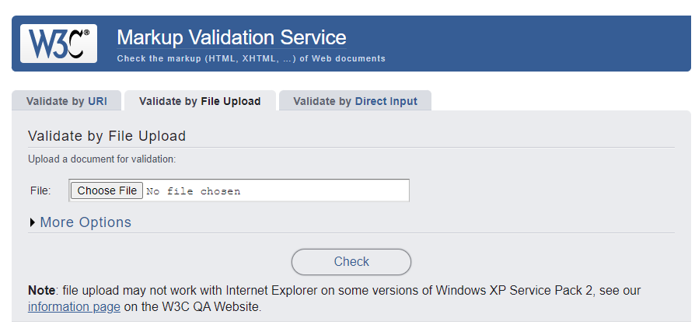

**Home Page**

**HTML**

1. The value in the element “a” should not be space between angle braces.
2. In line 38, the error is there has forgotten the element “ul” closing tag.

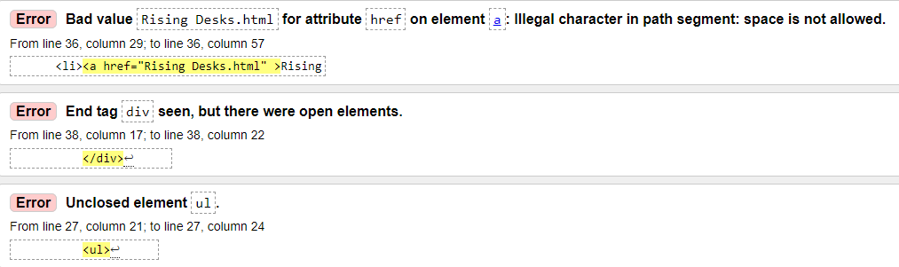

1. There must “alt” attribute in element “img”. The reason when the image would not found the “alt” would show with its name what picture is included.



1. Here is the video closing tag is forgotten to put. That’s why the error would occur.

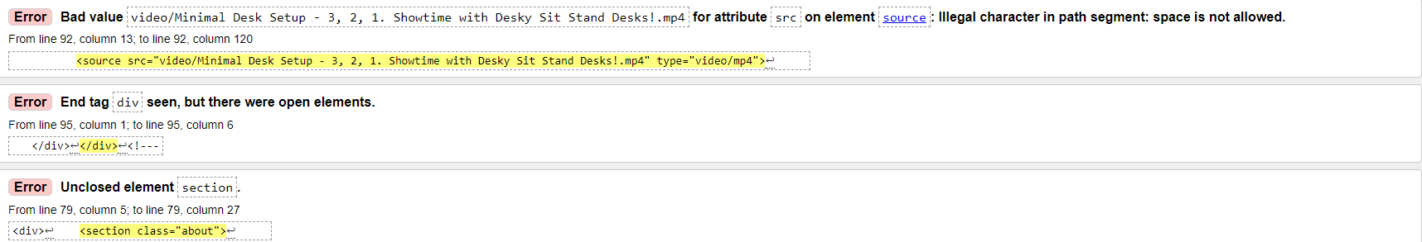

1. In this, the error of an unquoted element no need to put in alt attribute.

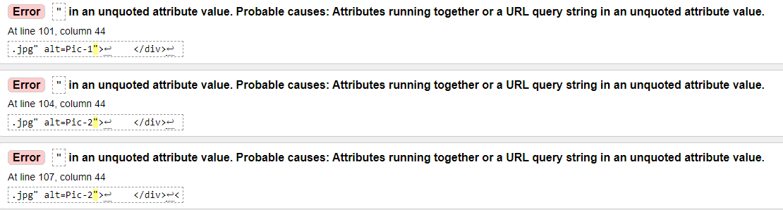

1. The error includes the extra id attribute. This is forgot to delete.

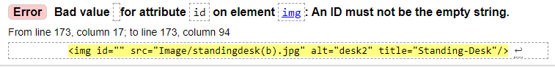

1. The closing tag “section” got placing wrong path.



1. This error is also caused by forgetting to attribute the alt element for the image tag.



**Rising Desk**

**HTML**

1. This is also the space including the space between the element “href” attributes the close tag.
2. There is need to put the element “ul” closing tag. Thus, the error is appearing.

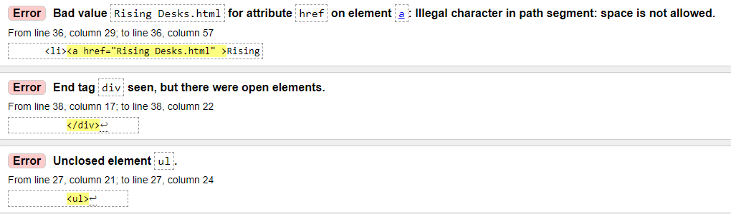

1. The closing tag </i> is accidently put as the extra tag.
2. The “sechearder” of closing tag is forgotten to put.

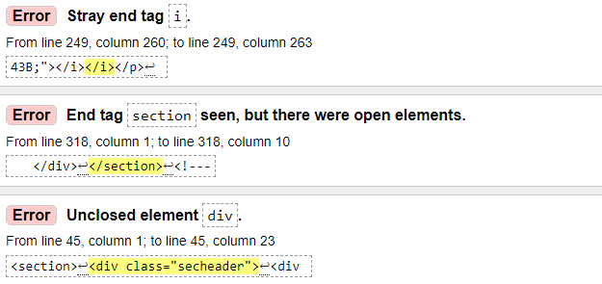

1. The attribute “alt” have to use in this “img” element to show the image description when the image display wouldn’t work.



1. This <hr/> element put accidentally and forgot to delete. Putting the style color element is unsuitable.

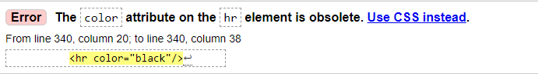 **Contact Us**

**HTML**

1. The attribute “alt” has to put in the element “img” because this will aid for the image description when the image won’t work



1. Attributing the style of hr closing is not suitable in the way.

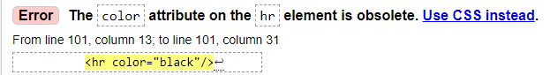

**Benefits Page**

**HTML**

1. The error shows value “Rising Desks” is the unsuitable character in the path segment and the space is not allowed between the tag.

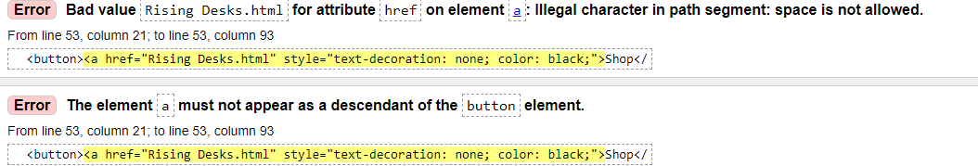

1. The element “img” should have the attribute “alt” to describe the kind of photo when the image wouldn’t work.

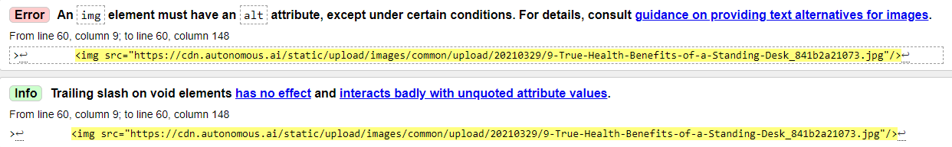

1. The element can’t be accepted in this way and this should use CSS instead of.

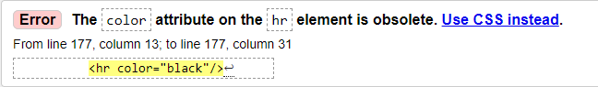

**Basket Page**

**HTML**

1. In this page the errors are occurring by forgetting the closing tag, in the element “img” the attribute “alt” should consider to put and in the <hr/> tag should not use the style attribute use in the CSS instead.

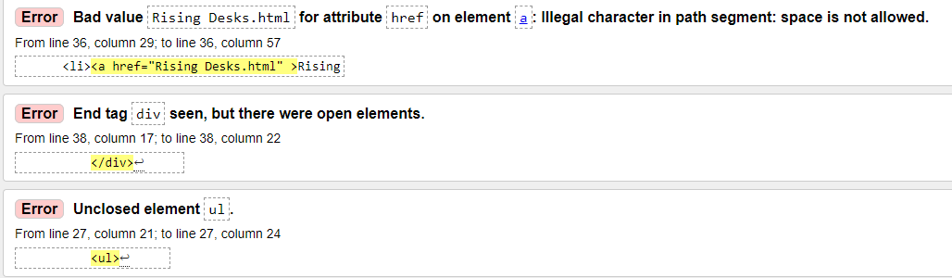

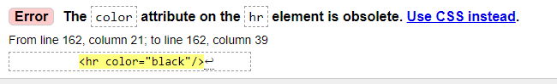 

CSS

CSS codes are tested on this CSS Validation Service to find out the errors inside the code.

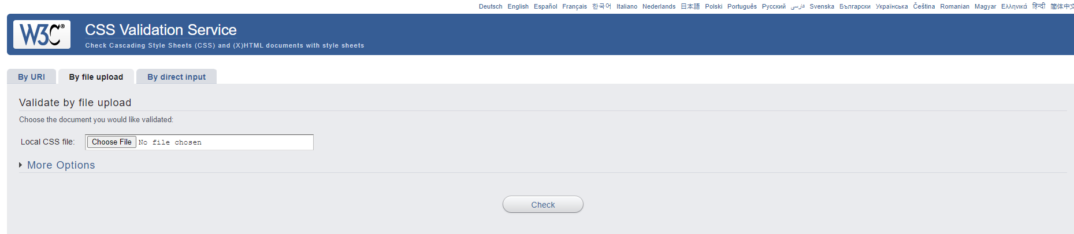If there have no errors inside the code the results will show like this**.**

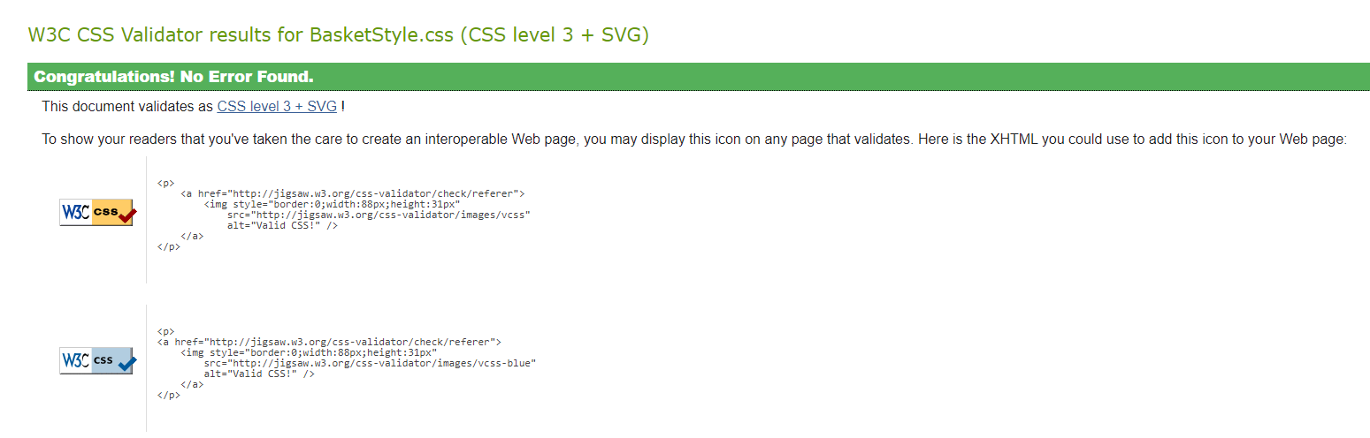

**Home Page**

In this error the value for “display” is unacceptable value.

The second is “padding-left” must be included the value “0px or 25px”.

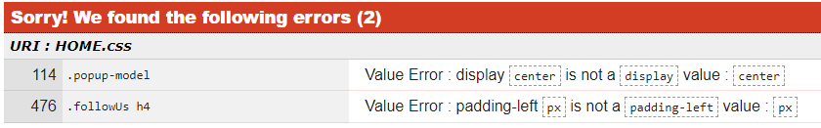

**Rising Desk**

On this page, there has no error.

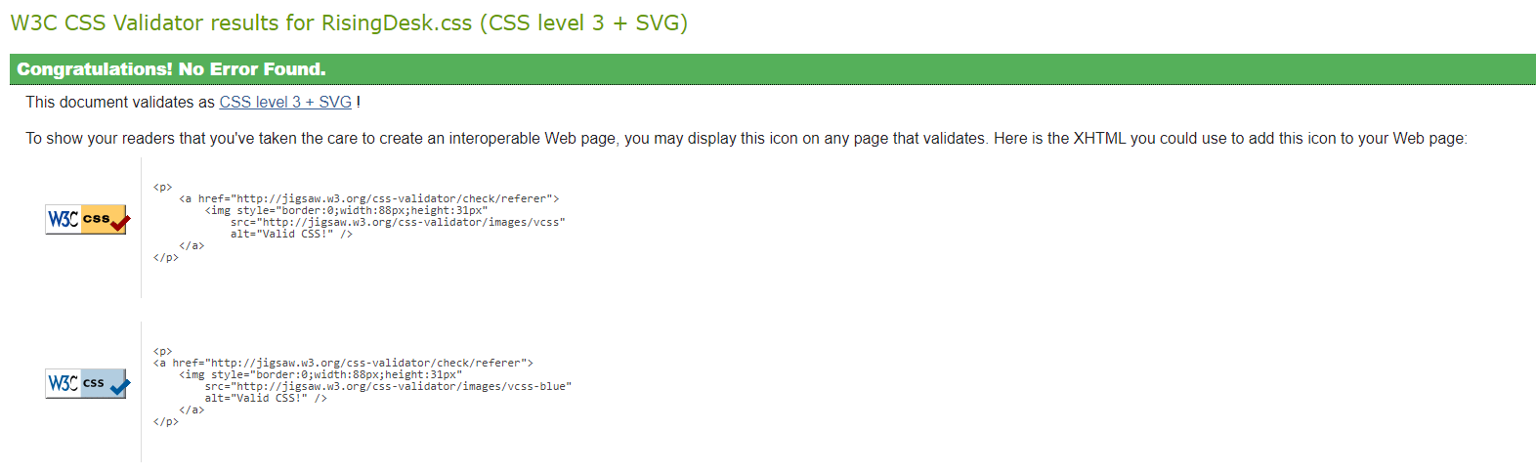

**Contact Us**

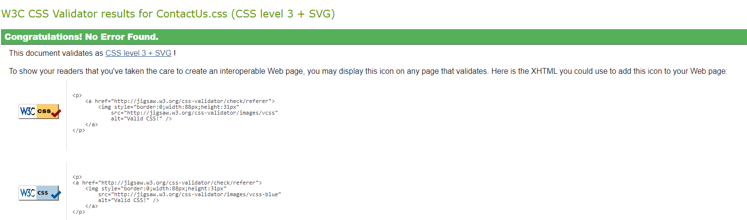

**Benefits**

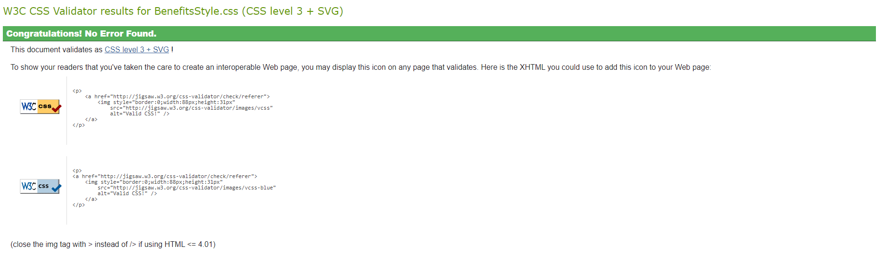

**Besket**



## Utilizing a screen reader

The screen reader is utilized for blind people. That is organized with multiple technology features to read out loud buttons, images, links, headings, and navigation bars where they are placed in by using the keyboard shortcuts. Around 16 percent of disabled users are utilizing this aid for their destination a half of life. Moreover, the software system, by describing the price, images, and so on, can support the user when they desire to shop the products from the online website. The screen reader helps for the blind user to be accessible without sighted assistance.

## How a screen reader performing

According to the text-to-speech features the user can hear with voice action how the website is structured. It will be needed to control with the keyboard shortcut keys for that feature. This can perform all over the information on the website and give to the blind user digital experiences. It also can help in education opportunities such as the online platforms learning for disabled users. For employment opportunities the user who may work at a remote job the system supports the communication between them and many aspects that relate to online system’s experiences. (Williamson, 2023)

**Chrome**

**For Desktop View**

**Home Page**



**Drop-down contact**











**Rising Desk Page**







**Contant Us Page**





**Benefits Page**





**Basket Page**





Mobile Device View (IPhone 12 Pro)

Home Page

 

 

Rising Desk Page





**Contact Us page**





**Benefits Page**





**Basket**





**Tablet View (IPad Air)**

**Home Page**







**Rising Desk**



**Contact Us Page**





**Benefits Page**





**Basket Page**





**Microsoft Edge**

**Desktop View**

**Home Page**

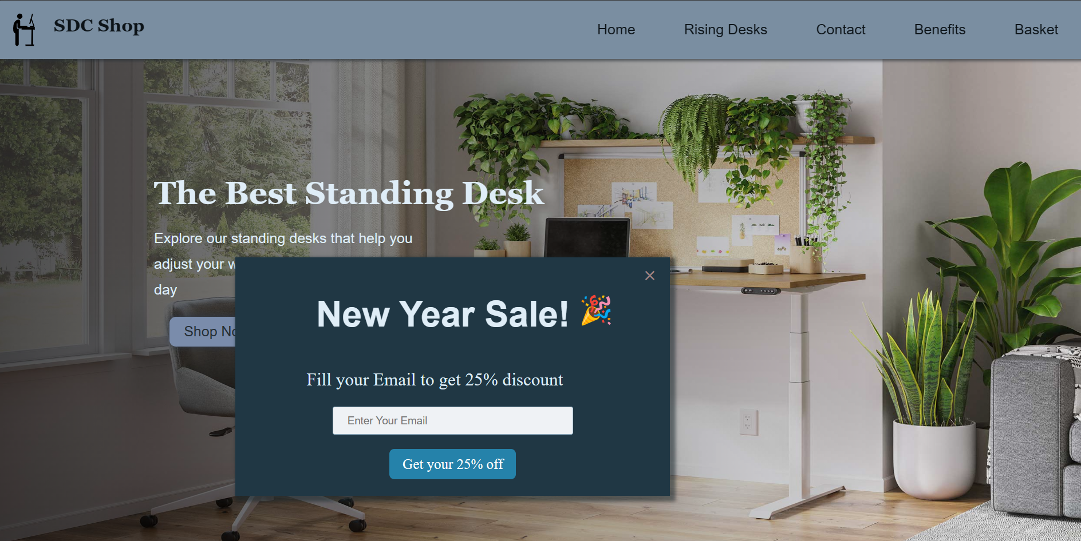

**Cotant Drop down**

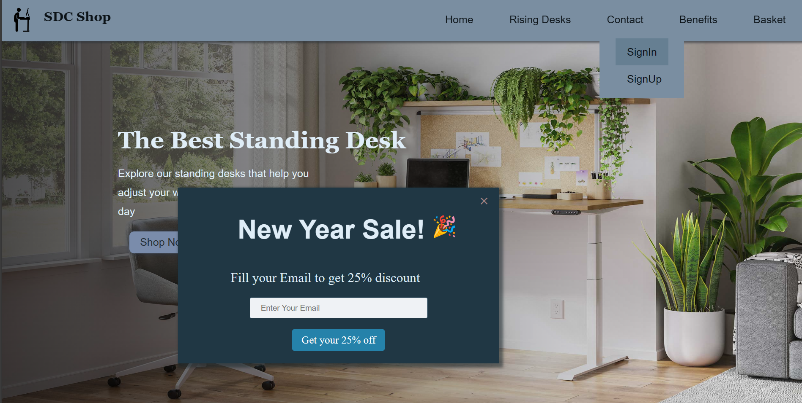

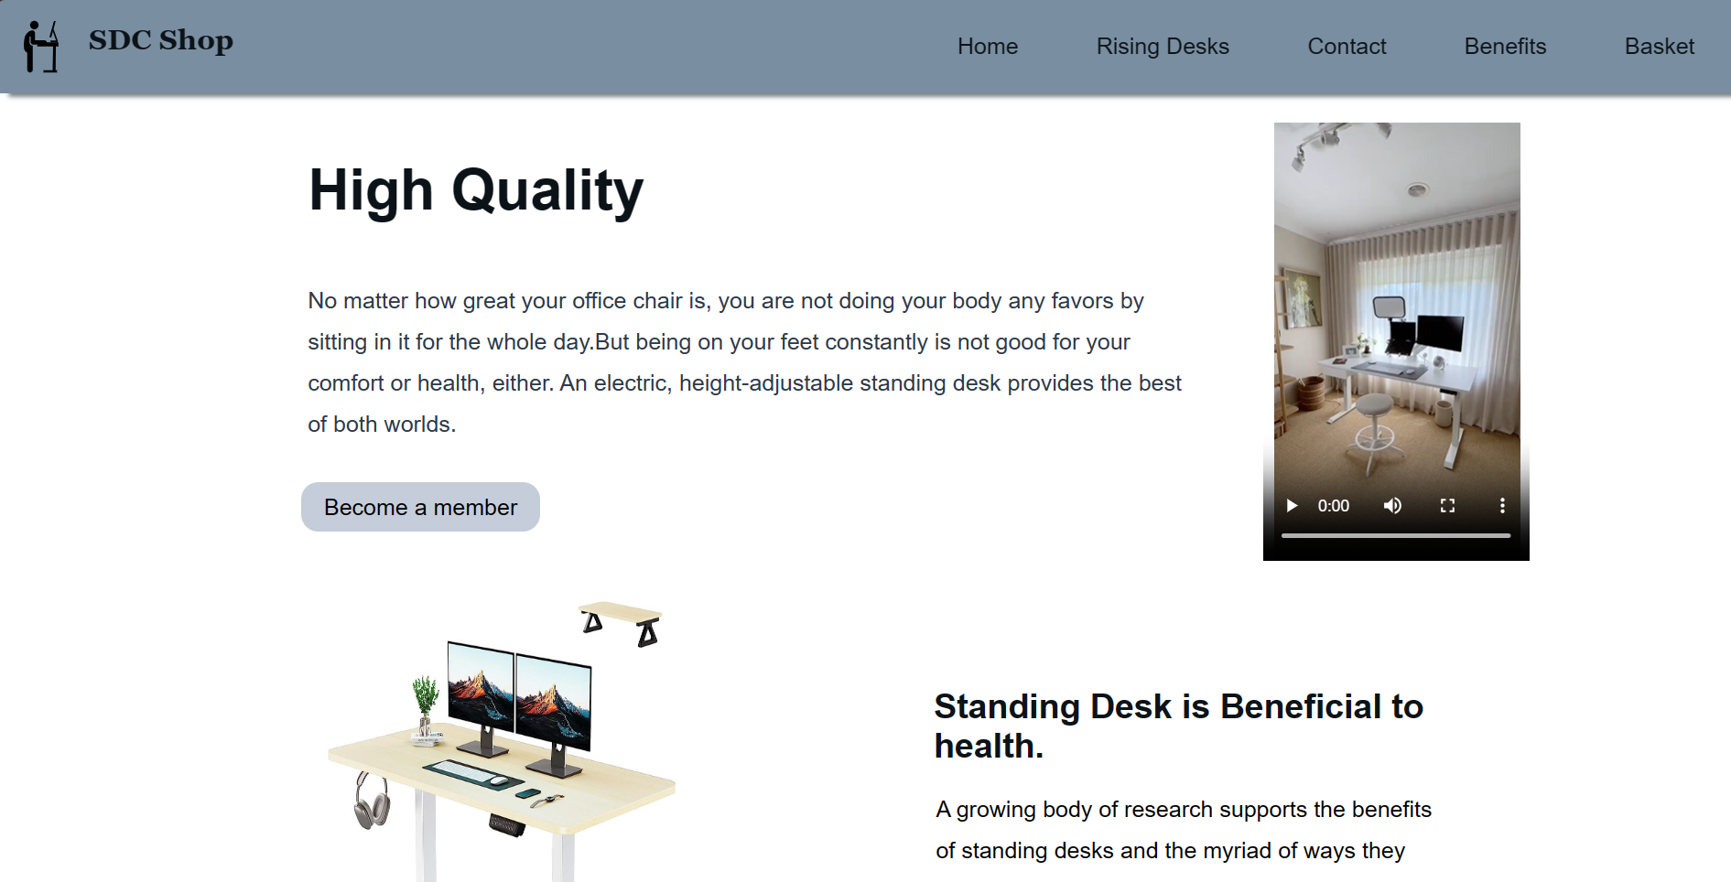

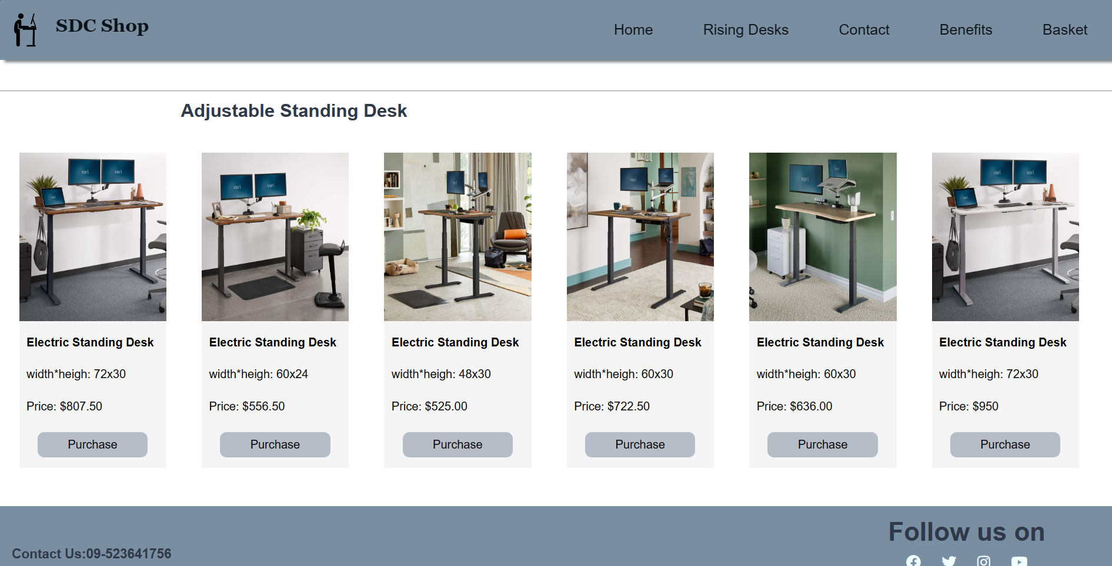

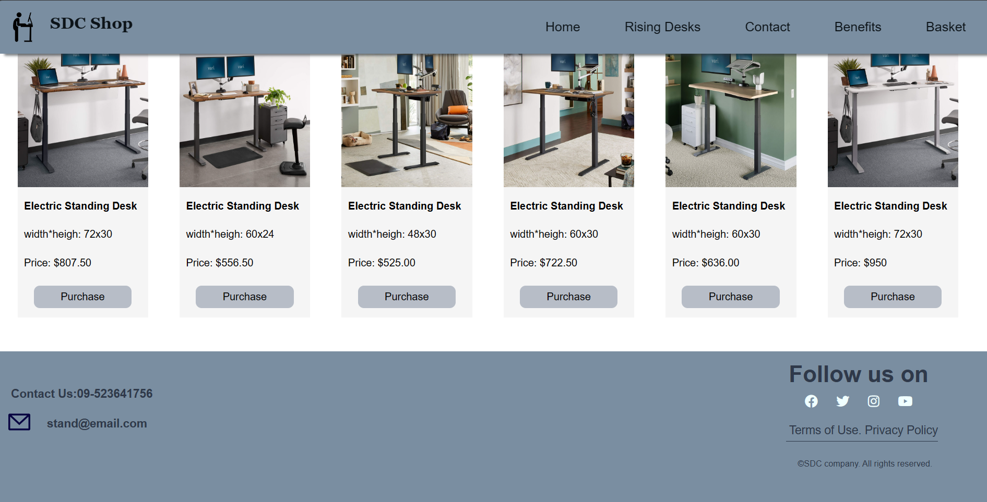

**Rising Desk Page**

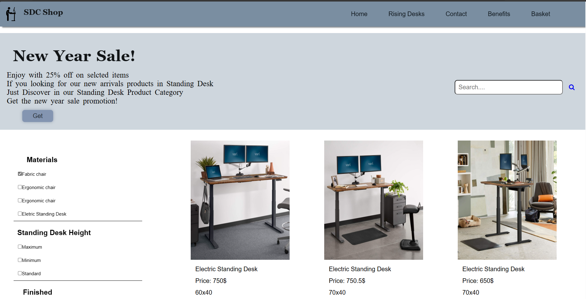

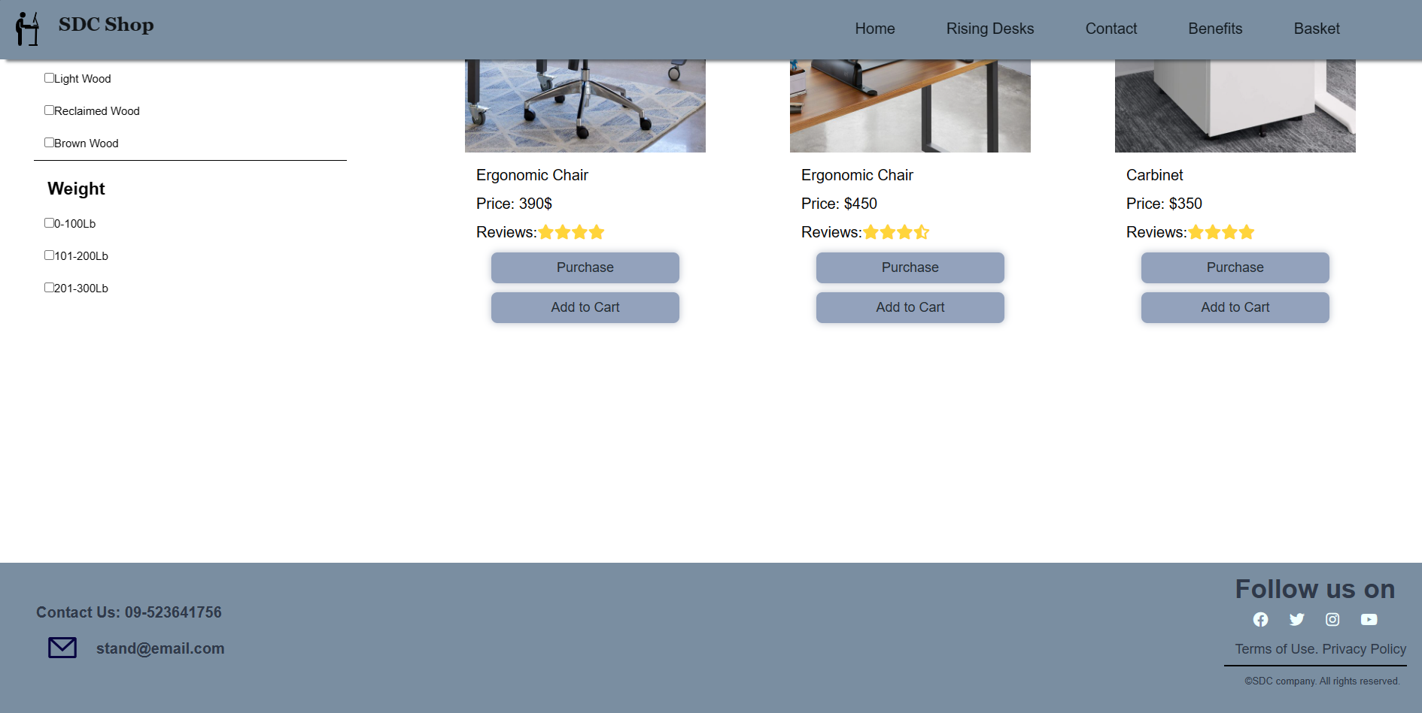

**Contant Us**

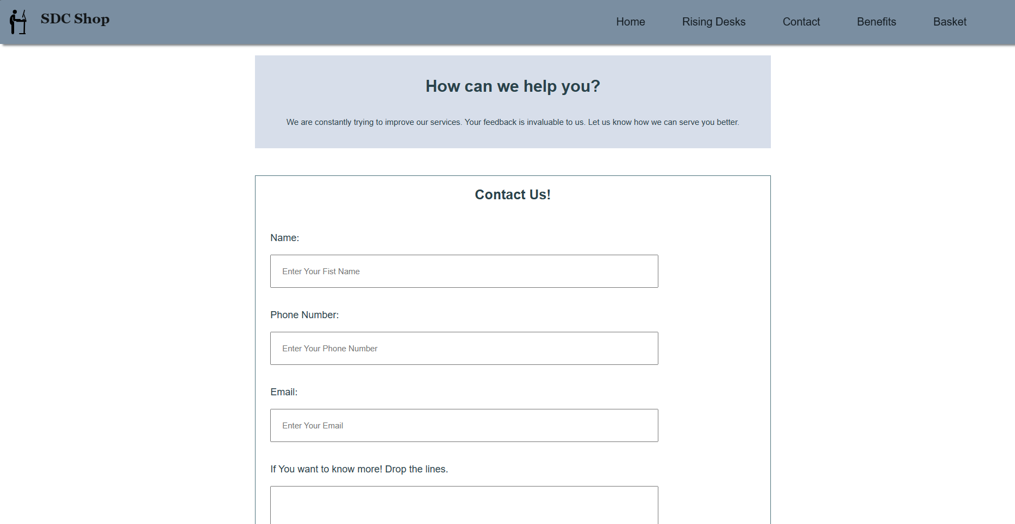

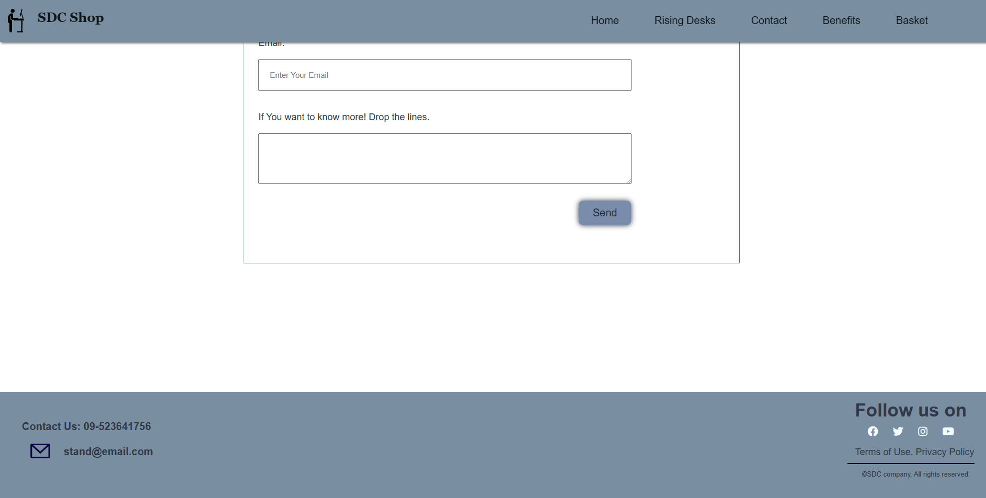

**Benefits Page**

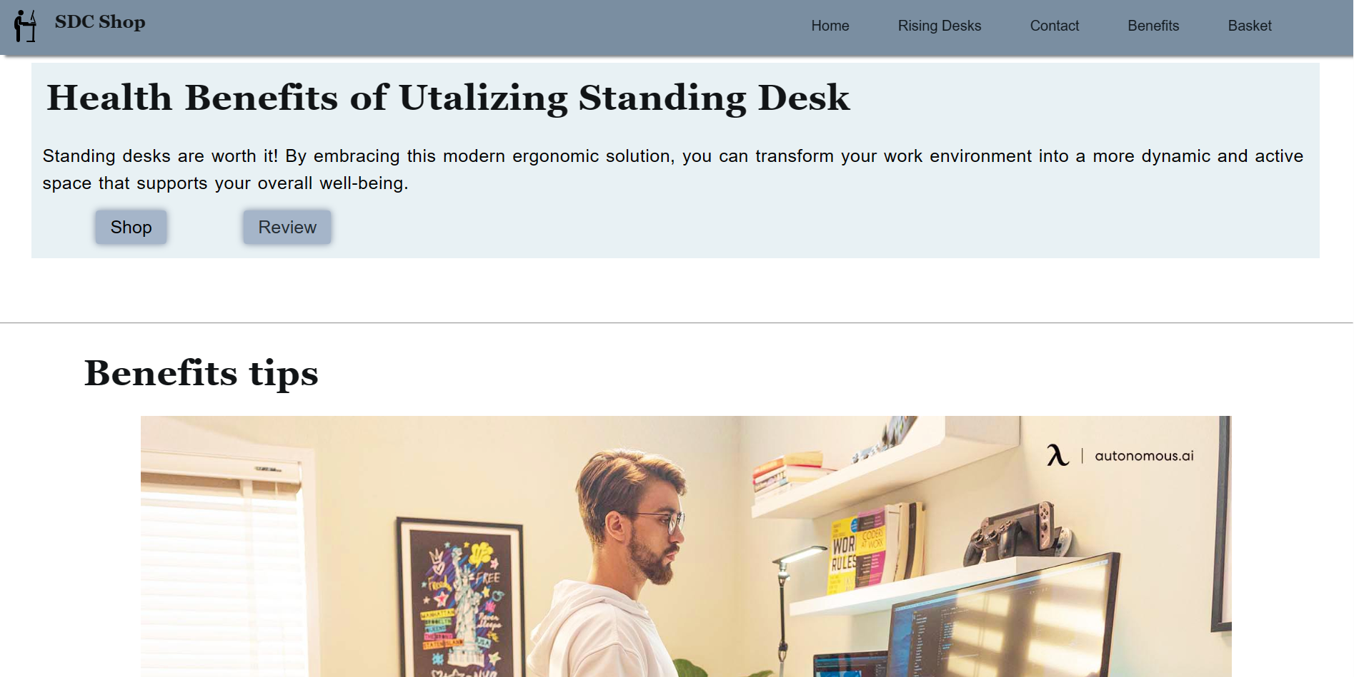

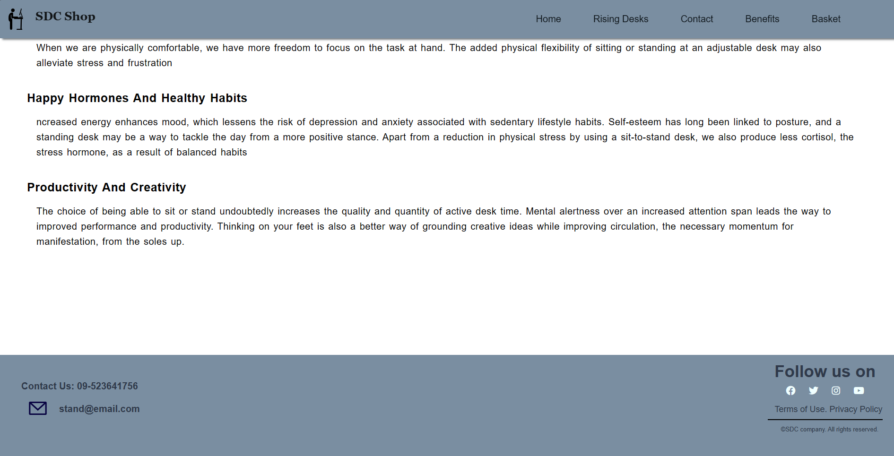

**Basket Page**

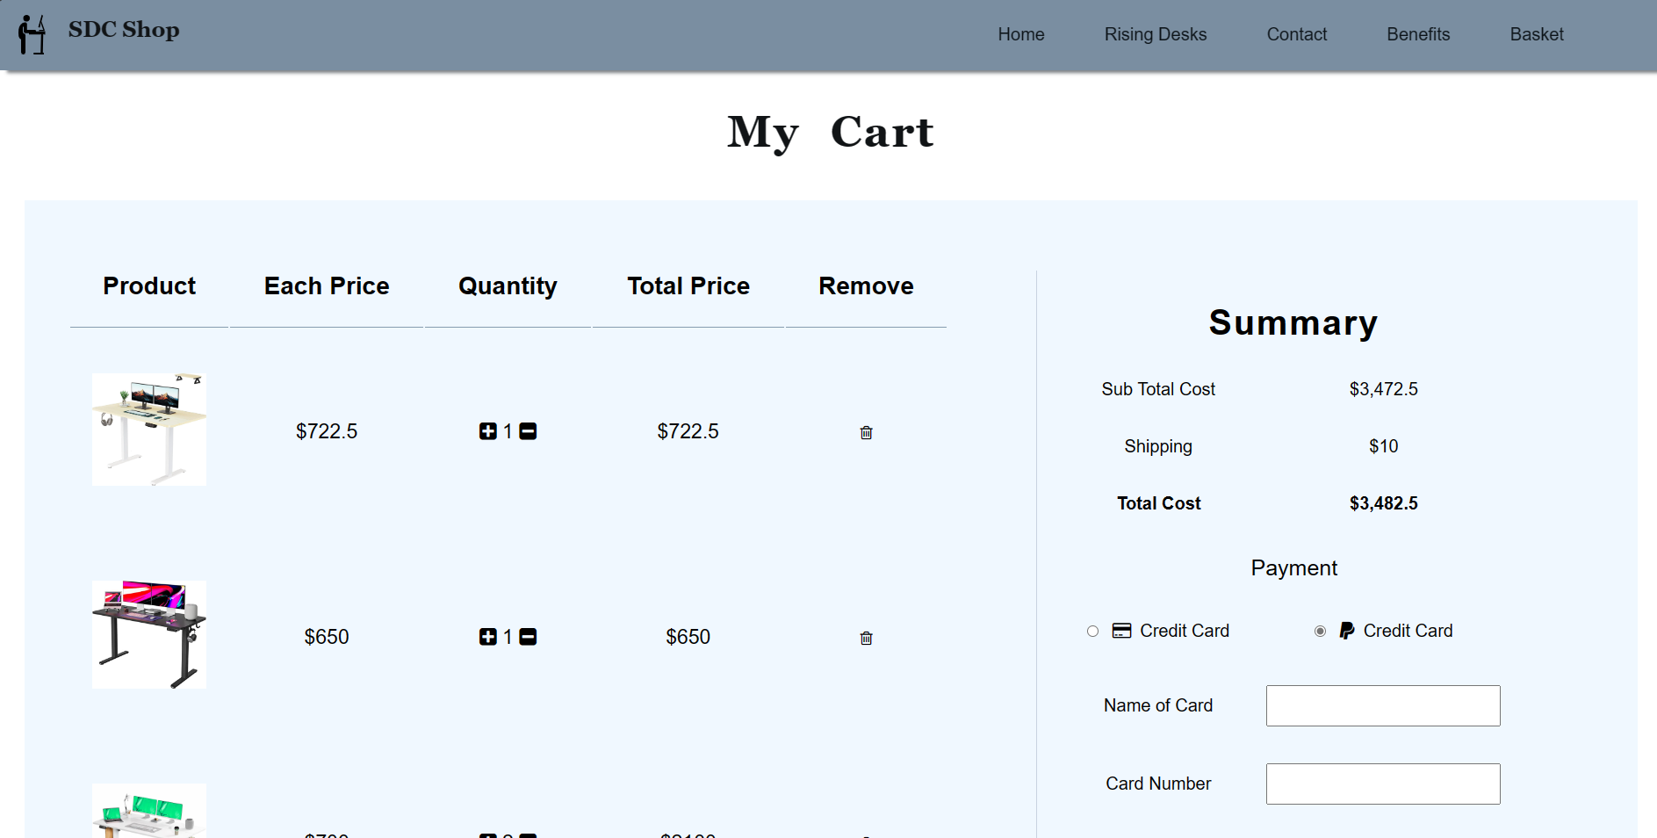

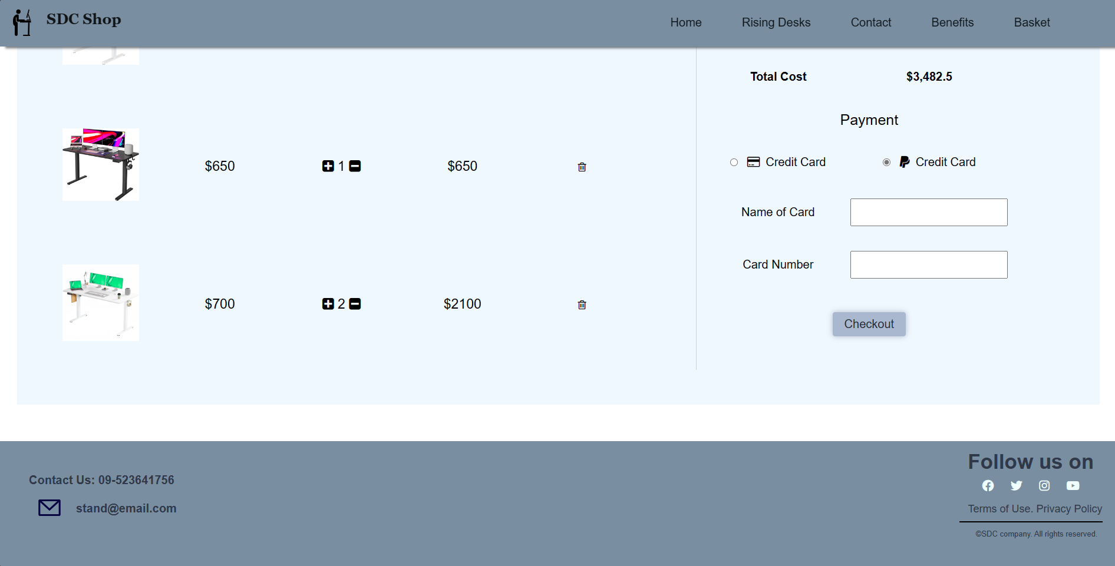

Mobile View (IPhone 12 Pro)

**Home Page**

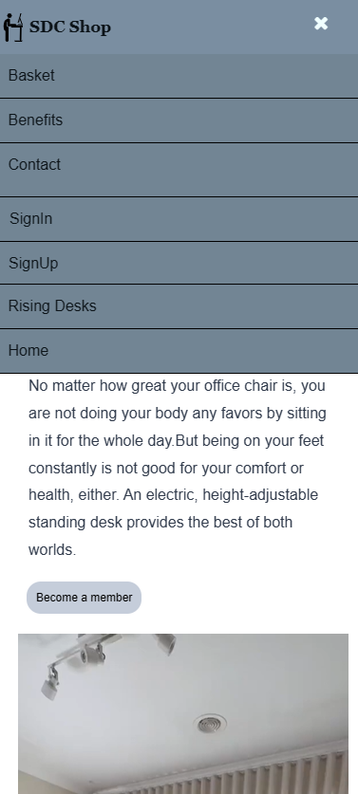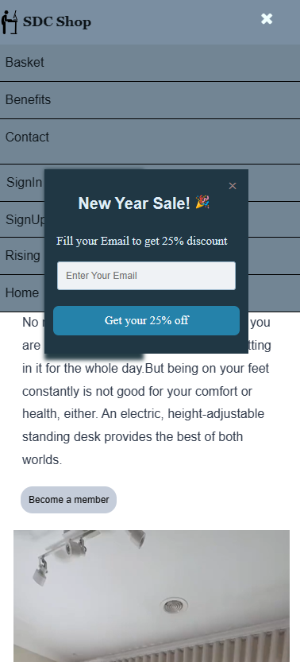

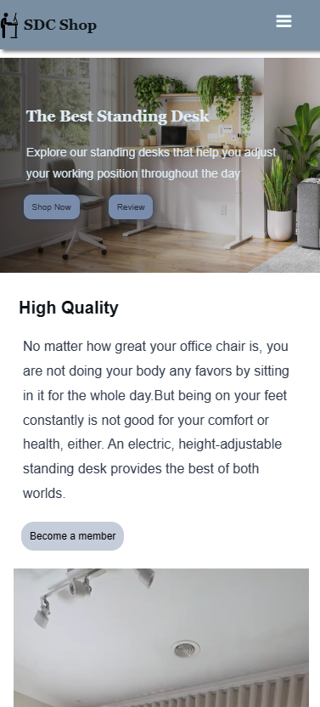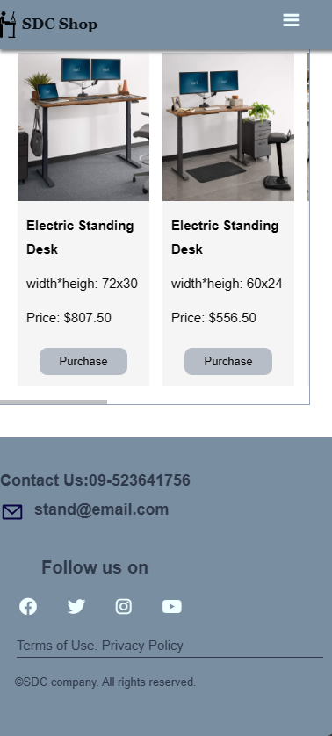

**Rising Desk Page**

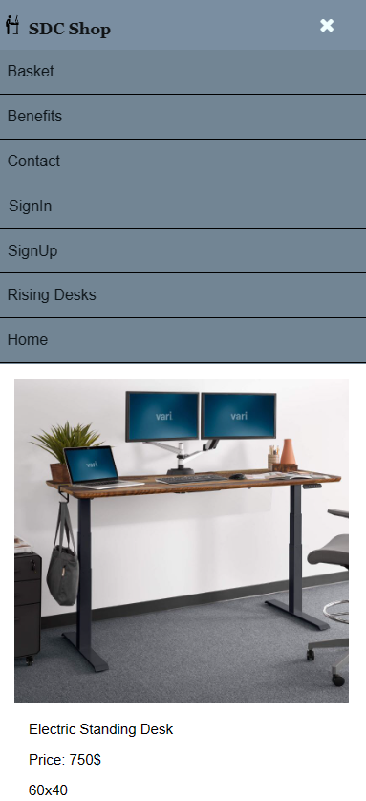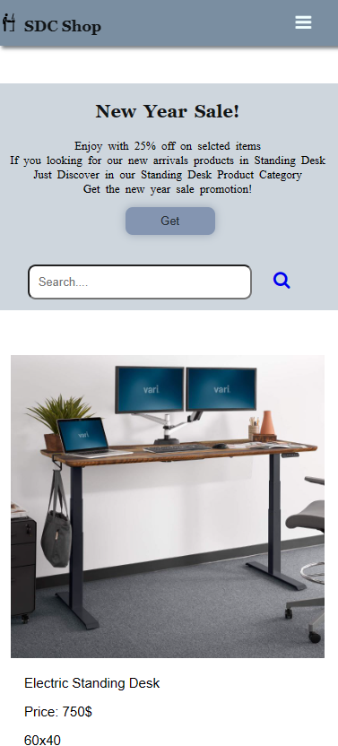

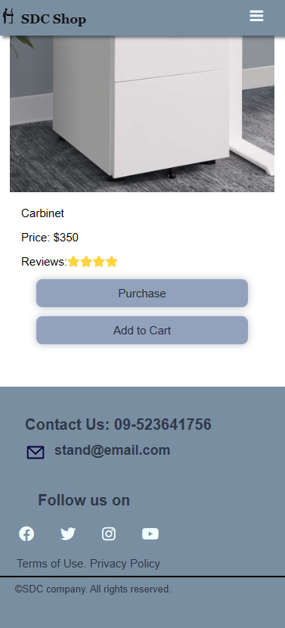

**Contact Us Page**

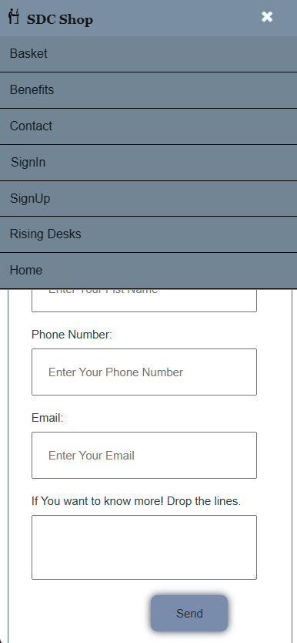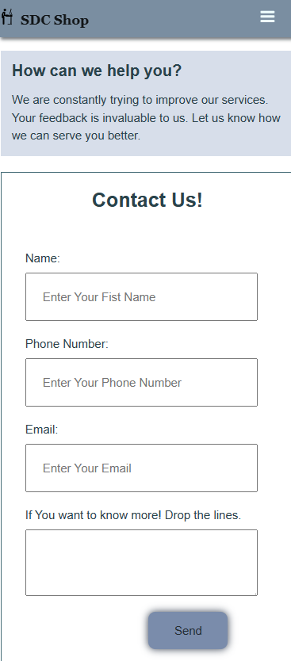

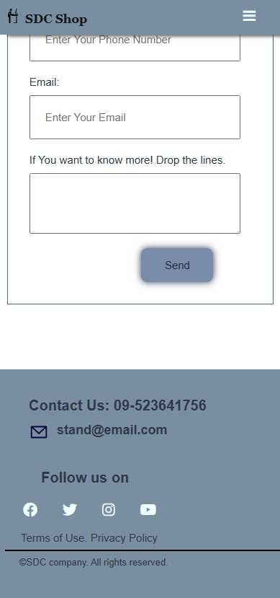

**Benefits Page**

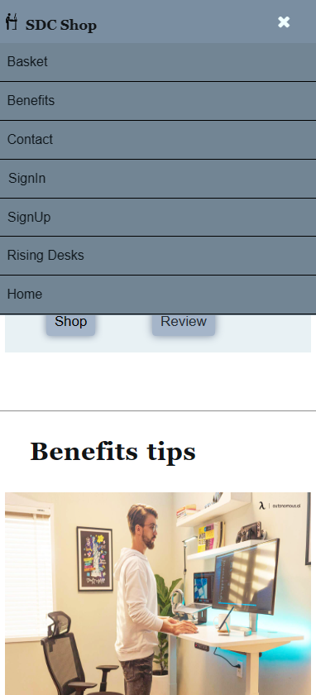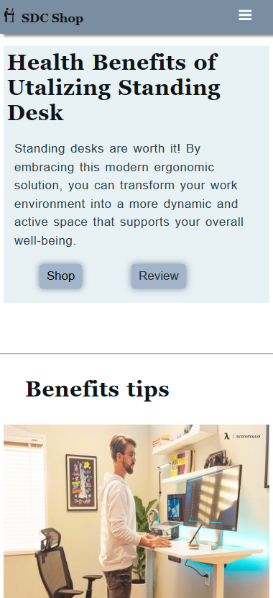

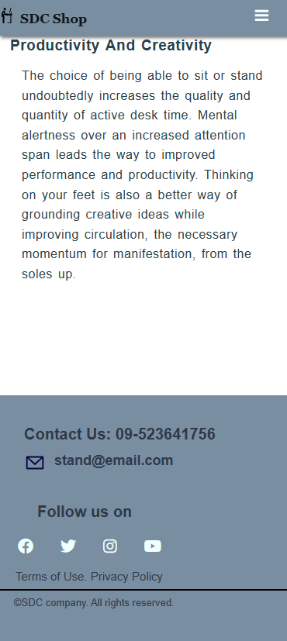

**Basket Page**

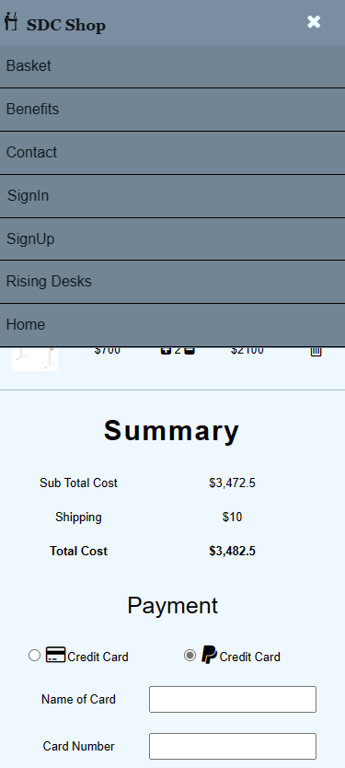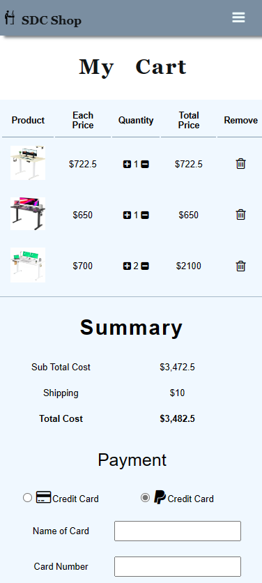

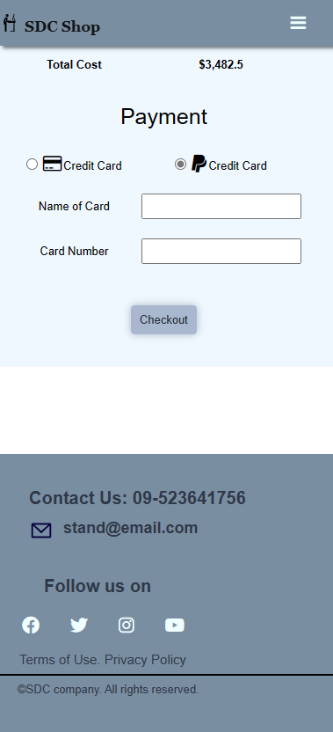

**Tablet Air (IPad Air)**

**Home Page**

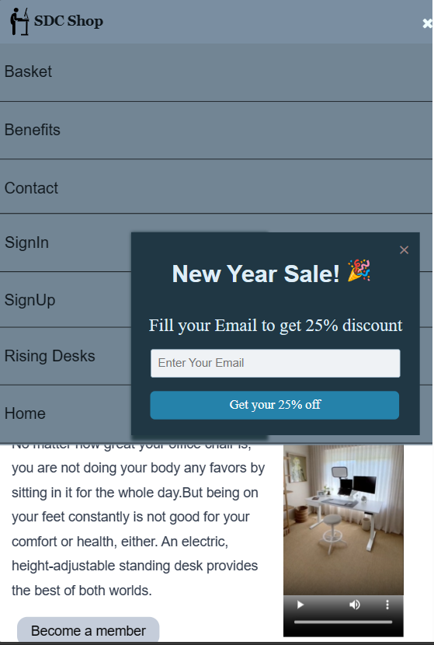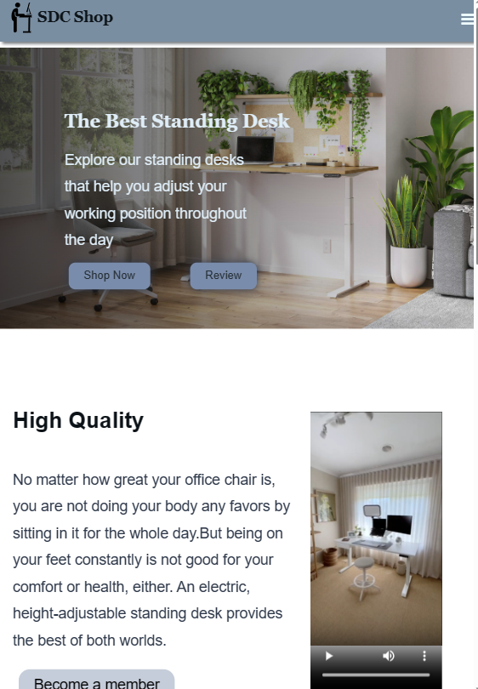

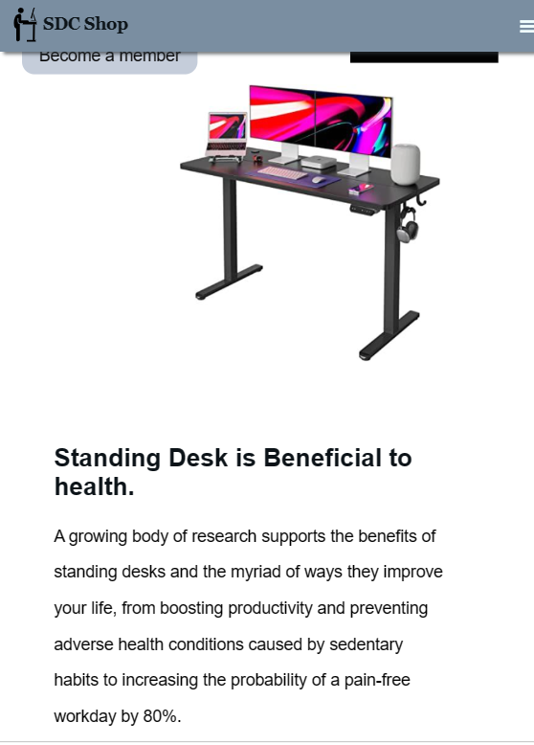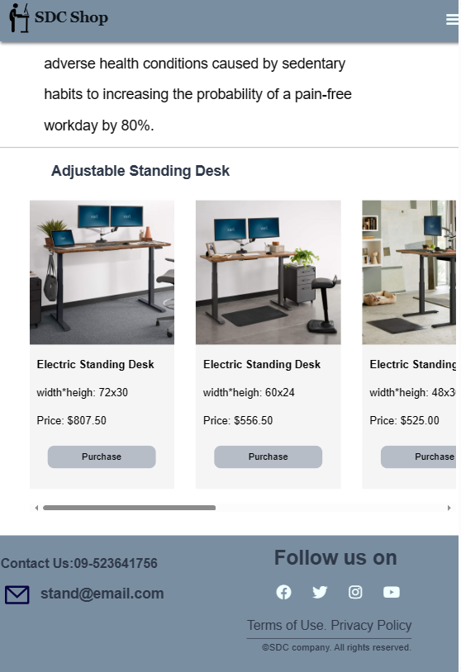

**Rising Desk**

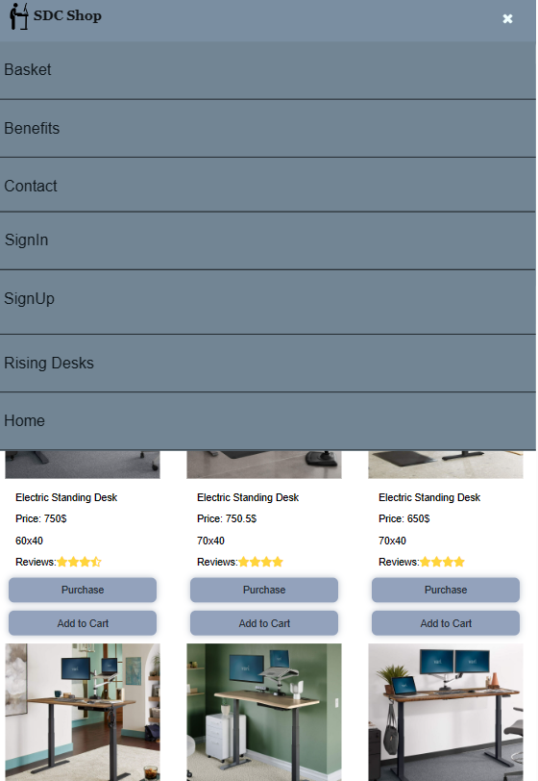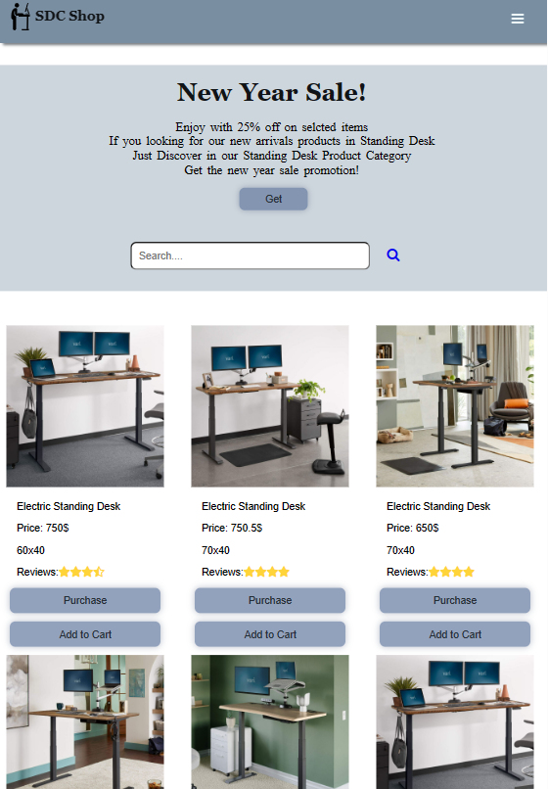

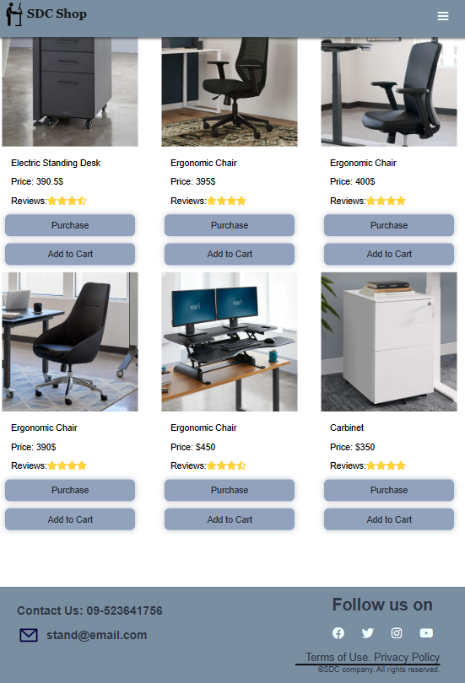

**Contact Us Page**

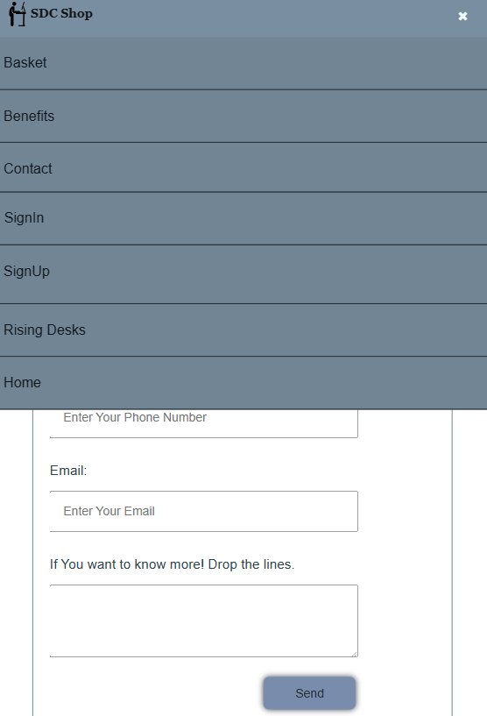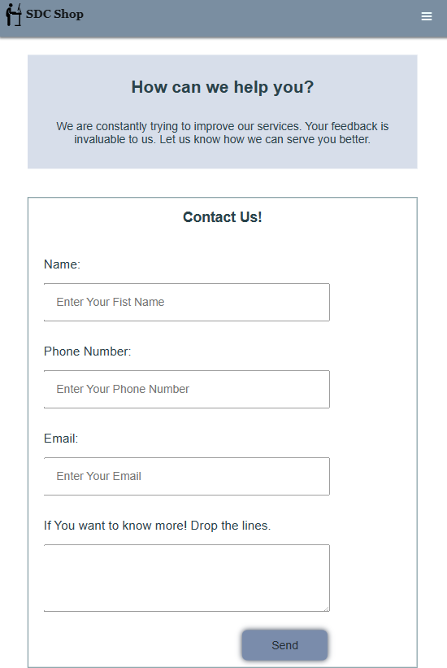

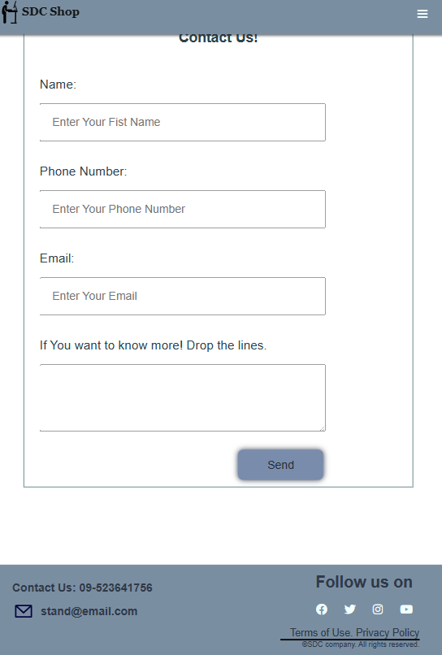

**Benefits Page**

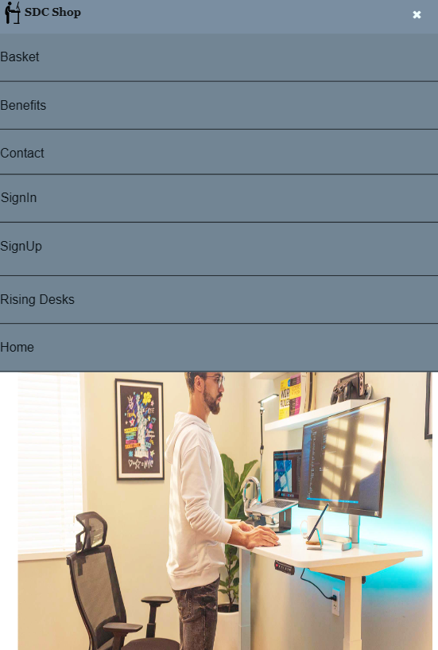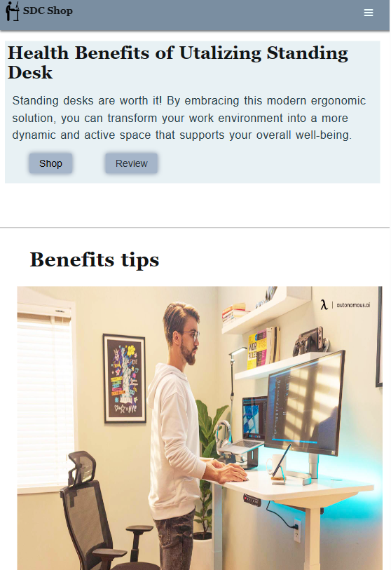

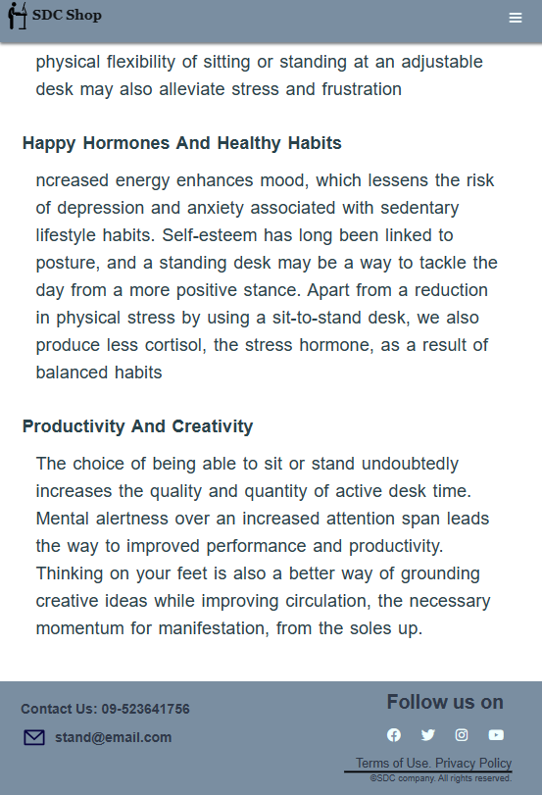

**Basket Page**

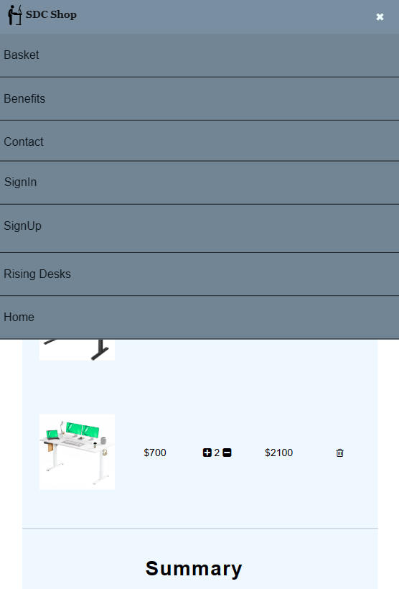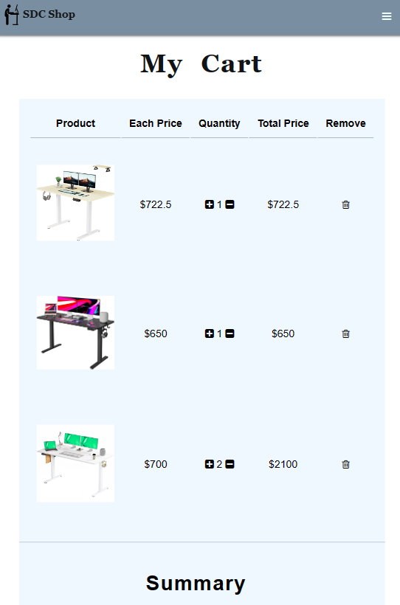

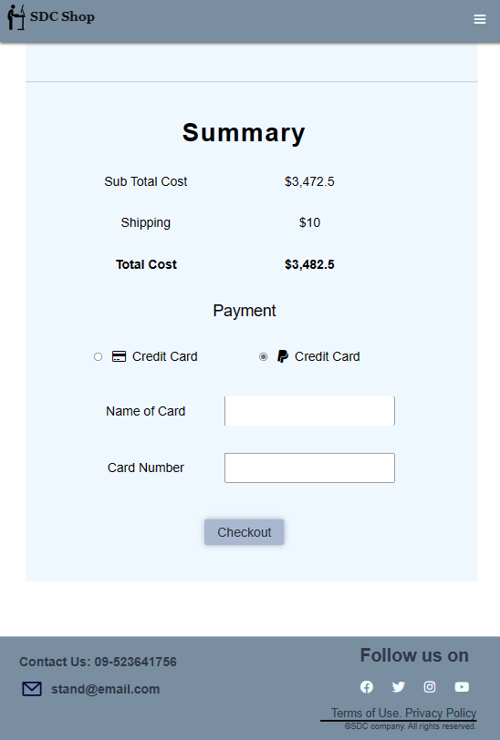

## The aspects of distinct between browser testing and Microsoft Edge testing

The website layouts and overall performance can be separated between Browser and Microsoft Edge. As the user interface, testing on the browser the website can seem small view pot compared with Microsoft Edge. On the other side Microsoft’s view pot can vast than the browser’s view pot. The font size and other objects are a little bit large size as well withing the website. As the loading the browser is slightly faster than the Microsoft Edge it’s because their different efficiency keys. Although the layout of the website isn’t different that much. The reason for testing the website on different browsers can promote the website's interface and user experiences. It can make the ensure of the website accessible on every browse and the same sight for all users.

## Evaluation of the errors

For the differences in user interfaces such as small and huge, there must need to adjust the units when identifying width and height. Use the “percentage” for the width instead of using the “px”. Utilizing percentage is one of the crucial parts for making website responsive as the size is fitted for any circumstances. The best practice for font sizing is (1em) to follow other sites and the font size still looks inconsistent. Following those solutions can aid the consistent website and improve the user interface of whatever is on the site.

## Role of the W3C

The World Wide Web Consortium (W3C) is also known as W3C. W3C is an international organization which is founded by Tim Berners-Lee in 1994. It is an open platform for innovation and communication. This website is to improve for web standards. That guide for the errors and unacceptable sentence structures by checking HTML, CSS, and JavaScript code. According to guide and describe those guidelines can develop the website and eliminate the lacking process. The website is very useful for end users and web-based developers. That is also maintaining for the HTML, CSS, JavaScript as their wrong format structures and web accessibility. As the above description, the W3C serves multiple crucial roles. (Kumar, 2023)

**Task 4**

# 

# Task-4

## Critical Evaluation

## How the tools, techniques, and software are crucial for developing a website

The web design tools can assist when creating a website. There are various kinds of software tools and each of their features can customize the website’s requirements and preferences. First of all, before designing the website it has to draw the website design’s draft. By drawing with those web tools, the user can imagine the website's background and the interface can come out quickly. Moreover, it can control the design such as trying the suitable color and some specific elements. These are some web design tools mostly that are affordable with small budgets plans.

1. Adobe Dreamweaver
2. WordPress
3. Adobe Photoshop
4. Wix
5. Sketch
6. Adobe XD
7. Figma
8. Invision Studio
9. Google Web Designer

Those are the popular tools among web designers as the research. Those tools aid and suitable in developing the website. (Team, 2022)

## Evaluation of the website’s satisfaction with user experience and efficiency of user-friendly

User experience is important things for viewer satisfaction and that is very related to their emotions. The reason is if the website design is created with so many features in one place, it can be complex. In this case, the user can be confused and cannot understand their means. Therefore, the key elements must be clear and relate to the goal. And also putting the content structure before coming to the web focus design ensures the user is understandable. The menu bar, link location, button, label, and so on must be designed clearly which also must relate to the direction focus. Consideration loading speed of the website is essential because the loading speed would lack over the limited time the viewer won’t into using the website. Eliminate and reduce the errors and bugs as much as possible. The responsive part is very required to acceptable the website on every device such as mobile, tablet, and desktops. If matching with those tips when creating the website may be usability and accessibility exactly. (team, 2023)

## Accessibility Features included from the created website

The content structure and the product’s card example shown on the Homepage are included as accessibility features. As the created the content structures may help with screen reader users who are disabilities. The reason is this will describe and guide which function, page, and links are located. For the images that are attributed with text so the screen can read out loud how the images are referring to. As the product’s card example shows enables to know viewer the how the products exist on the website and if the user just researches for the products benefits, by putting the buttons named “shop now” on that page, the user can view the website directly. Hence, making the accessibility features impact for website by reaching search engine optimization. Then, everyone can see the website first and reach to the website, product sales can increase by rapidly. (Hernandez, 2022)

## Recommendation for improving the website

Processing the website improvements is one of the ways to gain customers effectively. By making the improving the website, can aid the website in reaching search engine optimization. And it will for the product’s brand awareness. Via awareness, the organization of profit may increase and the organization’s goal will be fulfilled as much as possible. As the first tip on adding the advertisements on other social platforms that may be accessible the website. Make sure eliminate the website’s page errors and loading errors by testing frequently. Eliminating from the complicated distractions means making sure the website simplifies description and just focus on the important facts. The last is, utilizing search engine optimization and named that healthily can make the website growth by reading to audience widely. Those recommendation may improve the website and timeline the organization’s image. (Indeed Editorial Team, 2023)

# References

# References

Hernandez, I. (2022). *dreamhost*. Retrieved January 21, 2024, from https://www.dreamhost.com/blog/make-your-website-accessible/

Indeed Editorial Team. (2023). *indeed*. Retrieved January 21, 2024, from https://www.indeed.com/career-advice/career-development/improvement-of-website

Jordan. (2013, June 26). *The Importance of W3C Standards*. Retrieved from Bop Design: https://www.bopdesign.com/bop-blog/2013/06/the-importance-of-w3c-standards/#:~:text=Created%20in%201994%2C%20W3C%20is,ensure%20its%20long%2Dterm%20growth.

Microsoft. (2022). *Complete guide to Narrator*. Retrieved from Microsoft Support: https://support.microsoft.com/en-us/windows/complete-guide-to-narrator-e4397a0d-ef4f-b386-d8ae-c172f109bdb1#:~:text=Narrator%20is%20a%20screen%2Dreading,about%20what's%20new%20in%20Narrator.

Nick. (2015, October 14). *ProWebmasters*. Retrieved from StackExchange: https://webmasters.stackexchange.com/questions/14324/font-displays-differently-in-firefox-vs-chrome

team, A. (2023). *aicontentfy*. Retrieved January 21, 2024, from https://aicontentfy.com/en/blog/importance-of-user-experience-in-website-design

Team, I. E. (2022). *career-advice*. Retrieved January 21, 2024, from https://www.indeed.com/career-advice/career-development/web-design-tools

Williamson, G. (2023). *acadecraft*. Retrieved January 21, 2024, from https://www.acadecraft.com/blog/what-is-a-screen-reader-and-their-benefits-for-blind-people/#:~:text=Screen%20readers%20use%20a%20text,can%20enjoy%20using%20Screen%20readers.

# Candidate checklist

Please use the following checklist to ensure that your work is ready for submission.

Have you read the NCC Education documents 'What is Academic Misconduct? Guidance for Candidates' and 'Avoiding Plagiarism and Collusion: Guidance for Candidates' and ensured that you have acknowledge all the sources that you have used in your work?



Have you completed the 'Statement and Confirmation of Own Work' form and attached it to your assignment? You must do this.



Have you ensured that your work has not gone over or under the recommended word count by more than 10%?



Have you ensured that your work does not contain viruses and can be run directly?

